Marvell Based CLI Manual

Content

System Management 6
Command Line Interface Mode 6
Management IP Address 6
Configuring 6
Examples 7
Backup/Restore Configuration 7
Configuring 7
Examples 8
Clearing Log 9
System Warm Restart 9
User Management 9
Login Management 9
Configuring 9
Examples 11
System Hostname Configuration 11
Firmware Upgrade 11
System Data And Time Configuration 12
Configuring Ethernet Interface 14
Overview of Interface Types 14
Configuring 14
Examples 16
Display Information 16
Configuring Storm Control 19
Overview of Storm Control 19
Configuring 19
Examples 19
Display information 19
Configuring SPAN 20
Overview of SPAN 20
Configuring 20
Examples 21
Display information 21
Configuring Port Aggregation 22
Overview of Port Aggregation 22
Overview of LACP 22
Configuring 23
Examples 24
Display information 24
Configuring PoE 27
Overview of PoE 27
Configuring 27
Examples 28
Display Information 28
Log Management 29
Log Management Overview 29
Configuring 29
Configure Console Log Level 29
Configure Terminal Log Level 29
Configure Remote Server 29
Configure the Logging Buffer 30
Clear Log 30
Examples 30
Display Information 30
Configuring VLAN 32
Overview of VLAN 32
Configuring 32
Display Information 34
Configuring QINQ 35
Overview of QINQ 35
VLAN Stacking 35
VLAN Mapping 35
Configuring 36
Examples 37
Display Information 40
Configuring ERPS 41
Overview of ERPS 41
Introduction to ERPS Rationale 41
Configuring 43
Examples 45
Display Information 49
Configuring IGMP Snooping 50
Overview of IGMP Snooping 50
Configuring 50
Examples 51
Display Information 52
Configuring Spanning Tree Protocol 53
Overview of Spanning Tree Protocol 53
STP 53
RSTP 65
MSTP 70
Standard Specification 81
Configuring 81
Default Configuration 81
Configure STP Mode and Status 81
Configure STP Election Parameters 82
Configure Topology Convergence Parameters 82
Configure Edge Port 83
Configure MST Parameters 83
Configuration Protection Function 84
Other Optional Configuration 85
Examples 86
Example for Configuring RSTP 86
Example for Configuring MSTP 86
Display Information 88
Configuring MAC Address 89
Overview of MAC Address 89
Configuring 89
Examples 92
Display Information 92
Configuring LLDP 94
Overview of LLDP 94
Configuring 96
Configuring Switch and Operating Mode 96
Configuring Optional Basic Parameter 97
Configuring Optional State Machine Parameter 98
Configuring Send Tlv List 100
Examples 100
LLDP Basic Function Configuration Example 100
Display Information 100
Configuring LOOP-DETECT 102
Overview of LOOP-DETECT 102
Configuring 102
Enable LOOP-DETECT Globally 102
Enable LOOP-DETECT On Interface 102
Configure Port Loop Action 102
Specify Vlan Domain To Detect 102
Set Packet Sending Interval 103
Set Error-down Recovery Time 103
Error-down Recovery 103
Enable Trap 103
Examples 104
Display Information 104
Display LOOP-DETECT Information 104
Configuring GVRP 106
Overview of GVRP 106
Introduction to GVRP 106
Introduction to GARP 106
Port Registration Mode 106
Messages and Timers 106
Packet Format 107
Configuring 107
GVRP Enable Control 107
Set registration Mode 108
Set Timers 108
Clear Statistics 108
Examples 108
Typical Cases Case requirements: 108
Display Information 109
Display GVRP Status Information 109
Display GVRP VLAN Information 110
Display GVRP Statistics 110
Configuring L3 111
Overview of L3 111
Configuring 113
Examples 116
Display Information 117
Configuring ACL 119
Overview of ACL 119
Configuring 119
Configure IP Standard ACL 119
Configure IP Extended ACL 119
Configure MAC ACL 121
Configure IPv6 ACL 122
Other Configuration Items 123
Examples 124
Display Information 125
Configuring QoS 127
Overview of QoS 127
Configuring 128
Examples 132
Display Information 133
Configuring DHCP Snooping 136
Overview of DHCP Snooping 136
Configuring 136
Examples 138
Display Information 138
Configuring 802.1X Authentication 139
Overview of 802.1X Authentication 139
802.1X Architecture 139
802.1X Authentication Method 139
802.1X Basic Concepts 139
Authentication process for 802.1X 140
Configuring 142
Examples 144
802.1X Port Authentication Scenario 144
MAC Authentication Scenario 145
Display Information 146
Configuring Port Security 147
Overview of Port Security 147
Configuring 147
Examples 148
Display Information 148
Configuring Ip Source Guard 150
Overview of Ip Source Guard 150
Configuring 150
Examples 150
Display Information 150
Configuring Arp-check 152
Overview of Arp-check 152
Configuring 152
Examples 152
Configuring SNMP Network Management 153
Overview of SNMP Network Management 153
Configuring 153
Examples 154
Configuring RMON 155
Overview of RMON 155
Rationale 155
Configuring 157
Examples 158
Display Information 158
Configure sFlow 160
Overview 160
Principle 160
sFlow system composition 160
sFlow sampling 160
sFlow message 161
Configuration commands 161
Examples 162
Display Information 162
Configuring DHCP Server 164
Overview of DHCP Server 164
Configuring 164
Global Configuration Commands 164
Subnet Configuration Command 165
Address Pool Configuration Command 166
Examples 167
General DHCP Server Address Assignment Scenario 167
Supports DHCP Server Address Allocation Scenarios Delivered by Private Attributes 168
A DHCP Server Address Assignment Scenario that Supports Guest Separation 169
Display Information 170
Configuring AAA 171
Overview of AAA 171
Configuring 171
Examples 172
SSH Login Authentication Using Tacacs+ Method 172
Use the None Method to Perform Serial Port Login 173
Display Information 173
Fault Diagnosis 174
Ping/tracerout 174
Port Optical Module 174
Configuring Port Optical Module 174
Alarm/Warning Trap 175
Display Port Optical Module DDM Information 176
Dying Gasp 179
Cable Detect 180

System Management

Command Line Interface Mode
The command line interface is divided into many different modes, The commands available to you depend on which mode you are currently in. Enter a question mark (?) at the system prompt to obtain a list of commands available for each command mode.
Table following describes the main command modes, how to access each one, the prompt you see in that mode, and how to exit the mode. The examples in the table use the hostname SWITCH.
Table Command Mode Summary
Mode | Prompt | Enter Or Exit | About This Mode
User Exec | SWITCH> | Enter exit to quit | Use this mode to:  Perform basic tests.  Display system information.
Privileged Mode | SWITCH# | While in user EXEC mode, enter the enable command.  Enter disable to exit. | Use this mode to:  Exec network utilities.  Display module information.  System management operation.
Global Configuration | SWITCH(config)# | While in Privileged mode, enter the configuration terminal command.  Enter exit or end to return. | Use this mode to:  configure parameters that apply to the entire switch.
Interface Configuration | SWITCH(config-if)# | While in global configuration mode, e interface command (with a specific interface).  Enter exit or end to return. | Use this mode to:  configure parameters for the Ethernet ports.

Management IP Address

Configuring
- Manually Assigning IPv4 Information
Command | SWITCH(config)#management vlan VLANID ip address IPADDR/MASKLEN gateway IPADDR  SWITCH(config)#no management vlan
Description | Manually assigning switch management IPv4 information.
- Configuring DHCP-Based IPv4 Information Autoconfiguration
Command | SWITCH(config)#management vlan VLANID ip address dhcp  SWITCH(config)#no management vlan
Description | Configuring DHCP-Based IPv4 information autoconfiguration.
- Manually Assigning IPv6 Information
Command | SWITCH(config)#management vlan VLANID ipv6 address IPV6ADDR/MASKLEN gateway IPV6ADDR  SWITCH(config)#no management vlan
Description | Manually assigning switch management IPv6 information.

- Configuring DHCP-Based IPv6 Information Autoconfiguration
Command | SWITCH(config)#management vlan VLANID ipv6 address dhcp  SWITCH(config)#no management vlan
Description | Configuring DHCP-Based IPv6 information autoconfiguration.
- Display IP Information
Command | SWITCH#show management summary
Description | Display IP information.

Examples
Example 1: Manually assigning IPv4 information.
The following examples shows how to configure management IPv4 address, The management VLAN is 1, the management IP is 192.168.64.200/24, and the gateway address is 192.168.64.1.
Manually assigning IPv4 information：
SWITCH#configure terminal
SWITCH(config)#management vlan 1 ip address 192.168.64.200/24 gateway 192.168.64.1
Display IP information：
SWITCH#show management summary
Management interface with Ipv4:
Type: Static
Vlan: 1
Ip address: 192.168.64.200/24
Gateway: 192.168.64.1

Backup/Restore Configuration

Configuring
- Backup Configuration
Command | SWITCH#write
Description | Save your entries in the configuration file.
- Restore Configuration
Command | SWITCH#copy default-config startup-config  SWITCH#reload
Description | Restore the system default configuration, which will take effect after the device restarts.
- Configuration Import By TFTP
Command | SWITCH#copy tftp tftp://A.B.C.D/FILE startup-config  SWITCH#reload
Description | A.B.C.D：remote tftp server ip address  FILE：File name of configuration  Import the remote configuration into the device through the tftp protocol, replacing the existing configuration.  Take effect after device restart.
- Configuration Export By TFTP
Command | SWITCH#copy startup-config tftp tftp://A.B.C.D/FILE
Description | A.B.C.D：remote tftp server ip address  FILE：File name of configuration  Through the tftp protocol, the configuration is saved to the specified folder of the remote tftp server.
- Configuration Import By FTP
Command | SWITCH#copy ftp ftp://A.B.C.D/FILE startup-config  SWITCH#reload
Description | A.B.C.D：remote tftp server ip address  FILE：File name of configuration  Import the remote configuration into the device through the ftp protocol, replacing the existing configuration.  Take effect after device restart.
- Configuration Export By FTP
Command | SWITCH#copy startup-config ftp ftp://A.B.C.D/FILE
Description | A.B.C.D：remote tftp server ip address  FILE：File name of configuration  Through the ftp protocol, the configuration is saved to the specified folder of the remote tftp server.

Examples
Example 1：Export the configuration to the folder specified by the remote tftp server, the file name is startup.conf.
Environment construction：
The remote PC starts the tftp server and selects the tftp current directory.
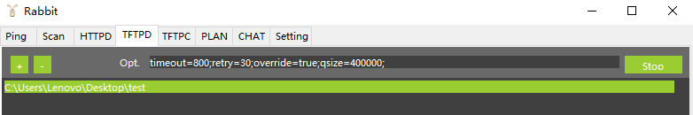
The IP address of the remote PC is 192.168.64.1, and the management IP of the switch is configured as 192.168.64.100, and the remote PC can be pinged. Execute the configuration export command：
SWITCH#
SWITCH# copy startup-config tftp tftp://192.168.64.1/startup.conf
% Total % Received % Xferd Average Speed Time Time Time Current
Dload Upload Total Spent Left Speed
100 1230 0 0 100 1230 0 151k --:--:-- --:--:-- --:--:-- 240k
100 1230 0 0 100 1230 0 144k --:--:-- --:--:-- --:--:-- 144k
Copy Success
In the test directory of the remote PC, you can view the newly created startup.conf file.

Example 2：Import the configuration file startup.conf under the folder specified by the remote ftp server into the device.
Environment construction：
Start the ftp server on the remote PC, select the current directory of ftp, and place the startup.conf file.
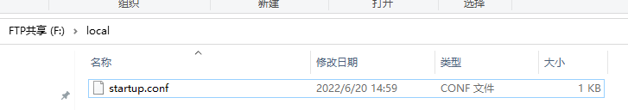
The IP address of the remote PC is 192.168.64.1, and the switch management IP is configured as 192.168.64.100, and the remote PC can be pinged. Execute the configuration import command：
SWITCH#
SWITCH# #copy ftp ftp://192.168.64.1/startup.conf startup-config
Enter Username:xxxxxx
Enter Password:xxxxxx
% Total % Received % Xferd Average Speed Time Time Time Current
Dload Upload Total Spent Left Speed
100 973 100 973 0 0 42572 0 --:--:-- --:--:-- --:--:-- 48650
Copy Success
After the configuration is imported, restart to take effect.

Clearing Log
- Clearing system log
Command | SWITCH# clear logging
Description | Clear system log

System Warm Restart
- System Warm Restart
Command | SWITCH#reload
Description | System warm restart.

User Management
- Configuring Username and Password
Command | SWITCH(config)# username NAME password LINE  SWITCH(config)# no username NAME
Description | If the user name does not exist, add a new user, if it exists, modify the user's password.  By default, the device has its own user "admin" and password "admin", which supports password modification and deletion operations.  The length of the user and password is 0-32 bytes.  Password display is encrypted.  Password characters are case sensitive.  The delete operation does not support deleting the user itself; to delete an online user, the user must be kicked off the line first.

Login Management

Configuring

Service Enablement Management
- Configure and Enable WEB Management
Command | SWITCH(config)# web-server enable { all | http | https }  SWITCH(config)# no web-server enable
Description | Configure and enable WEB management.  Default disabled state.  Support IPv4 and IPv6.
- Configure and Enable Telnet Management
Command | SWITCH(config)# telnet-server enable  SWITCH(config)# no telnet-server enable
Description | Configure and enable telnet management.  Default disabled state.  Support IPv4 and IPv6.
- Configure and Enable SSH Management
Command | SWITCH(config)# ssh-server enable  SWITCH(config)# no ssh-server enable
Description | Configure and enable SSH management.  Default disabled state.  Support IPv4 and IPv6.

ACL Applied to Services
- IPv4 ACL Applied to Services
Command | SWITCH(config)# ip { telnet | ssh | http | https } access-class {<1-199> | <1300-2699> | ACLNAME}  SWITCH(config)# no ip { telnet | ssh | http | https } access-class
Description | IPv4 ACL is applied to telnet, ssh, http, https and other services.  Users who meet the ACL permit rules are allowed to access the device, otherwise users cannot access the device.
- IPv6 ACL Applied to Services
Command | SWITCH(config)# ipv6 { telnet | ssh | http | https } access-class { ACLNAME }  SWITCH(config)# no ipv6 { telnet | ssh | http | https } access-class
Description | IPv6 ACL is applied to telnet, ssh, http, https and other services.  Users who meet the ACL permit rules are allowed to access the device, otherwise users cannot access the device.

ACL Applied to Vty
- ACL Applied to Vty
Command | SWITCH(config-line)# access-class {<1-199> | <1300-2699> | ACLNAME } in  SWITCH(config-line)# no access-class {<1-199> | <1300-2699> | ACLNAME } in
Description | ACL applied to vty.  For telnet, ssh and other servers on vty.  Users who meet the ACL permit rules are allowed to login by this line.

Service Management Based on Line
- Configure Services Supported on Line Vty
Command | SWITCH(config-line)# transport input { telnet | ssh | all | none }  SWITCH(config-line)# no transport input
Description | Configure services supported on vty.  telnet: only supports telnet service.  ssh: only supports ssh service.  all: supports telnet and ssh services.  none: No services are supported.  Supports telnet and ssh services by default.

Other Commands
- Kick Online Users Offline
Command | SWITCH# clear line { vty | console } LINE
Description | Vty represents the remote login user.  Console represents the serial port login user.  LINE information can be viewed in the show users command.  Kicking the user itself is not supported.
- Show Online User Commands
SWITCH#show users
Type Line User Idle Host
con 0 admin 00:00:03 --
vty 0 admin 00:00:11 192.168.64.1
Users display elements are as follows:
Field | illustrate
Type | console or vty
Line | console: fixed 0  vty : 0-7
User | username
Idle | Time in idle state, if the timeout time is exceeded, the terminal automatically exits.
Host | Login user ip address

Examples
Case 1 : The device enables the telnet service. Only users with the IP address 192.168.64.100 are allowed to access the device through telnet, and other users are denied access.
SWITCH(config)#telnet-server enable
SWITCH(config)#ip-access-list standard 1
SWITCH(config-std-acl)#permit host 192.168.64.100
SWITCH(config-std-acl)#exit
SWITCH(config)#ip telnet access-class 1
Case 2 : The device enables the telnet service, and the device only allows one user to log in to the device through telnet at the same time.
SWITCH(config)#telnet-server enable
SWITCH(config)#line vty 1 7
SWITCH(config-line)#transport input none

System Hostname Configuration
- Configuring Hostname
Command | SWITCH(config)# hostname WORD
Description | The name must consist of printable characters and the length cannot exceed 63 bytes.  This configuration takes effect immediately.

Firmware Upgrade
- Firmware Upgrade
Command | SWITCH# upgrade firmware tftp://SERVER/FILENAME
Description | You need to build a TFTP server on the terminal, and ensure the two-way interconnection between the terminal and the device network.  SERVER: TFTP server IP and the relative address of the server window and the firmware upgrade file.  FILENAME: Firmware upgrade file.  The firmware upgrade process will take 5-6 minutes, reboot the device to complete the firmware upgrade.  Do not power off the device during the upgrade process.
Example 1：The following examples shows firmware upgrade via tftp.
Step 1: As shown in the figure below, SWITCH-A is the device to be upgraded, and the telnet function is enabled; USER-A is the host on the same network segment in the LAN, and USER-B is the management device in the LAN, both of which can log in to SWITCH-A by telnet.
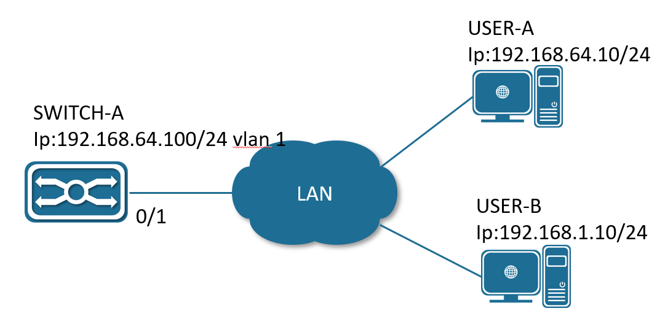
Firmware upgrade connection diagram
Step 2: Select USER-B to perform the version upgrade operation. Open the TFTP server on USER-B and place the upgrade file xcat-release-3.2.0.bin in the Y:/workspace directory.TFTP server as shown in the figure below.
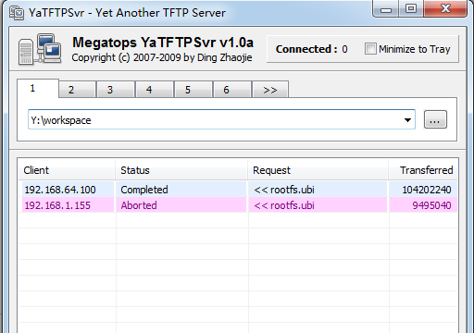
TFTP Server
Step 3: USER-B telnet logs in to SWITCH-A and executes the upgrade command in privileged mode. Upgrade information as shown in the figure below.
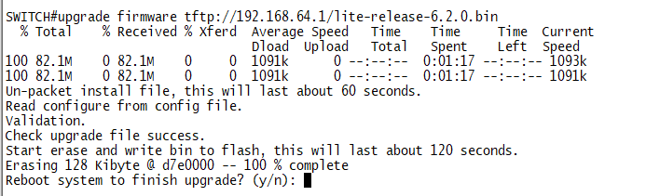
Upgrade Information
Step 4: After the upgrade is over, select "y" to restart the device to complete the upgrade, select "n" to continue running the device, and the upgrade operation will be completed after restart.

System Data And Time Configuration
- Setting the System Clock
Command | SWITCH# clock set HH:MM:SS DAY MON YEAR
Description | Setting the system clock.  For example：Clock set 15:30:00 1 october 2017.
- Setting NTP Server
Command | SWITCH(config)# ntp server {A.B.C.D | ipv6 X.X::X.X }
Description | Configure the IP address of the NTP server (domain name configuration is not supported).  After the configuration is complete, if the device and the server are connected to the network, the device will automatically synchronize the time information from the server.  It takes about 4-8 minutes to complete the time synchronization for the first time.
- Setting Time zone
Command | SWITCH(config)# clock timezone ZONE
Description | Configure the system time zone.  The default timezone is UTC.  Supports standard time zone configuration, such as Shanghai time zone keyword "Shanghai", Hong Kong time zone keyword "Hong_Kong", etc.
- Display System Clock
Command | SWITCH# show clock
Description | Display system clock.
- Display NTP Status
Command | SWITCH# show ntp status
Description | Display ntp status.

Configuring Ethernet Interface

Overview of Interface Types
The interfaces of switch can be divided into the following two categories: Layer 2 interfaces and Layer 3 interfaces.
L2 interface，Including common physical ports (Switch Port) and aggregate ports (Port Channel).
Switch Port consists of a single physical port on the device and only support Layer 2 switching. The port can be an Access Port, Hybrid Port or a Trunk Port.
Port Channel is formed by the aggregation of multiple physical member ports. We can bundle multiple physical links together to form a simple logical link, which we call an aggregate port. For Layer 2 switching, the aggregation port can superimpose the bandwidth of multiple ports to expand the link bandwidth.
L3 interface，Here mainly refers to the SVI port.
SVI is a switching virtual interface, a logical interface used to implement Layer 3 switching. SVI can be used as the local management interface, through which the administrator can manage the device. You can create an SVI with the interface vlan interface configuration command, and then assign an IP address to the SVI to establish routing between VLANs.

Configuring
- Interface Range Mode
Command | SWITCH(config)# interface IFNAME_RANGE
Description | Specify the range of interfaces to be configured, and enter interface-range configuration mode.  When there are multiple range combinations, separate them with ',' without spaces.  For example, the command interface range gigabitEthernet 0/1-4, gigabitEthernet 0/9-12 is a valid range.  You can use the interface range command to configure up to five port ranges;  Each interface-range must consist of the same port type.
- Adding a Description for an Interface
Command | SWITCH(config-if)# description DESC
Description | Add a description (up to 80 characters) for an interface.
- Shutdown the Interface
Command | SWITCH(config-if)# shutdown  SWITCH(config-if)# no shutdown
Description | Shut down an interface.
- Configuring Interface Speed
Command | SWITCH(config-if)# speed {10 | 100 | 1000 | auto}  SWITCH(config-if)# no speed
Description | Enter auto to enable the interface to autonegotiate speed with the connected device.  If you use the 10, 100, or the 1000 keywords with the auto keyword, the port autonegotiates only at the specified speeds；
- Configuring Interface Duplex Mode
Command | SWITCH(config-if)# duplex {auto | full | half}  SWITCH(config-if)# no duplex
Description | Enable half-duplex mode (for interfaces operating only at 10 or 100 Mbps). You cannot configure half-duplex mode for interfaces operating at 1000 Mbps
Attention:
✦ When both speed and duplex exit auto mode, port auto-negotiation is disabled.
- Configuring Interface Flowcontrol
Flow control enables connected Ethernet ports to control traffic rates during congestion by allowing congested nodes to pause link operation at the other end. If one port experiences congestion and cannot receive any more traffic, it notifies the other port by sending a pause frame to stop sending until the condition clears. Upon receipt of a pause frame, the sending device stops sending any data packets, which prevents any loss of data packets during the congestion period.
Command | SWITCH(config-if)# flowcontrol {on | off }
Description | Configure the flow control mode for the port.  on: The port cannot send pause frames but can operate with an attached device that is required to or can send pause frames; the port can receive pause frames.  off: Flow control does not operate in either direction. In case of congestion, no indication is given to the link partner, and no pause frames are sent or received by either device.
- Configuring Interface MTU
When a port performs high-throughput data exchange, it may encounter a frame larger than the Ethernet standard frame length, which is called a jumbo frame.
The user can control the maximum frame length that the port is allowed to send and receive by setting the MTU of the port.
Frames received or forwarded by the port, if the length exceeds the set MTU, will be discarded.
Due to chip limitations, the MTU value only supports even numbers. If the user configures an odd number, the device will auto-align to even. For example, if the MTU is configured as 127, it actually works as 128.
Command | SWITCH(config-if)# mtu LENGTH  SWITCH(config-if)# no mtu
Description | Change the MTU size for the interface on the switch. The range is 46 to 10222 bytes; the default is 1500 bytes.
- Configuring SFP Interface Mode
Command | SWITCH(config-if)# port mode {sgmii | 2500BASE-X | 1000BASE-X | 10G}  SWITCH(config-if)# no port mode
Description | 1000BASE-X:The port operate at 1000Mbps, full-duplex only.  Sgmii: Enables connection to external copper transceivers.  2500BASE-X: The port operate at 2.5G, full-duplex only.  10G: The port operate at 2.5G, full-duplex only.
- Configuring Interface Medium Type
If a port can be configured both fiber and copper medium types, you can only use one of them. Once the medium type is determined, configure the properties of the port, such as duplex, flow control, and rate, which all refer to the properties of the currently selected type of port.
Command | SWITCH(config-if)# medium {copper | fiber | auto [prefer (copper | fiber)]}  SWITCH(config-if)# no medium
Description | Configuring interface medium type.  Default is auto mode，prefer copper.  Copper：Indicates the choice of copper medium type.  Fiber：Indicates the choice of fiber medium type.  Auto：Indicates the adaptive port media type，Determine whether it is an copper or fiber port based on the access medium, prefer copper.  Auto prefer copper：Indicates the adaptive port media type，When both fiber and copper are connected, prefer the copper port.  Auto prefer fiber：Indicates the adaptive port media type，When both fiber and copper are connected, prefer the fiber port.  No operation restores the media type to copper.
- Configuring Interface Isolate
In some situations, you need to prevent Layer 2 (L2) connectivity between end devices on a switch, you can use the isolate function.
When some ports are set as isolated ports, the isolated ports cannot communicate with each other, the isolated port and the non-isolated port can communicate normally, and the non-isolated port and the non-isolated port can communicate normally.
Command | SWITCH(config-if)#switchport isolate  SWITCH(config-if)# no switchport isolate
Description | Setting the port as an isolated port.
- Configuring Interface Auto negotiation
Command | SWITCH(config-if)# autoneg on  SWITCH(config-if)# no autoneg
Description | Configure port auto-negotiation on and off.  Only applicable to 1000M optical port, If this command is configured on other ports, it prompts failure.  Default is on.  By show interface brief command, You can view the auto-negotiation status of the link up ports.

Examples
- Enter gigabitEthernet0/1 Interface Configuration Mode：
SWITCH#
SWITCH#configure terminal
Enter configuration commands, one per line. End with CNTL/Z.
SWITCH(config)#interface gigabitEthernet0/1
SWITCH(config-if)#
- Configure the Port Description Information as "TEST_A"
SWITCH(config-if)#description TEST_A
- No Shutdown Port
SWITCH(config-if)#no shutdown
- Setting the Port Speed 100M, Duplex Full, and Flowcontrol On
SWITCH(config-if)#speed 100
SWITCH(config-if)#duplex full
SWITCH(config-if)#flowcontrol on
- Setting the Port MTU value 1024
SWITCH(config-if)#mtu 1024

Display Information
- Display Brief Information of All Ports
SWITCH#show interface brief

--------------------------------------------------------------------------------
Ethernet Type Status Reason Speed Duplex Flowcontrol Autoneg Port
Interface Ch #
--------------------------------------------------------------------------------
GiE0/1 ETH down none -- -- -- -- --
GiE0/2 ETH up none 1000M FULL OFF ON --
GiE0/3 ETH down none -- -- -- -- --
GiE0/4 ETH down none -- -- -- -- --
GiE0/5 ETH down none -- -- -- -- --
GiE0/6 ETH down none -- -- -- -- --
GiE0/7 ETH down none -- -- -- -- --
GiE0/8 ETH up none 100M FULL OFF ON --
GiE0/9 ETH down none -- -- -- -- --
GiE0/10 ETH down none -- -- -- -- --
GiE0/11 ETH down none -- -- -- -- --
GiE0/12 ETH down none -- -- -- -- --
- Display Single Port Configuration and Status
SWITCH#show interface gigabitethernet0/1
Interface gigabitethernet0/1
Hardware is eth current hw addr: 0050.4c82.89a0
Physical:0050.4c82.89a0
Description: test_a
Index 1 metric 0 mtu 1024 speed-unknown duplex-unknown flowcontrol-unknown
Port mode is invalid
<up>
vrf binding: not bound
Bandwidth -8
Input packets 0677, bytes 072690,
Multicast packets 0327 broadcast packets 0350 fcs error 00 undersizeerrors 00 oversizeerrors 00
Output packets 00, bytes 00,
Multicast packets 00 broadcast packets 00
- Display Port Packet Statistics
SWITCH#show interface gigabitEthernet0/1 counters
Interface gigabitEthernet16/1
Good Octets Tx : 1914949
Good Octets Rx : 0
Bad Octets Rx : 0
Mac Tx Err Pkts : 0
Good Packets Tx : 1913
Good Packets Rx : 0
Bad Packets Rx : 0
Broadcast Packet Tx : 24
Broadcast Packets Rx : 0
Multicast Packet Tx : 55
Multicast Packets Rx : 0
pkts_64_octets : 285
pkts_65_127_octets : 263
pkts_128_255_octets : 42
pkts_256_511_octets : 36
pkts_512_1023_octets : 91
pkts_1024_max_octets : 1196
Excessive Collisions : 0
UnRecg MAC Cntl Pkts Rx : 0
Flow Ctrl Pkts Sent : 0
Flow Ctrl Pkts Recvd : 0
Drop Events : 0
Undersized Pkts Recvd : 0
Fragments Recvd : 0
Oversized Pkts Recvd : 0
Jabber Pkts Recvd : 0
mac_rcv_error : 0
Bad CRC : 0
Collisions : 0
Late Collisions : 0
Bad Flow Ctrl Recv : 0
- Display Port Isolation Configuration
SWITCH#show switchport isolate
interface config
GiE0/1 isolated
GiE0/2 normal
GiE0/3 normal
GiE0/4 normal
GiE0/5 normal
GiE0/6 normal
GiE0/7 normal
GiE0/8 normal
GiE0/9 normal
GiE0/10 normal

Configuring Storm Control

Overview of Storm Control
Storm control prevents traffic on a LAN from being disrupted by a broadcast, multicast, or unicast storm on one of the physical interfaces. A LAN storm occurs when packets flood the LAN, creating excessive traffic and degrading network performance. Errors in the protocol-stack implementation, mistakes in network configurations, or users issuing a denial-of-service attack can cause a storm.。
Storm control uses bandwidth as a percentage of the total available bandwidth of the port that can be used by the broadcast, multicast, or unicast traffic, to measure traffic activity.
because of hardware limitations and the way in which packets of different sizes are counted, threshold percentages are approximations.

Configuring
- Configuring Storm Control
Command | SWITCH(config-if)#storm-control {broadcast | multicast | unicast | all | unicast-broadcast | multicast-broadcast} level LINE  SWITCH(config-if)#no storm-control
Description | Configure broadcast, multicast, or unicast storm control. By default, storm control is disabled.  If you set the threshold to the maximum value (100 percent), no limit is placed on the traffic. If you set the threshold to 0.0, traffic on that port is blocked.  The range is 0.00 to 100.00.  Support adaptive port rate change.  Unicast only containing unknown unicast packets.

Examples
Example 1：Configure the unknown multicast storm control on port gigabitEthernet0/1 to 10% of the total bandwidth.
Step 1: Specify the interface gigabitEthernet0/1 to be configured, and enter interface configuration mode.
SWITCH#
SWITCH#configure terminal
Enter configuration commands, one per line. End with CNTL/Z.
SWITCH(config)#interface gigabitEthernet0/1
SWITCH(config-if)#
Step 2: Configure the unknown multicast storm control on port gigabitEthernet0/1 to 10%.
SWITCH(config-if)#storm-control multicast level 10

Display information
- Display All Port Storm Control Configurations
SWITCH#show storm-control
Port BcastLevel McastLevel Unicastlevel
GiE0/1 100.00% 10.00% 100.00%
GiE0/2 100.00% 100.00% 100.00%
GiE0/3 100.00% 100.00% 100.00%
GiE0/4 100.00% 100.00% 100.00%
GiE0/5 100.00% 100.00% 100.00%
GiE0/6 100.00% 100.00% 100.00%
GiE0/7 100.00% 100.00% 100.00%
GiE0/8 100.00% 100.00% 100.00%
GiE0/9 100.00% 100.00% 100.00%
GiE0/10 100.00% 100.00% 100.00%
GiE0/11 100.00% 100.00% 100.00%
GiE0/12 100.00% 100.00% 100.00%

Configuring SPAN

Overview of SPAN
You can analyze network traffic passing through ports by using SPAN（Local Switched Port Analyzer）to send a copy of the traffic to another port on the switch that has been connected to a network analyzer or other monitoring or security device. SPAN copies traffic received or sent (or both) on source ports to a destination port for analysis.
SPAN does not affect the switching of network traffic on the source ports. You must dedicate the destination port for SPAN use. Except for traffic that is required for the SPAN session, destination ports do not receive or forward traffic.
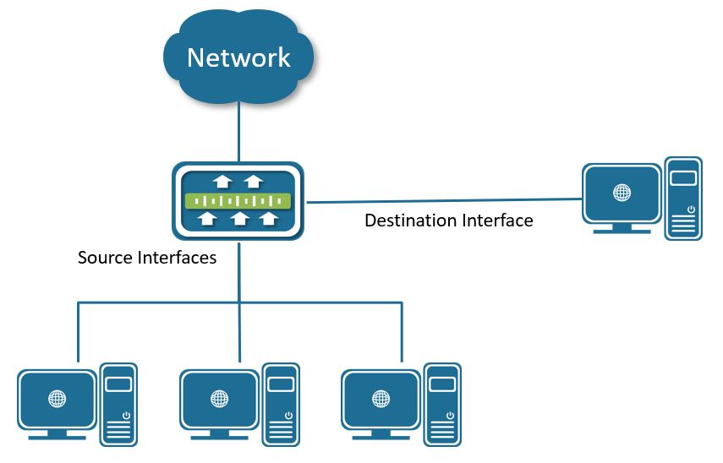
Example of SPAN configuration
SPAN supports a session entirely within one switch. all source ports and destination ports are in the same switch.
SPAN sessions allow you to monitor traffic on one or more ports, and send the monitored traffic to only one destination port. A SPAN session is an association of a destination port with source ports, all on a single network device.

Configuring
- Creating a Session
Command | SWITCH(config)#monitor session SESSION-ID  SWITCH(config)#no monitor session SESSION-ID
Description | Create a SPAN session.  For session_number, the range is 1 to 7
- Configuring Session Description
Command | SWITCH(config-monitor)#description DESC
Description | Add a description (up to 64 characters) for an interface
- Configuring Source interface
Command | SWITCH(config-monitor)#source interface IFNAME {both | rx | tx}  SWITCH(config-monitor)#no source interface IFNAME {both | rx | tx}
Description | Specify the SPAN session and the source port.

- Configuring Destination Interface
Command | SWITCH(config-monitor)#destination interface IFNAME  SWITCH(config-monitor)#no destination interface IFNAME
Description | Specify the SPAN session and the destination port.

Examples
Example 1： This example shows how to create SPAN session, and configure session source interfaces and destination interface.
Step 1: Create session.
SWITCH#configure terminal
Enter configuration commands, one per line. End with CNTL/Z.
SWITCH(config)#monitor session 1
SWITCH(config-monitor)#
Step 2: Configuring session description.
SWITCH(config-monitor)#description TRAFFIC_MONITOR
Step 3: Configuring session source interfaces.
SWITCH(config-monitor)#source interface gigabitEthernet0/1 rx
SWITCH(config-monitor)#source interface gigabitEthernet0/2 both
Step 4: Configuring session destination interface.
SWITCH(config-monitor)#destination interface gigabitEthernet0/8

Display information
- Display Single Session
SWITCH#show monitor session 1
session 1
---------------
description : TRAFFIC_MONITOR
type : local
source intf :
tx : gigabitEthernet0/2
rx : gigabitEthernet0/1 gigabitEthernet0/2
both : gigabitEthernet0/2
source VLANs :
rx :
destination ports : gigabitEthernet0/8
Legend: f = forwarding enabled, l = learning enabled

Configuring Port Aggregation

Overview of Port Aggregation
Port aggregation provides fault-tolerant high-speed links between switches, routers, and servers. You can use it to increase the bandwidth between the wiring closets and the data center, and you can deploy it anywhere in the network where bottlenecks are likely to occur. Port aggregation provides automatic recovery for the loss of a link by redistributing the load across the remaining links. If a link fails, port aggregation redirects traffic from the failed link to the remaining links in the channel without intervention.
Port aggregation consists of individual Fast Ethernet or Gigabit Ethernet links bundled into a single logical link called channel, as shown in Figure below.
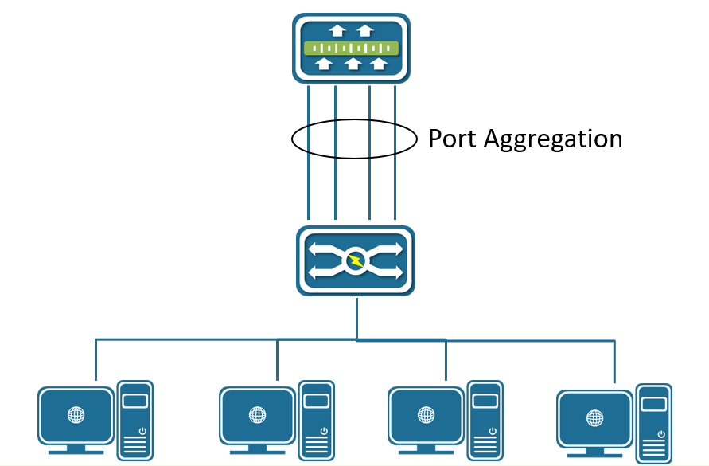
Typical Port Aggregation application
Each Channel can consist of up to eight compatibly configured Ethernet ports. All ports in each Channel must be configured as Layer 2 ports. The number of Channels is limited to 12.
You can configure an Channel in one of these modes: Manual(Static), Active(LACP), or Passive(LACP).

Overview of LACP
LACP (Link Aggregation Control Protocol) based on the IEEE802.3ad standard is a dynamic link aggregation protocol. If a port enables the LACP, the port will send LACPDU message to announce its system priority, system MAC, port priority, port number and operation key, etc. After the connected device receives the LACP message from the peer end, it compares the system priorities of the two ends according to the system ID in the message. On the side with the higher system ID priority, the ports in the aggregation group are set to be in the aggregation state according to the order of port ID priority from high to low, and the updated LACP message is sent out. It will also set the corresponding port to the aggregation state, so that the two sides can reach the same agreement when the port exits or joins the aggregation group.
After the LACP member interface link is bound, periodic LACP packet exchange will be carried out. When no LACP packet is received for a period of time, it is considered that the packet reception timed out, the member interface link is unbound, and the port is in a state of non-forwarding again. There are two modes of timeout here: long timeout mode and short timeout mode. In the long timeout mode, the port sends a packet every 30 seconds. If it does not receive a packet from the peer for 90 seconds, it will be in a packet receiving timeout.；In the short timeout mode, the port sends a packet every 1 second. If it does not receive a packet from the peer for 3 seconds, it is in the packet receiving timeout.
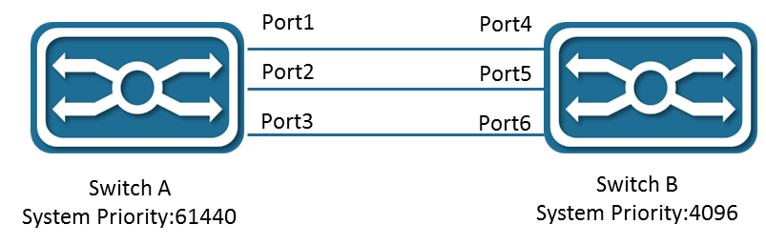
Figure Typical LACP application
As shown Figure, switch A and switch B are connected together through 3 ports. We set the system priority of switch A to 61440, and set the system priority of switch B to 4096. Enable LACP link aggregation on the three directly connected ports of switches A and B.
After receiving the LACP message from the peer, switch B finds that its system ID has a higher priority (switch B has a higher system priority than switch A), so it follows the order of port ID priority (in the case of the same port priority) , in the order of port numbers from small to large) set ports 4, 5, and 6 to be in the aggregation state.
After switch A receives the updated LACP packet from switch B, it finds that the system ID of the peer end has a higher priority, and set the ports 1, 2, and 3 to the aggregation state.

Configuring
- Configuring Layer 2 Channels
Command | SWITCH(config-if)#channel-group ID mode manual  SWITCH(config-if)#channel-group ID mode {active | passive}  SWITCH(config-if)#no channel-group
Description | Assign the port to a channel group, and specify the mode.  For ID, the range is 1 to 12.
Note
✦ When the first port is added to the aggregation port, a PO port is actively created, and the default attribute of the PO port is the first port attribute.
✦ For Layer 2 Channels:
Ports with different native VLANs cannot form an EtherChannel.
- Configuring LACP System Priority
Command | SWITCH(config)#lacp system-priority SYSTEM-PRIORITY  SWITCH(config)#no lacp system-priority
Description | The system priority range is 1 to 65535, the default value is 32768.  All dynamic link groups of a device can only have one LACP system priority. Modifying this value will affect all aggregation groups on the switch.
- Configuring LACP Interface Priority
Command | SWITCH(config-if)#lacp port-priority PORT-PRIORITY  SWITCH(config-if)#no lacp port-priority
Description | The interface priority range is 1 to 65535, the default value is 32768.
- Configuring LACP Timeout Mode
Command | SWITCH(config-if)#lacp timeout {long | short}  SWITCH(config-if)#no lacp timeout
Description | In long mode, the interval for sending LACP protocol packets is 30S, and the timeout is 90S.  In short mode, the interval for sending LACP protocol packets is 1S, and the timeout is 3S.  Default is in long mode.
- Configuring Load-balance Method
Command | SWITCH(config)#port-channel load-balance {dst-ip | dst-mac | dst-port | src-dst-ip | src-dst-mac | src-dst-port | src-ip | src-mac | src-port}  SWITCH(config)#no port-channel load-balance
Description | Configure an Channel load-balancing method.  The default is src-mac.  Select one of these load-distribution methods: •  dst-ip: Load distribution is based on the destination IP address.  dst-mac: Load distribution is based on the destination MAC address of the incoming packet.  Dist-port: Load distribution is based on the destination L4-port of the incoming packet  src-dst-ip: Load distribution is based on the source-and-destination IP address.  src-dst-mac: Load distribution is based on the source-and-destination MAC address.  src-dst-port: Load distribution is based on the source-and-destination L4-port of the incoming packet.  src-ip: Load distribution is based on the source IP address.  src-mac: Load distribution is based on the source-MAC address of the incoming packet.

Examples
Example 1: This example shows how to assign the ports to a channel, and set load-balance method.
- Assign the gigabitEthernet0/5, gigabitEthernet0/6 to PO 1, set load-balance to src-ip：
SWITCH(config)#interface gigabitEthernet0/5
SWITCH(config-if)#channel-group 1 mode manual
SWITCH(config-if)#exit
SWITCH(config)#interface gigabitEthernet0/6
SWITCH(config-if)#channel-group 1 mode manual
SWITCH(config-if)#exit
SWITCH(config)#port-channel load-balance src-ip

Display information
- Display Channels Configuration and Status
SWITCH#show port-channel
Load balance: Source and Destination Mac address

Interface po3
Type: static
Member:
gigabitEthernet0/18 link down Disable

Interface po8
Type: LACP
Member:
gigabitEthernet0/19 link up Enable
gigabitEthernet0/17 link up Enable

SWITCH#show port-channel 8
Interface po8
Type: LACP
Member:
gigabitEthernet0/19 link up Enable
gigabitEthernet0/17 link up Enable

SWITCH#show port-channel load-balance
Source and Destination Mac address
- Display LACP Summary
SWITCH#show lacp summary
% Aggregator po8 1008
% Aggregator Type: Layer2
% Admin Key: 0008 - Oper Key 0008
% Link: gigabitEthernet0/17 (17) sync: 1 status: Bundled
% Link: gigabitEthernet0/19 (19) sync: 1 status: Bundled

SWITCH#show lacp detail
% Aggregator po8 1008
% Aggregator Type: Layer2
% Mac address: 74:b9:eb:ee:25:46
% Admin Key: 0008 - Oper Key 0008
% Actor LAG ID- 0x8000,74-b9-eb-ee-25-46,0x0008
% Receive link count: 2 - Transmit link count: 2
% Individual: 0 - Ready: 1
% Partner LAG ID- 0x8000,00-01-a0-00-10-10,0x0032
% Link: gigabitEthernet0/17 (17) sync: 1 status: Bundled
% Link: gigabitEthernet0/19 (19) sync: 1 status: Bundled

SWITCH#show lacp 8
% Aggregator po8 1008 Admin Key: 0008 - Oper Key 0008
% Partner LAG ID: 0x8000,00-01-a0-00-10-10,0x0032
% Partner Oper Key 0050

SWITCH#show lacp sys-id
% System 8000,74-b9-eb-ee-25-46

SWITCH#show lacp port gigabitEthernet0/19
% LACP link info: gigabitEthernet0/19 - 19
% LAG ID: 0x8000,74-b9-eb-ee-25-46,0x0008
% Partner oper LAG ID: 0x8000,00-01-a0-00-10-10,0x0032
% Actor Port priority: 0x8000 (32768)
% Admin key: 0x0008 (8) Oper key: 0x0008 (8)
% Physical admin key:(1)
% Receive machine state : Current
% Periodic Transmission machine state : Slow periodic
% Mux machine state : Collecting/Distributing
% Oper state: ACT:1 TIM:0 AGG:1 SYN:1 COL:1 DIS:1 DEF:0 EXP:0
% Partner oper state: ACT:1 TIM:0 AGG:1 SYN:1 COL:1 DIS:1 DEF:0 EXP:0
% Partner link info: admin port 0
% Partner oper port: 20
% Partner admin LAG ID: 0x0000-00:00:00:00:0000
% Admin state: ACT:1 TIM:0 AGG:1 SYN:0 COL:0 DIS:0 DEF:1 EXP:0
% Partner admin state: ACT:0 TIM:0 AGG:1 SYN:0 COL:0 DIS:0 DEF:1 EXP:0
% Partner system priority - admin:0x0000 - oper:0x8000
% Partner port priority - admin:0x0000 - oper:0x8000
% Aggregator ID: 1008
- Display Only One Channel Information
SWITCH#show int po8
Interface po8
Hardware is AGG Current HW addr: 74b9.ebee.2546
Logical:(not set)
Port Mode is access
interface configure:
medium-fiber mtu 1526 speed-auto duplex-auto flowcontrol-off autonego-off
interface status:
link-up bandwidth-2g
Aggregate Members:(LACP)
gigabitEthernet0/19 link up Enable
gigabitEthernet0/17 link up Enable
input packets:
Good Octets Rx : 18986
Good Packets Rx : 104
Broadcast Packets Rx : 0
Multicast Packets Rx : 104
ouput packets:
Good Octets Tx : 38529
Good Packets Tx : 359
Broadcast Packet Tx : 4
Multicast Packet Tx : 355
un-normal packets:
Drop Events : 0
Undersized Pkts Recvd : 0
Oversized Pkts Recvd : 0
Bad CRC : 0

Configuring PoE

Overview of PoE
Power over Ethernet (PoE) is a technology that transmits both electrical power and network data over an ethernet cable. With PoE, each Ethernet interface of LAN switches can supply power to devices like VoIP phones, IP cameras or security cameras, and wireless access points (AP), As shown in the figure below.
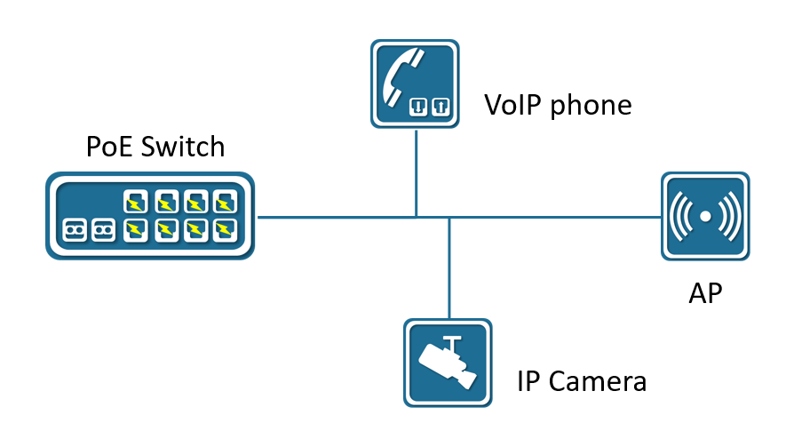
PoE powersupply diagram
The PoE device like LAN switches that are supplying power is called Power Sourcing Equipment (PSE). The power that is supplying is in Direct Current (DC) form.
PoE (Power over Ethernet) Standards:
PoE : IEEE 802.3af standard that supplies up to 15 watts of DC power from PSE and 12.95 watts from PD due to losses on an ethernet cable. It uses two pairs of wires like CAT3 or CAT5 cables as a medium.
PoE+: IEEE 802.3at standard that supplies power up to 30 watts of DC power from PSE and 25.5 watts from PD due to losses on an ethernet cable. It is also using two pairs of wires like CAT5 or higher as a medium.
UPoE(Universal PoE): IEEE 802.3bt standard that supplies power up to 60 watts of DC power from PSE and 51 watts from PD due to losses on an ethernet cable. It uses four pairs of wire as a medium.
UPoE+(Universal PoE +): IEEE 802.3bt standard that supplies power up to 100 watts of DC power from PSE and 71.3 watts from PD due to losses on an ethernet cable. It is also using four pairs of ethernet cabling as a medium.

Configuring
- Configuring the External Powersupply
Command | SWITCH(config)#poe powersupply POWER  SWITCH(config)#no poe powersupply
Description | The default power calculation method: the product of the number of PoE power supply ports and the single port 15.4W.  If the configured power is less than the current device power consumption, power off the PD device on the port with the lower priority, and the port priority is a higher priority with a smaller port ID.
- Enabling Port Powersupply
Command | SWITCH (config-if)#poe enable  SWITCH (config-if)#no poe enable
Description | Default port power supply enabled.
- Enabling Powersupply Legacy Mode
Command | SWITCH (config)#poe legacy  SWITCH (config)#no poe legacy
Description | Using this command on a port that is not connected to a PD device may cause the peer device to be burned by wrong power-on. Please make sure that the port uses this command when connecting to a PD device.

Examples
Example 1: Enable interface gigabitEthernet0/1 powersupply.
SWITCH(config)#interface gigabitEthernet0/1
SWITCH(config-if)#poe enable

Display Information
- Display System Powersupply Information
SWITCH#show poe powersupply
Power supply : 123.2W
Power consume : 44.1W
Power management : energy-saving
Disconnect mode : DC
Powered ports : 2
- Display Interfaces Powersupply Information
SWITCH#show poe interfaces
Interface enable status reason class icut(mA) power(W)
----------------------------------------------------------------
GiE0/1 YES OFF short 4 -- --
GiE0/2 YES OFF -- - -- --
GiE0/3 YES OFF -- - -- --
GiE0/4 YES OFF -- - -- --
GiE0/5 YES OFF -- - -- --
GiE0/6 YES ON -- 4 270.2 14.0
GiE0/7 YES OFF -- - -- --
GiE0/8 YES OFF -- - -- --

Log Management

Log Management Overview
During the operation of the device, various status changes will occur, such as link status UP, DOWN, etc., and some events such as processing exceptions will also be encountered.
The syslog provides a series of services. When the status changes or an event occurs, fixed-format messages will be automatically generated, and these messages will be recorded on the device log file. It can be displayed on the console port and remote login terminal, and can also be sent to 1-3 groups of log servers on the network for administrators to analyze network conditions and locate problems.
In order to facilitate administrators to read and manage log messages, these log messages can be classified according to the priority of the log information.

Configuring

Configure Console Log Level
Command | SWITCH(config)# logging console {| <0-7>}  SWITCH(config)# no logging console
Description | Configure console log output level  Default level is 6  When executing the no command, the log will not be output on the console.  Execute logging console, no level parameters, configured as default level 6

Configure Terminal Log Level
- Configure Terminal Log Level
Command | SWITCH(config) #logging monitor {| < 0-7>}  SWITCH(config)# no logging monitor
Description | Configure terminal log output level  Default level is 6  When executing the no command, the log will not be output  Execute logging monitor, no level parameters, configured to the default level 6
- Enable Terminal Output Log
Command | SWITCH# terminal monitor  SWITCH# terminal no monitor
Description | Enable log output on the terminal  By default, the terminal does not output log  When executing the no command, the terminal does not output log

Configure Remote Server
- Configure Remote Server
Command | SWITCH(config)# logging server {| second | third} {A.B.C.D | ipv6 XX::XX } udp-port <1-65535>  SWITCH(config)# no logging server {| second | third}
Description | Configure remote server  Supports up to 3 remote server configurations  Support remote server UDP protocol port configuration, range <1-65535>  When no UDP protocol port parameters are configured, the default port number is 514
- Configure the Log Level Sent to the Remote Server
Command | SWITCH(config) #logging trap {| < 0-7>}  SWITCH(config)# no logging trap
Description | Configure the level of logs sent to the server  Default level is 6  When executing the no command, no logs will be sent to the server.  Execute logging trap , no level parameters, configured as default level 6
- Configure the Rate Limit for Sending Server Logs
Command | SWITCH(config) #logging rate-limit interval <1-30> burst <1-1000>  SWITCH(config)#no logging rate-limit
Description | Configure the rate at which the device sends logs to the remote server  Interval is the time range, the default is 6, the range is <1-30>, the unit is seconds  burst is the maximum number of logs that can be sent within the time range, the default is 60, the range is <1-1000>  By default, up to 60 sys logs can be sent to the server every 6 seconds

Configure the Logging Buffer
Command | SWITCH(config) #logging buffer <64-4096>  SWITCH(config)#no logging buffer
Description | Configure log storage entries, log storage starts from device startup  Default number of storage entries is 1024  The range is <64-4096>

Clear Log
Command | SWITCH# clear logging
Description | Clear syslog

Examples
Case 1 : The device sent syslog to the remote server, the device IP is 1 92.168.1.240 , the remote server IP is 1 92.168.1.33 ,UDP port number is 10514.
Configure the remote server on the device:
SWITCH(config)# logging server 192.168.1.33 udp-port 10514
The device generates syslog information:
*1970 Jan 01 14:19:34 SWITCH %HAL-4: Interface gigabitEthernet0/1 changed state to down
Monitor syslog information on the remote server:
LOCAL7.warn: *1970 Jan 1 14:19:34 SWITCH %HAL-4: Interface gigabitEthernet0/1 changed state to down

Display Information
- Display Logs Stored in Device
Command | SWITCH# show logging
Description | Show all syslog stored in device
- Display Logs Stored in Device of Last entries
Command | SWITCH# show logging last <1 4096>
Description | Show last specific number of logs stored in device
- Display Log Configuration Information
Command | SWITCH# show logging summary
Description | Display log configuration information

SWITCH#show logging summary
Summary of logging configuration:
Logging console : 6
Logging monitor : 6
Logging trap : 6
Logging buffer : 1024

Server:
Ip address : 192.168.1.33
Udp port : 10514

Server second : Disabled

Server third : Disabled

Rate-limit:
Interval : 1 seconds
Burst : 2

Field | Illustrate
Logging console | Log console output control  <0-7>: Indicates the log level  Disabled: Indicates no console output
Logging monitor | Log terminal line output control  <0-7>: Indicates the log level  Disabled: Indicates that it is not output in terminal line
Logging trap | Log trap remote server output control  <0-7>: Indicates the log level  Disabled: Indicates not sending to the remote server
Logging buffer | Log storage entries, log storage starts from device startup  <64-4096>: Indicate max log storage entries
Server  Server second  Server third | Server, currently supports 3 servers
Ip address  Ipv6 address | Ipv4, ipv6 address information
Udp port | UDP port information
Rate-limit | Speed limit for sending logs to remote server
Interval | Speed limit effective time range
Burst | Speed limit value within interval time

Configuring VLAN

Overview of VLAN
A VLAN is a switched network that is logically segmented by function, project team, or application, without regard to the physical locations of the users. VLANs have the same attributes as physical LANs, but you can group end stations even if they are not physically located on the same LAN segment. Any switch port can belong to a VLAN, and unicast, broadcast, and multicast packets are forwarded and flooded only to end stations in the VLAN. Each VLAN is considered a logical network, and packets destined for stations that do not belong to the VLAN must be forwarded through a router or a switch supporting fallback bridging.
The port link types of Ethernet switches can be divided into three types：Access, Trunk, and Hybrid. These three ports will be processed differently when they join VLAN and forward packets.
Access：An access port can belong to one VLAN and is manually assigned to that VLAN.
Trunk：A trunk port is a member of all VLANs by default, but membership can be limited by configuring the allowed-VLAN list. A trunk port have a native vlan, the switch forwards untagged traffic in the native VLAN configured for the port. The native VLAN is VLAN 1 by default.
Hybrid：A hybrid port is a member of all VLANs by default, but membership can be limited by configuring the allowed-VLAN list. A hybrid port allow users to configure traffic of a vlan forwards tagged or untagged. A trunk port has a hybrid vlan, The hybrid VLAN is VLAN 1 by default.

Configuring
- Creating VLAN
Command | SWITCH(config)#vlan (<vlan-id> | <vlan-range>)  SWITCH(config)#no vlan (<vlan-id> | <vlan-range>)
Description | Create a VLAN, vlan-id 1-4094, vlan-range example: 2-10.
- Configuring the Interface as an Access Port
Command | SWITCH(config)#interface IFNAME  SWITCH(config-if)#switchport mode access
Description | Configure the interface port mode access.

Command | SWITCH(config-if)#switchport access vlan VLANID  SWITCH(config-if)#no switchport access vlan
Description | Specify the default VLAN of the interface, which is used if the interface is access mode.  Default vlan is 1.
- Configuring the Interface as a Trunk Port
Command | SWITCH(config)#interface IFNAME  SWITCH(config-if)#switchport mode trunk
Description | Configure the interface port mode trunk.

Command | SWITCH(config-if)#switchport trunk allowed vlan { all | VLAN_LIST | none}  SWITCH(config-if)#no switchport trunk allowed vlan VLAN_LIST
Description | Configure the list of VLANs allowed on the trunk, which is used if the interface is trunk mode.  All: Adds all VLANs in available in the VLAN table, New VLANs added to the VLAN table are added automatically.  None: Removes all VLANs.  VLAN_LIST: It will manually set the Allowed VLAN list, if it belongs to ALL, the Allowed VLAN list will be cleared first, and then the new VLAN list will be added; vlan-list parameter is either a single VLAN number from 1 to 4094 or a range of VLANs described by two VLAN numbers, the lower one first, separated by a hyphen. Do not enter any spaces between comma-separated VLAN parameters or in hyphen-specified ranges.  Only created VLANs can be added to the Allowed VLAN list; when a VLAN is deleted, the corresponding VLAN in the Allowed VLAN list will be automatically deleted.  All VLANs are allowed by default.

Command | SWITCH(config-if)#switchport trunk native vlan VLANID  SWITCH(config-if)#no switchport trunk native vlan
Description | Configure the VLAN that is sending and receiving untagged traffic on the trunk port. For VLANID, the range is 1 to 4094.  Native VLAN has nothing to do with whether the Allowed VLAN contains this VLAN, or even whether the VLAN is created.  Default vlan is 1.
Note:
✦ The default VLAN ID of the trunk port of the local device must be the same as the default VLAN ID of the trunk port of the connected device, otherwise the packets of the default VLAN will not be transmitted correctly.
- Configure the Interface as a Hybrid Port
Command | SWITCH(config)#interface IFNAME  SWITCH(config-if)#switchport mode hybrid
Description | Configure the interface port mode hybrid.

Command | SWITCH(config-if)#switchport hybrid allowed vlan { all | VLAN_LIST | none}  SWITCH(config-if)#no switchport hybrid allowed vlan VLAN_LIST
Description | Configure the list of VLANs allowed on the trunk, which is used if the interface is hybrid mode.  All: Adds all VLANs in available in the VLAN table, New VLANs added to the VLAN table are added automatically.  None: Removes all VLANs.  VLAN_LIST: It will manually set the Allowed VLAN list, If it belongs to ALL , the Allowed VLAN list will be cleared first, and then the new VLAN list will be added; vlan-list parameter is either a single VLAN number from 1 to 4094 or a range of VLANs described by two VLAN numbers, the lower one first, separated by a hyphen. Do not enter any spaces between comma-separated VLAN parameters or in hyphen-specified ranges.  Only created VLANs can be added to the Allowed VLAN list; when a VLAN is deleted, the corresponding VLAN in the Allowed VLAN list will be automatically deleted.  All VLANs are allowed by default.

Command | SWITCH(config-if)#switchport hybrid vlan VLANID  SWITCH(config-if)#no switchport hybrid vlan
Description | Configure the default VLAN that is sending and receiving untagged traffic on the hybrid port. For VLANID, the range is 1 to 4094.  Native VLAN has nothing to do with whether the Allowed VLAN contains this VLAN, or even whether the VLAN is created.  Default vlan is 1.

Command | SWITCH(config-if)#switchport hybrid untagged vlan VLAN_LIST  SWITCH(config-if)#no switchport hybrid untagged vlan VLAN_LIST
Description | Configure the list of untagged VLANs, which is used if the interface is hybrid mode.  The default VLAN must be untagged output, therefore, it is not maintained by the untagged VLAN list.  By default the untagged VLAN list is empty.  The Untagged VLAN list must be in the Allowed VLAN list of the Hybird port, Therefore, when a VLAN is deleted from the Allowed VLAN, it will also be deleted from the Untagged VLAN list.  Since the untagged VLAN list does not maintain the default VLAN, if a VLAN in the previous list is set as the default VLAN, it will be deleted from the untagged VLAN list.
Note
✦ The default VLAN ID of the hybrid port of the local device must be the same as the default VLAN ID of the hybrid port of the connected device, otherwise the packets of the default VLAN will not be transmitted correctly.

Display Information
Displays the VLAN table, includes VLAN VID, VLAN status, VLAN member ports, and VLAN configuration information.
- Display VLAN Information
VLAN ID Name State H/W Status Member ports
(u)-Untagged, (t)-Tagged
======= ============ ======= =========== ============================
1 default ACTIVE Up gigabitEthernet0/2(u)
gigabitEthernet0/3(u)

Configuring QINQ

Overview of QINQ
QINQ technology also known as Stacked VLAN. The standard is derived from IEEE 802.1ad, which means that the public network VLAN Tag of a service provider network is encapsulated before the user packet enters the service provider network, and the private network user VLAN Tag in the user packet is regarded as data, so that the packet carries Two-layer VLAN tag traversal of service provider network.
In the metropolitan area network, a large number of VLANs are required to isolate users. The 4094 VLANs supported by the IEEE 802.1Q protocol are far from meeting the requirements. Through the double-layer Tag encapsulation of QINQ technology, in the service provider network, the packets are only transmitted according to the unique outer VLAN Tag allocated on the public network, so that the VLANs of different private network users can be reused, and the number of VLAN tags available to users is expanded. At the same time, it provides a simple Layer 2 VPN function, so QINQ technology is actually a VLAN VPN technology.
In addition to QINQ, common VLAN VPN technologies also include VLAN Mapping. The only difference between the two is that QINQ is for stacking VLANs, and VLAN Mapping is for VLAN mapping.

VLAN Stacking
VLAN Stacking: From the user network to the provider network, a single-layer tag becomes a double-layer tag, and the C-Tag remains in the packet as an inner-layer tag; reverse, from a double-layer tag to a single-layer tag.
VLAN Stacking QINQ is divided into three categories:
- Type A: Basic QINQ, which is enabled and disabled based on the interface. When an interface with basic QINQ enabled receives a packet, it is treated as an un-tagged packet. On the basis of the original packet, a VLAN tag of the default VLAN of the port is added.
- Type B: Flexible QINQ based on C-tag, according to the C-VLAN Tag on the user side, according to the configured mapping policy, an S-VLAN tag is added to the original packet. There are two optional configuration methods for this type of QINQ, and only one of them can be selected. One way is to configure the mapping relationship between C-VLAN and S-VLAN directly on the interface; the other way is to configure VLAN VPN globally (which includes the mapping relationship between C-VLAN and S-VLAN), and then associate the VPN on the interface. When using the same mapping policy for multiple interfaces, generally choose the latter configuration method. For this type of QINQ, if the packets received by the interface are un-tagged, the C-tag is the default VLAN Tag of the interface.
- Class C: ACL-based flexible QINQ, adding outer tags according to the configured traffic policy. The configuration of this type of QINQ is placed in the "QOS" module. For details, please refer to the "Configuring QOS" chapter. The policy pair between Policy-map and Class-map: "nest vlan <1-4094>" is used to configure ACL-based Flexible QINQ.
The above three types of QINQ can be enabled at the same time on the same port, and their priority relationship is: Type C > Type B > Type A.

VLAN Mapping
VLAN Mapping: From the user network to the provider network, it is still a single-layer Tag, but the C-Tag becomes S-Tag; in reverse, from S-Tag to C-Tag.
VLAN Mapping is divided into 1:1 VLAN Mapping and 1:N VLAN Mapping (the reverse is N:1). Currently, only 1:1 VLAN Mapping is supported. VLAN Mapping is configured by configuring VLAN VPN globally, and then associating VPN on interface. VLAN Mapping only takes effect on tag packets, which is very different from the QINQ function.
The following points should be noted when configuring QINQ and VLAN Mapping.
VLAN Mapping takes effect only for tagged packets. Upstream, original packets must carry tags to implement CVLAN-to-SVLAN mapping; for downstream, the VLAN output rule on downlink interfaces must be tag output to implement SVLAN-to-SVLAN mapping. Mapping of CVLANs.
Note
Only physical interfaces support the configuration of QINQ and VLAN Mapping, but aggregated interfaces do not
When using the QINQ function or the VLAN Mapping function, it needs to be used in conjunction with the VLAN configuration. In the input and output directions, the filtering function of the VLAN, and the rules for whether the VLAN carries tags are all subject to the VLAN configuration. Specific requirements are as follows:
- Both CVLAN and SVLAN need to be added to the allow list of the downlink interface (connected to the Customer network), otherwise the flow will be filtered.
- The SVLAN needs to be added to the allow list of the uplink interface (connected to the provider network), otherwise the flow will be filtered.
- For QINQ, on the downlink interface, SVLAN should be configured with untag output, so as to strip the outer tag of QINQ downstream.
- For VLAN-Map, since it only takes effect for untag packets, for downlink interfaces, SVLAN should be configured with tag output, otherwise the downstream flow cannot complete the mapping from SVLAN to CVLAN.
The globally configured VLAN VPN is either used for VLAN Stacking (QINQ) or VLAN Mapping, but not both.
VLAN Mapping only supports 1:1 mapping. Therefore, if there are VLAN VPNs with N:1 mapping, they cannot be associated with the interface as the VPN of VLAN mapping. Similarly, if the VPN has been associated with the interface as the VLAN mapping, the mapping relationship Cannot change to N:1
The mapping relationship of VLAN Mapping must be consistent globally. Therefore, different interfaces can only be associated with the same VLAN VPN.
On the same interface, if you need to apply VLAN Mapping and QINQ at the same time, it should be noted that the two functions need to control different CVLANs and SVLANs. The specific constraints are as follows.
- If VLAN Mapping is used together with basic QINQ, the basic QINQ will take effect and VLAN Mapping will be invalid.
- If VLAN Mapping and flexible QINQ are used together, if a flow passes through the SVLAN mapped by VLAN Mapping and can be used as CVLAN to match the mapping policy of flexible QINQ, the final packet will take effect with flexible QINQ, adding SVLAN as external Layer TAG, the inner layer TAG remains unchanged (not the VLAN mapped by VLAN Mapping).
- Due to the above constraints, when two applications are enabled on the same interface, it is necessary to pay attention that the VLANs controlled by the two do not overlap. Invalid.
For Type B QINQs, you can either choose to configure the mapping policy directly under the interface, or choose to associate with VPN, but cannot be configured at the same time.

Configuring
- Creating VLAN VPN
Command | SWITCH(config)#vlan-vpn VPN-NAME  SWITCH(config)#no vlan-vpn VPN-NAME
Description | There can be multiple VPNs in the system, and each VPN maintains the mapping relationship between independent CVLANs and SVLANs. A VPN will only actually take effect when applied to an interface. A VPN can be applied to VLAN Stacking (QINQ) or VLAN Mapping, but only one of the two can be selected.
- Adding VPN Mapping Relations
Command | SWITCH(config-vlan-vpn)#cvlan VLAN_LIST svlan VLANID  SWITCH(config-vlan-vpn)#no cvlan VLAN_LIST  SWITCH(config-vlan-vpn)#no cvlan
Description | The valid range of VLAN_LIST and VLANID is <1,4094>, VLAN_LIST supports standard multi-vlan representation method ("-" and "," and combination of both).  no cvlan without any parameters, clear all the mapping relationships in the VPN.
- Configuring Port-based QINQ
Command | SWITCH(config-if)#switchport vlan-stacking basic  SWITCH(config-if)#no switchport vlan-stacking basic
Description | After basic QINQ is enabled, all incoming packets from this interface match the QINQ rules, and the mapped SVLAN is the default VLAN ID of the interface.
- Configuring Mapping Relationship of QINQ on the interface
Command | SWITCH(config-if)#switchport vlan-stacking cvlan VLAN_LIST svlan VLANID  SWITCH(config-if)#no switchport vlan-stacking cvlan VLAN_LIST  SWITCH(config-if)#no switchport vlan-stacking cvlan
Description | Similar to the mapping relationship configuration under VPN. Only when the interface is not associated with a VPN, can the mapping relationship be configured directly.
- Attaching QINQ VPN on the Interface
Command | SWITCH(config-if)#switchport vlan-stacking vpn VPN-NAME  SWITCH(config-if)#no switchport vlan-stacking vpn
Description | An interface can only be associated with one VPN. The VPN association configuration can be performed only when the interface is not configured with a mapping relationship.

- Clearing QINQ Configuration on the Interface
Command | SWITCH(config-if)#no switchport vlan-stacking
Description | Equivalent to three commands:  no switchport vlan-stacking basic  no switchport vlan-stacking cvlan  no switchport vlan-stacking vpn
- Attaching VLAN Mapping VPN on the Interface
Command | SWITCH(config-if)#switchport vlan-mapping vpn VPN-NAME  SWITCH(config-if)#no switchport vlan-mapping
Description | VLAN mapping configured on different interfaces must be associated with the same VPN. And the mapping relationship in the corresponding VPN must be 1:1.

Examples
Example 1: This example shows how to configure L2 VPN service.
Service Provider provides VPN for Enterprise A and Enterprise B:
- Enterprise A and enterprise B belong to different VLANs on the public network, and communicate through their own public network VLANs.
- The VLANs in enterprise A and enterprise B are transparent to the public network, and the user VLANs in enterprise A and enterprise B can be reused without conflict.
- Tunnel encapsulates a layer of VLAN Tag of Native VLAN to user data packets. In the public network, user data packets are transmitted in the native VLAN, which does not affect the use of VLANs in different enterprise user networks, and implements a simple Layer 2 VPN.
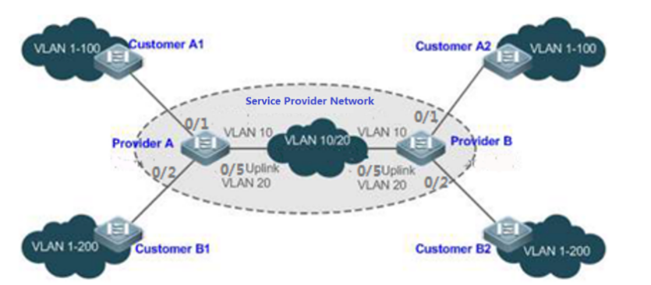
Illustration：
- Customer A1, Customer A2, Customer B1 and Customer B2 are the edge devices of the network where enterprise user A and enterprise user B are located, respectively. Provider A and Provider B are edge devices of the service provider network, and enterprise A and enterprise B access the public network through the edge devices of the provider.
- The VLAN range of the office network used by enterprise A is VLAN 1-100.
- The VLAN range of the office network used by enterprise B is VLAN 1-200.
ProviderA and ProviderB are completely symmetrical and have exactly the same configuration:
- Configuring VLAN
SWITCH(config)#vlan 2-200
SWITCH(config)#interface gigabitEthernet0/1
SWITCH(config-if)#switchport mode trunk
SWITCH(config-if)#switchport trunk allowed vlan 1-100
SWITCH(config-if)#switchport trunk native vlan 10
SWITCH(config)#interface gigabitEthernet0/2
SWITCH(config-if)#switchport mode trunk
SWITCH(config-if)#switchport trunk native vlan 10
SWITCH(config-if)#interface gigabitEthernet0/5
SWITCH(config-if)#switchport mode trunk
- Configuring Base QINQ
SWITCH(config)#interface gigabitEthernet0/1-2
SWITCH(config-if)#switchport vlan-stacking basic
SWITCH(config-if)#exit
Example 2: This example shows how to Implement Layer 2 VPN and service flow management based on Flexible QINQ.
Basic QinQ can only encapsulate user data packets in the outer tag of a native VLAN, that is, the encapsulation of the outer tag depends on the native VLAN of the tunnel port. Flexible QinQ provides flexible encapsulation of external tags (S-Tags) of service providers (ISPs) according to the tags of user packets (ie C-Tags), so as to flexibly implement VPN transparent transmission and service flow QoS policies.
- Broadband Internet access and IPTV services are an important part of the services carried by the MAN. The MAN service provider network divides VLANs for different service flows to differentiate management, and provides QoS policy settings for these VLANs. You can use QinQ based on C-Tag on the edge device of the service provider to encapsulate the relevant VLAN of the user's business flow, and use the QoS policy of the service provider network for guaranteed transmission while transparent transmission.
- Unified VLAN planning is implemented between enterprise branches, and important services and general services are in different VLAN ranges. The enterprise network can use the flexible QinQ based on C-Tag to transparently transmit the internal services of the company, and can also use the service provider network. The QOS strategy of the company gives priority to ensuring the data transmission of important services.
As shown in the figure below, the client devices in the metropolitan area network are aggregated through the corridor switches in the community, and broadband Internet access and IPTV services are differentiated by assigning different VLANs to enjoy different QoS service policies.
- In the public network, different service flows of broadband Internet access and IPTV are transmitted in different VLANs to realize transparent transmission of user services.
- The ISP network sets the QoS policy for VLAN, and the corresponding VLAN can be encapsulated for the user service on the edge device of the service provider, so that the IPTV service is transmitted preferentially in the ISP network.
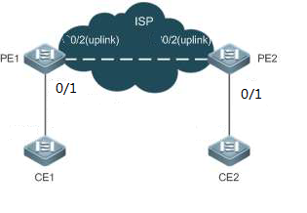
Illustration:
- CE1 and CE2 are edge devices that connect to the user's network, and PE1 and PE2 are edge devices that the provider serves on the network.
- VLAN 1-100 and VLAN 101-200 on CE1 and CE2 devices are the broadband Internet service flow for users, and the IPTV service flow for users.
- PE1 and PE2 devices package different s-tags for vlans of different businesses to distinguish different business data. VLAN 1-100 package VLAN100, vlan101-200 package VLAN200.
PE1 and PE2 are configured exactly the same:
- Configuring VLAN
SWITCH(config)#vlan 2-200
SWITCH(config)#interface gigabitEthernet0/1
SWITCH(config-if)#switchport mode hybrid
SWITCH(config-if)#switchport hybrid untagged vlan 100,200
SWITCH(config-if)#switchport hybrid vlan 100
SWITCH(config-if)#interface gigabitEthernet0/2
SWITCH(config-if)#switchport mode trunk
SWITCH(config-if)#exit
- Configuring Flexible QINQ
SWITCH(config)#vlan-vpn isp
SWITCH(config-vlan-vpn)# cvlan 1-100 svlan 100
SWITCH(config-vlan-vpn)# cvlan101-200 svlan 200
SWITCH(config-vlan-vpn)# interface gigabitEthernet0/1
SWITCH(config-if)#switchport vlan-stacking vpn isp
SWITCH(config-if)#exit
Example 3: This example shows how to Implement Layer 2 VPN and service flow management based on VLAN Mapping.
Similar to Case 2, the broadband Internet access service and the IPTV service of the user are distinguished. For example, the broadband Internet access service is VLAN2, and the IPTV service is VLAN3. In the ISP network, VLAN200 and VLAN300 are respectively used to represent broadband Internet access services and IPTV services. All ports 1-10 of the PE device are connected to the CE device, and the uplink interface is gigabitEthernet0/11.
PE1 and PE2 are configured exactly the same:
- Configuring VLAN
SWITCH(config)#vlan2-3,200,300
SWITCH(config)#interface gigabitEthernet0/1-10
SWITCH(config-if)#switchport mode trunk
SWITCH(config-if)#interface gigabitEthernet0/11
SWITCH(config-if)#switchport mode trunk
SWITCH(config-if)#exit
- Configuring VLAN Mapping
SWITCH(config)#vlan-vpn isp-map
SWITCH(config-vlan-vpn)#cvlan 2 svlan 200
SWITCH(config-vlan-vpn)#cvlan 3 svlan 300
SWTICH(config-vlan-vpn)#interface gigabitEthernet0/1-10
SWITCH(config-if)#switchport vlan-mapping vpn isp-map
SWITCH(config-if)#exit

Display Information
- Display a VPN Information
SWITCH#show vlan-vpn test
-----------------------------------------------------------
VLAN VPN: test
Class: vlan-stacking
Mapping attributes:
cvlan 1-25,73,75-80 svlan 3
cvlan 200 svlan 4
Applied interfaces:
gigabitEthernet0/17
gigabitEthernet0/18
- Display all VPN Information
SWITCH#show vlan-vpn
-----------------------------------------------------------
VLAN VPN: test
Class: vlan-stacking
Mapping attributes:
cvlan 1-25,73,75-80 svlan 3
cvlan 200 svlan 4
Applied interfaces:
gigabitEthernet0/17
gigabitEthernet0/18
-----------------------------------------------------------
VLAN VPN: test-map1
Class: vlan-mapping
Mapping attributes:
cvlan 100 svlan 1
cvlan 200 svlan 2
cvlan 800 svlan 8
cvlan 900 svlan 9
Applied interfaces:
gigabitEthernet0/18
gigabitEthernet0/19
-----------------------------------------------------------
VLAN VPN: test1
Class: unkown
Mapping attributes:
cvlan 800 svlan 8
cvlan 900 svlan 9
Applied interfaces:
empty!

Configuring ERPS

Overview of ERPS
ERPS (Ethernet Ring Protection Switching) was developed by ITU, also known as G.8032.It is a link layer protocol specifically applied to Ethernet. It can prevent the broadcast storm caused by the data loop when the Ethernet ring network is complete, and can quickly restore the communication between each node on the ring network when a link on the Ethernet ring is disconnected.
At present, the technology to solve the Layer 2 network loop problem is STP.STP is more mature to use, but its convergence time is longer (seconds).ERPS is a link layer protocol that is specially applied to Ethernet and has a faster rate than STP for convergence, up to 50ms.
ERPS typical scenario：
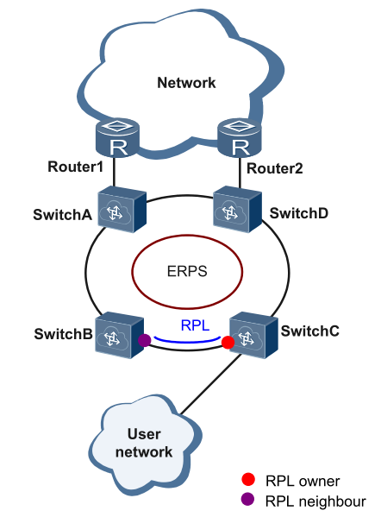

Introduction to ERPS Rationale
ERPS is a standard ring network protocol dedicated to the Ethernet link layer, with the ERPS ring as the basic unit. Only two ports on each layer 2 switch can be added to the same ERPS ring. In the ERPS, in order to prevent network loop, a break-down mechanism can be launched, blocking the RPL owner port and eliminating the ring route. When the ring connection fails, the equipment running the ERPS protocol can quickly forward the blocked port, make the link protection replacement, and restore link communication between various nodes on the ring network. This section mainly presents the rationale for the implementation of ERPS under the basic network based on the normal ->link failure->link recovery process (including protection switch operations).
Link OK
As shown in the diagram below, the equipment on the ring consisting of SwitchA~SwitchE is in good condition.
To prevent loops, ERPS first blocks the RPL owner port. If the RPL neighbor port is configured, the port will also be blocked, and other ports can forward traffic normally.
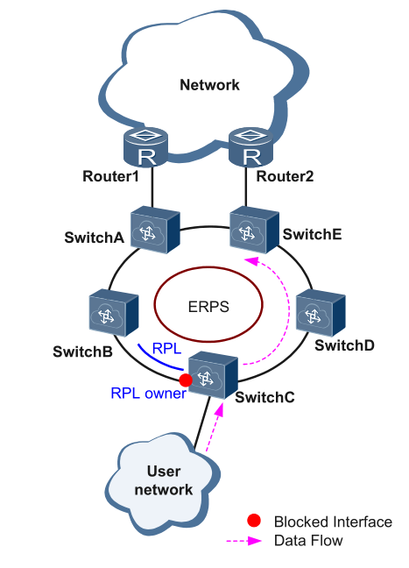
Link Failure
As shown in the diagram, when the link between SwitchD and SwitchE fails, the ERPS protocol starts the protection switching mechanism, blocks the ports on both ends of the faulty link, and then forward the RPL owner port, and the two ports resume user traffic. receiving and sending, thus ensuring uninterrupted traffic.
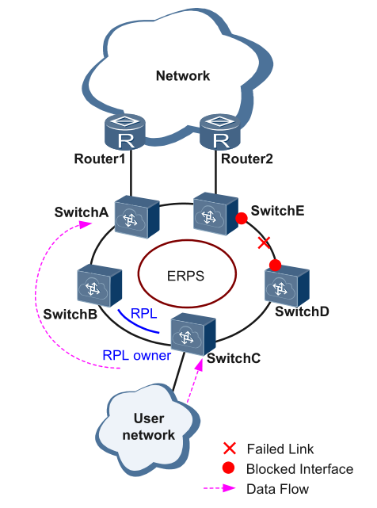
Link Restore
After the link returns to normal, if the ERPS ring is configured in revert mode, the device where the RPL owner port resides will block the traffic on the RPL link again, and the faulty link will be used again to transmit user traffic.

Configuring
- Creating Ring
Command | SWITCH(config)#erps ring <1-255> east-interface IFNAME west-interface IFNAME  SWITCH(config)#no erps ring <1-255>
Description | Create/delete ERPS ring.  The ERPS ring is made up of the same set of VLAN and interconnected layer 2 switch, which is the basic unit of the ERPS protocol and needs to be configured on each device in the ring.  The ring number is the unique identifier for the ERPS ring.
- Creating ERPS Instance
Command | SWITCH(config)#erps instance NAME  SWITCH(config)#no erps instance NAME
Description | Create/remove ERPS instances; Create an instance to go into instance configuration mode.  For the layer 2 switch operating an ERPS protocol, VLAN transmitting ERPS and data articles must be mapped into a protective instance so that ERPS protocol can be forwarded or blocked in accordance with their blocking principles. Otherwise, user traffic could cause broadcast storms in a ring network that could make the network unavailable.
- Associating ERPS Instances and Rings
Command | SWITCH(config-erps-inst)#ring <1-255>
Description | Configure the corresponding relationships between ERPS instances and rings.
- Configuring ERPS Instance Level
Command | SWITCH(config-erps-inst)#level <0-7>
Description | Configure ERPS instance level.
- Configuring RPL Roles in ERPS Instance
Command | SWITCH(config-erps-inst)#rpl-role NAME
Description | Configure the ERPS instance RPL role;  An ERPS ring has only one RPL owner port, which is determined by user configuration. The RPL owner port is blocked from forwarding user traffic to prevent loops in the ERPS ring.
- Configuring Raps VLAN for Instance
Command | SWITCH(config-erps-inst)#vlan <1-4094> raps-channel  SWITCH(config-erps-inst)#no raps-channel
Description | Configuration/delete raps VLAN for ERPS instances;  Each ERPS ring must be configured with a raps VLAN.Different ERPS rings cannot use the same raps VLAN ID.
- Configuring MST Instance
Command | SWITCH(config-erps-inst)#protected-mst-instance <0-255>
Description | Configure MST Instance；  The relationship between VLAN and Instance can be configured in MST mode, after STP mode be set to MSTP, refer to STP configuration for more details; by default, all VLANs belong to Instance 0; the default value is 0.  Note: Multi-instance is currently not supported in intersecting rings!
- Configuring Intersecting Sub-ring Block Port
Command | SWITCH(config-erps-inst)#sub-ring block (east-interface | west-interface)
Description | Configure the ERPS instance as a sub-ring instance and specify a sub-ring block port.
- Configuring Sub-ring Virtual Channels and Non-virtual Channels
Command | SWITCH(config-erps-inst)#virtual-channel attached-to-instance NAME  SWITCH(config-erps-inst)# non-virtual-channel
Description | Configure the type of ERPS intersecting sub-ring: virtual channel and associated main ring; or non-virtual channel type.  Note: The position displayed by this command in show running-config must be after the displayed position of the associated instance. Normally only need to ensure that the sub-ring ID and instance name are larger than the main ring ID and instance name.

- Configuring ERPS Revert Mode
Command | SWITCH(config-erps-inst)#revertive | non-revertive
Description | Configure ERPS revertive/non-revertive.
- Configuring ERPS Timer Parameters
Command | SWITCH(config-erps-inst)# (wtr-timer (<1-12> | default) | holdoff-timer (<0-100> | default) | guard-timer (<1-200> | default))
Description | Configure ERPS timer parameters.  <1-12>: in minutes; revert time after recovery, default is 5 minutes.  <0-100>：in 100 milliseconds; hold time before port forwarding, the default is 0, direct forwarding without delay.  <1-200>：in 10 milliseconds; protection window when state changes, avoid receiving messages from previous state leading to protocol errors, default is 50：500 ms.  guard-timer parameters limit network size. It is conservatively recommended that when there are more than 300 nodes in the ring network, directly configure this parameter to the maximum value to avoid the failure of old packets to be discarded due to the large network size; no special configuration is required for nodes within 300 nodes.
- Configuring ERPS Logging
Command | SWITCH(config)# erps logging  SWITCH(config)# no erps logging
Description | Configure ERPS logging.

Examples
1. Single-ring case requirements: As shown in the figure, the configuration blocks the direct links of S1 and S2 by default, and restores the link in time to ensure the availability of the network in case of failure. Where the data VLANs are 1, 2 and 3.
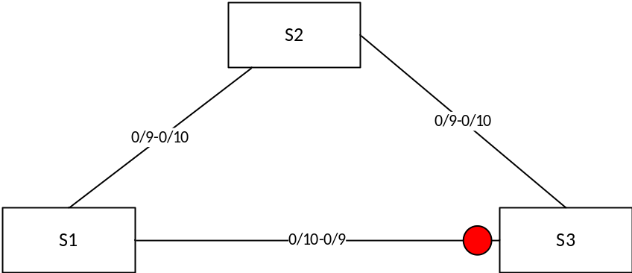
S1/S2：
- Enter global configuration mode, create ERPS and set related parameters, command reference list below：
Create vlan 2,3;vlan 1 default exists
SWITCH(config)#vlan 2,3
Change the interface mode to trunk. By default, trunk mode will add all data vlans and management vlans to the interface for forwarding.
SWITCH(config)#interface gigabitEthernet0/9-10
SWITCH(config-if)#switchport mode trunk
Create ERPS ring 1
SWITCH(config)#erps ring 1 east gigabitEthernet0/9 west gigabitEthernet0/10
Create ERPS instance 1, associated with ring 1, and associated details configuration
SWITCH(config)#erps instance 1
SWITCH(config-erps-inst)#ring 1
SWITCH(config-erps-inst)#rpl-role non-owner
SWITCH(config-erps-inst)#vlan 1000 raps-channel
S3：
- Enter global configuration mode, create ERPS and set related parameters, command reference list below：
SWITCH(config)#Vlan 2,3
SWITCH(config)#interface gigabitEthernet0/9,gigabitEthernet0/10
SWITCH(config-if)#switchport mode trunk
SWITCH(config)#Erps ring 1 east gigabitEthernet0/9 west gigabitEthernet0/10
SWITCH(config)#Erps instance 1
SWITCH(config-erps-inst)#ring 1
SWITCH(config-erps-inst)#rpl-role owner east
SWITCH(config-erps-inst)#vlan 1000 raps-channel
2. Intersection ring case requirements
As shown in the following topology, S1, S2, S3, and S4 form intersecting rings, and the data vlans are 1, 2, 3, and 4. It is required to achieve fast convergence when a single point of failure occurs in each ring; a maximum of two faults can occur in the network Points (different rings), without user disconnection, to achieve optimal reliability.
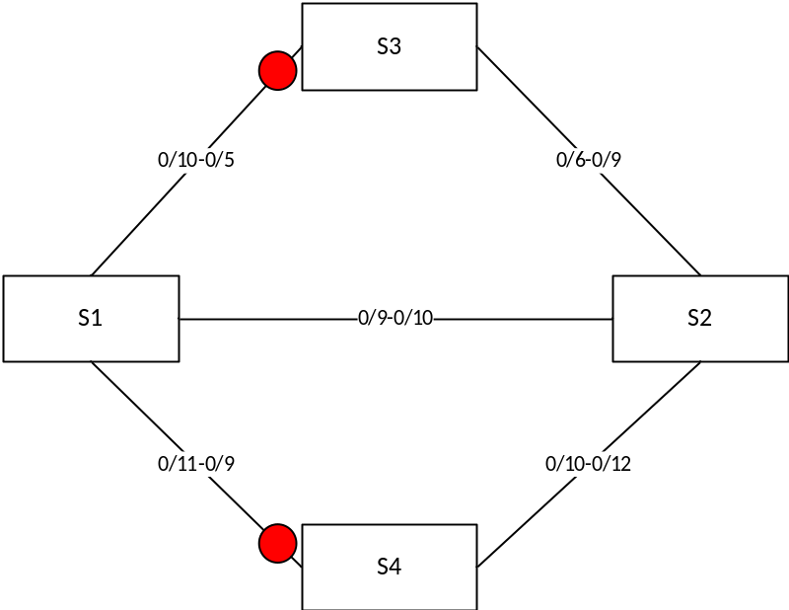
Typical configuration examples：
S1:
Vlan 2,3,4
interface gigabitEthernet0/9-12
switchport mode trunk
Erps ring 1 east gigabitEthernet0/9 west gigabitEthernet0/10
Erps instance 1
ring 1
vlan 1000 raps-channel

Erps ring 2 east gigabitEthernet0/9 west gigabitEthernet0/11
Erps instance 2
ring 2
sub-ring block east-interface
vlan 1100 raps-channel
virtual-channel attached-to-instance 1
S2:
Vlan 2,3,4
interface gigabitEthernet0/9-12
switchport mode trunk
Erps ring 1 east gigabitEthernet0/9 west gigabitEthernet0/10
Erps instance 1
ring 1
vlan 1000 raps-channel

Erps ring 2 east gigabitEthernet0/12 west gigabitEthernet0/10
Erps instance 2
ring 2
sub-ring block east-interface
vlan 1100 raps-channel
virtual-channel attached-to-instance 1
S3:
Vlan 2,3,4
interface gigabitEthernet0/5-6
switchport mode trunk
Erps ring 1 east gigabitEthernet0/5 west gigabitEthernet0/6
Erps instance 1
ring 1
rpl-role owner east
vlan 1000 raps-channel
S4:
Vlan 2,3,4
interface gigabitEthernet0/9-12
switchport mode trunk
Erps ring 2 east gigabitEthernet0/9 west gigabitEthernet0/10
Erps instance 2
ring 2
rpl-role owner east
vlan 1100 raps-channel
3. Tangent ring case requirements
The topology diagram is shown below. S1 is located in the central computer room, which can be supervised and maintained by the administrator in real time, and has high reliability; S2-S5 are distributed in various deployment points, in order to improve the reliability of the network and avoid the occurrence of single-link external connection The single-point failure risk is avoided, and the single-machine failure risk that may occur in a dual-link external connection is avoided, and the dual-link external connection is used to form a ring network.
It is required that each ring network can converge quickly when a single point of failure occurs to avoid user network interruption.
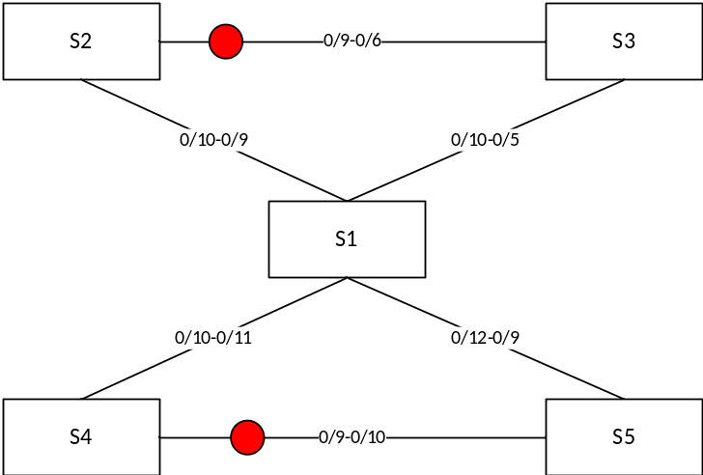
Typical configuration examples：
S1:
Vlan 2,3,4
interface gigabitEthernet0/9-12
switchport mode trunk
Erps ring 1 east gigabitEthernet0/9 west gigabitEthernet0/10
Erps instance 1
ring 1
vlan 1000 raps-channel

Erps ring 2 east gigabitEthernet0/11 west gigabitEthernet0/12
Erps instance 2
ring 2
vlan 1100 raps-channel
S2:
Vlan 2,3,4
interface gigabitEthernet0/9-12
switchport mode trunk
Erps ring 1 east gigabitEthernet0/9 west gigabitEthernet0/10
Erps instance 1
ring 1
rpl-role owner east
vlan 1000 raps-channel
S3:
Vlan 2,3,4
interface gigabitEthernet0/5-6
switchport mode trunk
Erps ring 1 east gigabitEthernet0/5 west gigabitEthernet0/6
Erps instance 1
ring 1
vlan 1000 raps-channel
S4:
Vlan 2,3,4
interface gigabitEthernet0/9-12
switchport mode trunk
Erps ring 2 east gigabitEthernet0/9 west gigabitEthernet0/10
Erps instance 2
ring 2
rpl-role owner east
rpl-role owner east
S5:
Vlan 2,3,4
interface gigabitEthernet0/9-12
switchport mode trunk
Erps ring 2 east gigabitEthernet0/9 west gigabitEthernet0/10
Erps instance 2
ring 2
vlan 1100 raps-channel

Display Information
- Show ERPS Ring Information
SWITCH#show erps ring 1

Ring : 1
==========
Bridge : 1
East : gigabitEthernet0/23
West : gigabitEthernet0/24
ERP Inst :1, 2,
SWITCH#
- Show ERPS Instances
SWITCH#
SWITCH#show erps instance 1
Name : 1
Protected MST Instance: 0
Protected VLANs : 1
State : ERPS_ST_IDLE
Last Priority : RAPS-NR-RB
Phy Ring : 1
Role : NON-OWNER
East Link : Link_Unblocked(up)(78-A9-12-12-13-12, 1)
West Link : Link_Unblocked(up)(78-A9-12-12-13-12, 1)
TCN Propagation : Disabled
Attached : -
Attached To : -
Virtual ID : -:-
-----------------------------------------------------
Channel | Interface
(LEVL, VID, RID) | (east,ver) , (west,ver)
=====================================================
(0, 1000, 1) | (gigabitEthernet0/23, V=1), (gigabitEthernet0/24, V=1)
=====================================================
Wait-To-Restore : 5 mins
Hold Off Timer : 0 secs
Guard Timer : 500 ms
Wait-To-Block : 5500 ms
Protection Type : Revertive
SWITCH#

Configuring IGMP Snooping

Overview of IGMP Snooping
IGMP Snooping is a short term for Internet Group Management Protocol Snooping, a mechanism running on a layer 2 device for managing and controlling multicast groups.
A Layer 2 device running IGMP Snooping analyzes the received IGMP packets, establishes a mapping relationship between ports and MAC multicast addresses, and forwards multicast data according to the mapping relationship. When the Layer 2 device does not run IGMP Snooping, the multicast data is broadcast at Layer 2; when the Layer 2 device runs IGMP Snooping, the multicast data of the known multicast group will not be broadcast at Layer 2, but at Layer 2.
As shown in the figure below, when the Layer 2 multicast device does not run IGMP Snooping, the IP multicast packets are broadcast in the VLAN; when the Layer 2 multicast device runs IGMP Snooping, the IP multicast packets are only sent to the group members recipient.
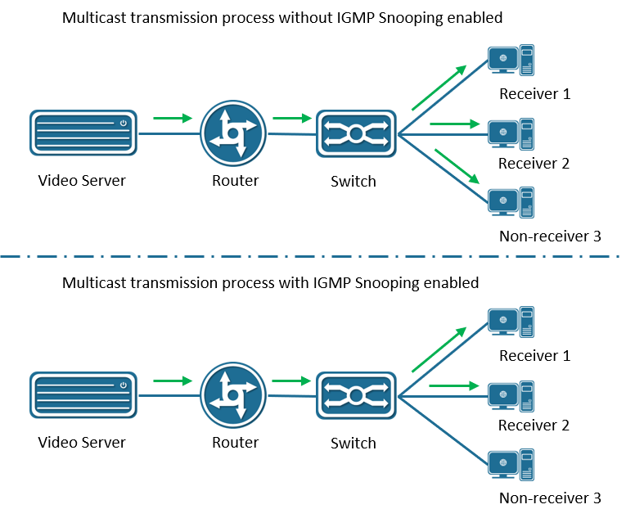

Configuring
- Enabling IGMP Snooping
Command | SWITCH( config)# igmp snooping  SWITCH( config)# no igmp snooping
Description | Enable/disable IGMP Snooping function; disabled by default.  Global configuration mode.
- Configuring IGMP Snooping Upstream Ports
Command | SWITCH( config-if)# igmp snooping mrouter interface IFNAME  SWITCH( config-if)# no igmp snooping mrouter interface IFNAME
Description | Configure/delete IGMP Snooping upstream port; optional configuration.  SVI interface mode.
- Configuring IGMP Snooping Static Groups
Command | SWITCH( config-if)# igmp snooping static-group IPADDR source IPADDR interface IFNAME  SWITCH( config-if)# no igmp snooping static-group IPADDR source IPADDR interface IFNAME
Description | Configure/delete IGMP Snooping static group; optional configuration.  SVI interface mode.
- Configuring IGMP Snooping Fast Leave
Command | SWITCH( config-if)# igmp snooping fast-leave  SWITCH( config-if)# no igmp snooping fast-leave
Description | Configure/delete IGMP Snooping fast leave function; optional configuration.  SVI interface mode.

Examples
Simplified topology:
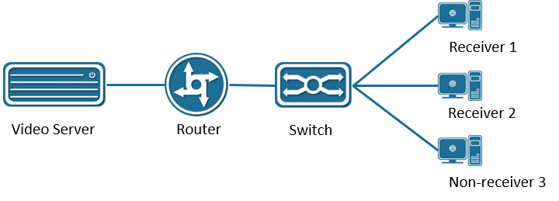
Basic configuration /roles: (top down)
server:
During the test, VLC is used as the multicast server to provide the multicast service: udp://225.0.0.1:1234, the server IP is 3.3.3.10
router:
Run the multicast routing protocol and enable IGMP, and use Ruijie S57 Layer 3 switch to simulate the test. The main configurations are as follows:
Enable multicast routing
ip multicast-routing
Configure the uplink port , connect to the server, here is simply to select the PIM dense mode, the actual network scale is large, and the multicast use is less, it is recommended to use the sparse mode
interface GigabitEthernet 0/23
no switchport
no ip proxy- arp
ip pim dense-mode
ip address 3.3.3.3 255.255.255.0
Configure the downlink port. The PIM dense mode is simply selected here. The actual network scale is large and the multicast usage is small. It is recommended to use the sparse mode
interface VLAN 1
no ip proxy- arp
ip pim dense-mode
ip address 2.2.2.1 255.255.255.0
SWITCH:
Multicast can be enabled
igmp snooping
Client:
Watch server multicast video through udp://225.0.0.1:1234, IP 2.2.2.10

Display Information
- View IGMP Snooping Multicast Groups
SWITCH#show igmp snooping groups
- Viewing IGMP Snooping Interface Information
SWITCH#show igmp snooping interface {ifname}
Example:
IGMP Snooping information for vlan1
IGMP Snooping enabled
Snooping Querier none
IGMP Snooping other querier timeout is 255 seconds
Group Membership interval is 260 seconds
IGMPv2 fast-leave is disabled
IGMPv1/v2 Report suppression enabled
IGMPv3 Report suppression enabled
Router port detection using IGMP Queries
Number of router-ports: 2
Number of Groups: 2
Number of Joins: 891
Number of Leaves: 4
Active Ports:
gigabitEthernet0/1
gigabitEthernet0/2
- Viewing IGMP Snooping Routing Port Information
SWITCH#show igmp snooping mrouter vlan1
Example:
SWITCH#show igmp snooping mrouter vlan1
VLAN Interface IP-address Expires
1 gigabitEthernet0/18(dynamic) 2.2.2.1 00:03:34
gigabitEthernet0/20(static) -- --
- Viewing IGMP Snooping Interface Statistics
SWITCH#show igmp snooping statistics interface vlan1
IGMP Snooping statistics for vlan1
Group Count : 2
IGMP reports received : 893
IGMP leaves received : 4
IGMPv1 query warnings : 0
IGMPv2 query warnings : 456
IGMPv3 query warnings : 0

Configuring Spanning Tree Protocol

Overview of Spanning Tree Protocol
Spanning Tree Protocol is a Layer 2 management protocol that eliminates Layer 2 loops by selectively blocking redundant links in the network, and also has the function of link backup.
Like the development process of many protocols, the Spanning Tree Protocol is constantly updated with the development of the network, from the original STP (Spanning Tree Protocol, Spanning Tree Protocol) to RSTP (Rapid Spanning Tree Protocol, Rapid Spanning Tree Protocol), to the latest MSTP (Multiple Spanning Tree Protocol).
Comparison of three spanning tree protocols:
Spanning Tree Protocol | Features | Application Scenario
STP | Form a loop-free tree, resolve broadcast storms and implement redundant backup.  Slow convergence. | There is no need to distinguish user or service traffic, all VLANs share a spanning tree.
RSTP | Form a loop-free tree, resolve broadcast storms and implement redundant backup.  Convergence is fast.
MSTP | Form a loop-free tree, resolve broadcast storms and implement redundant backup.  Convergence is fast.  Multiple spanning trees implement load balancing among VLANs, and traffic of different VLANs is forwarded according to different paths. | It is necessary to distinguish user or service traffic and implement load balancing. Different VLANs forward traffic through different spanning trees, and each spanning tree is independent of each other.

STP

Requirement Background
STP is a protocol for eliminating loops in local area networks. Devices running this protocol discover loops in the network by exchanging information with each other, and appropriately block certain ports to eliminate loops. Due to the continuous growth of LAN scale, Spanning Tree Protocol has become one of the most important LAN protocols.
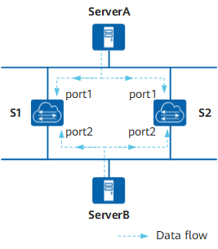
Figure12-1 Schematic diagram of typical local area network
In the network shown in Figure12-1, the following two situations will occur:
- Network unavailable due to broadcast storm.
The loop generates a broadcast storm, which can make the network unavailable. Assume that the STP protocol is not enabled on the switch device. If ServerA sends a broadcast request, then the broadcast packet will be received by the port port1 of the other two switching devices, and broadcast from the port port2 respectively, and then the port port2 will receive another switching device. The broadcast packets are forwarded from the ports port1 of the two switching devices respectively. Repeatedly, the entire network resources will be exhausted and the network will be paralyzed and unavailable.
- MAC address table flapping caused MAC address table entries to be destroyed.
Even unicast packets may cause confusion in the MAC address table entries of the switching device, thus destroying the MAC address table of the switching device.
Assuming that there is no broadcast storm in the network shown, ServerA sends a unicast packet to ServerB. If ServerB is temporarily removed from the network at this time, then the MAC address entry about ServerB on the switching device will also be changed. been deleted. At this time, the unicast packet sent by ServerA to ServerB will be received by port 1 of switching device S1. Since there is no corresponding MAC address forwarding entry on S1, the unicast packet will be forwarded to port 2. Then the port port2 of the switching device S2 receives the unicast message sent from the peer port2 port, and then sends it out from port1. At the same time, the port port1 of the switching device S2 will also receive the unicast message sent by ServerA to ServerB, and then send it out from port2. So repeatedly, on the two switching devices, since the unicast packets from host A are continuously received from ports port1 and port2, the switching device will constantly modify its own MAC address entries. , thus causing the MAC address table to jitter. If this goes on, the MAC address entry will eventually be destroyed.

Basic Concepts
- One Root Bridge
For an STP network, there is only one root bridge in the entire network, which is the logical center of the entire network, but not necessarily the physical center. The root bridge changes dynamically according to changes in the network topology.
After the network converges, the root bridge will generate and send configuration BPDUs at certain time intervals. Other devices will only process the packets and communicate the topology change records to ensure topology stability.

- Two metrics
The generation calculation of spanning tree has two basic metrics: ID and path cost.
ID
ID is divided into: BID (Bridge ID) and PID (Port ID).
BID: Bridge ID
The IEEE 802.1D standard stipulates that the BID is composed of the bridge priority (Bridge Priority) and the bridge MAC address. BID bridge priority occupies the upper 16 bits, and the remaining lower 48 bits are the MAC address.
In an STP network, the device with the smallest bridge ID will be elected as the root bridge.
PID: Port ID
PID consists of two parts, the upper 4 bits are the port priority, and the lower 12 bits are the port number.
PID is only useful for selecting the designated port in some cases.
Path cost
Path Cost is a port variable and a reference value used by the STP protocol to select links. The STP protocol selects the 'stronger' link by calculating the path cost, blocks the redundant links, and prunes the network into a loop-free tree network structure.
In an STP network, the path cost from a port to the root bridge is the accumulation of the path costs of the outgoing ports on the bridges it passes through. This value is called the Root Path Cost.
- Three-element election
From ring network topology to tree structure, there are generally three elements: root bridge, root port and designated port. The following three elements are introduced in combination with Figure12-2.
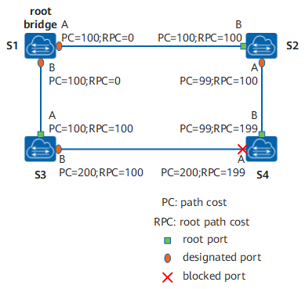
Figure12-2 STP network structure
Root Bridge RB
The root bridge is the bridge with the smallest bridge ID, and the smallest BID is selected by configuring the BPDU protocol packets interactively.
Root Port RP
The so-called root port is the port with the least path cost to the root bridge. The root port is responsible for forwarding data to the root bridge. The selection criteria of this port are determined based on the cost of the root path. Among all STP-enabled ports on a device, the one with the lowest root path cost is the root port. Obviously, there is only one root port on a device running the STP protocol, and there is no root port on the root bridge.
Designated Port (Designated Port)
See Table12-1 for the description of the designated bridge and designated port.
Table12-1 Meaning of Designated Bridge and Designated Port
Classification | Specify bridge | Designated port
Device | A device directly connected to this machine and responsible for forwarding configuration messages to this machine | The designated bridge's port that forwards configuration BPDUs to the device
LAN | The device responsible for forwarding configuration messages to this network segment | The designated bridge's port that forwards configuration BPDUs to the LAN
As shown in , AP1, AP2, BP1, BP2, CP1, and CP2 represent the ports of devices S1, S2, and S3, respectively.
S1 forwards configuration messages to S2 through port AP1, then the designated bridge of S2 is S1, and the designated port is port AP1 of S1.
There are two devices connected to the local area network LAN: S2 and S3. If S2 is responsible for forwarding configuration messages to the LAN, the designated bridge of the LAN is S2, and the designated port is the BP2 of S2.
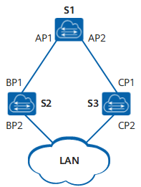
Figure12-3 Designated Bridge and Designated Port Diagram
Once the root bridge, root port, and designated port are elected successfully, the entire tree topology is established. After the topology is stable, only the root port and the designated port forward traffic, and other non-root and non-designated ports are in the blocking state. They only receive STP protocol packets and do not forward user traffic.
- Four comparison principles
STP election has four comparison principles to form a message priority vector: < root bridge ID, root path cost, sending device BID, sending port PID>.
The main information of this port carried in the configuration BPDU is shown in Table12-2.
Table12-2 Four Important Information Fields
Field Content | Brief Description
Root Bridge ID | There is exactly one root per STP network.
Root path cost | The distance from the port sending the configuration BPDU to the root bridge determines the path cost to the root bridge.
Sender BID | The BID of the device that sent the configuration BPDU.
PID | PID of the port that issued the configuration BPDU.
Other devices in the STP network will compare the fields described in table after receiving the configuration BPDU message. The four basic comparison principles are as follows:
Minimum BID: used to elect the root bridge. Select the smallest BID according to the root bridge ID field between devices running the STP protocol.
Minimum root path cost: used to select root ports on non-root bridges. On the root bridge, the root path cost from each port to the root bridge is 0.
Minimum sender BID: When a device running the STP protocol wants to select a root port among two or more ports with the same root path cost, it is calculated by the STP protocol, and the received configuration message will be selected. The port with the smaller sender's BID. As shown in Figure12-2, assuming that the BID of S2 is smaller than the BID of S3, if the root path costs in the BPDUs received by ports A and B of S4 are equal, then port B will become the root port .
Minimum PID: When the root path cost is the same, the port with the smallest PID is not blocked, but the port with the larger PID value is blocked. The PID only works in the case shown in Figure12-4, the PID of port A of S1 is smaller than the PID of port B, because in the BPDUs received on the two ports, the root path overhead, sending exchange The device BIDs are the same, so the basis for eliminating the loop is only the PID.
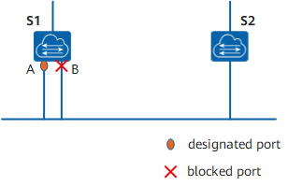
Figure12-4 Topology applied to PID for comparison
- Five Port States
The port status on the device running the STP protocol is shown in Table12-3.
Table12-3 STP Port Status
Port Status | Purpose | Description
Forwarding | The port both forwards user traffic and processes BPDUs. | Only the root port or the designated port can enter the Forwarding state.
Learning | The device will build a MAC address table based on the received user traffic, but will not forward user traffic. | Transition state, add Learning state to prevent temporary loops.
Listening | Determine the port role. The root bridge, root port and designated port will be elected. | Transition state.
Blocking | The port only receives and processes BPDUs and does not forward user traffic. | The final state of the blocked port.
Disabled | The port not only does not process BPDUs, but also does not forward user traffic. | The port status is Down.
The port state migration mechanism is shown in .
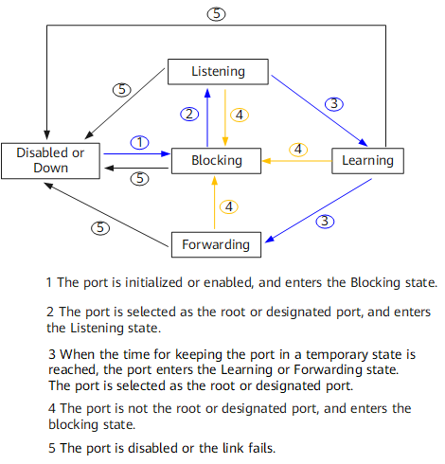
Figure12-5 STP port state transition diagram
For STP, the following 3 parameters affect port status and port convergence.
- Hello Time
The time interval at which the device running the STP protocol sends the configuration message BPDU, which is used by the device to detect whether the link is faulty. The device will send hello packets to surrounding devices every Hello Time to confirm whether the link is faulty.
When the network topology is stable, the modification of this timer will only take effect after the root bridge is modified. The new root bridge will populate the appropriate fields in outgoing BPDUs to pass the timer modification information to other non-root bridges. But when the topology changes, the sending of TCN BPDUs is not managed by this timer.
- Forward Delay
Delay time for device state transition. A link failure will cause the network to recalculate the spanning tree, and the structure of the spanning tree will change accordingly. However, the new configuration message obtained by recalculation cannot immediately spread to the entire network. If the newly selected root port and designated port start data forwarding immediately, it may cause a temporary loop. For this reason, STP adopts a state transition mechanism. The newly selected root port and designated port can enter the forwarding state after 2 times of the Forward Delay. Configuration messages are propagated throughout the network, preventing temporary loops.
Forward Delay Timer refers to the respective durations of a port in the Listening and Learning states. The default is 15 seconds. The Listening state lasts for 15 seconds, followed by the Learning state for another 15 seconds. Ports in these two states do not forward user traffic, which is exactly what STP is used to avoid temporary loops.
- Max Age
The aging time of BPDU packets of the port can be manually changed by commands on the root bridge.
Max Age can be guaranteed to be consistent in the entire network by configuring the transmission of BPDU packets. After the non-root bridge device in the network running the STP protocol receives the configuration BPDU message, the Message Age and Max Age in the message will be compared:
If Message Age is less than or equal to Max Age, the non-root bridge device continues to forward configuration BPDUs.
If Message Age is greater than Max Age, the configuration BPDU will be aged out. The non-root bridge device directly discards the configuration BPDU. It can be considered that the network diameter is too large and the root bridge connection fails.
If the configuration BPDU is sent by the root bridge, the Message Age is 0. Otherwise, Message Age is the total time from the root bridge to the BPDU received by the current bridge, including transmission delay, etc. In the actual implementation, when BPDU packets pass through a bridge, the Message Age is increased by 1.

Message Format
Information such as bridge ID, path cost, and port ID were introduced in the previous chapters, all of which are transmitted via BPDU protocol packets.
The configuration BPDU is a heartbeat message. As long as the port is enabled with STP, the configuration BPDU will be sent from the designated port at the interval specified by the Hello Time timer.
TCN BPDUs are sent when the device detects that the network topology has changed.
BPDUs are encapsulated in Ethernet data frames, the destination MAC is multicast MAC: 01-80-C2-00-00-00, the Length/Type field is the MAC data length, followed by LLC header, LLC is followed by the BPDU header. The Ethernet data frame format is shown in Figure12-6.
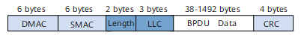
Figure12-6 Ethernet Data Frame Format
- Configuring BPDU
Most commonly referred to as BPDUs refer to configuration BPDUs.
During initialization, each bridge actively sends configuration BPDUs. But after the network topology is stable, only the root bridge actively sends configuration BPDUs, and other bridges trigger to send their own configuration BPDUs after receiving configuration BPDUs from upstream. The length of the configuration BPDU must be at least 35 bytes, including parameters such as bridge ID, path cost, and port ID. Only when at least one of the sender's BID or port PID is different from the receiving port of the bridge, the BPDU will be processed, otherwise it will be discarded. This avoids processing BPDUs with the same port information.
The configuration BPDU will be generated in the following 3 cases:
- As long as the port is enabled with STP, the configuration BPDU will be sent from the designated port at the interval specified by the Hello Time timer.
- When the root port receives a configuration BPDU, the device where the root port is located will copy a configuration BPDU to each of its designated ports.
- When the designated port receives a configuration BPDU that is worse than its own, it will immediately send its own BPDU to the downstream device.
The basic format of the configuration BPDU message is shown in Table12-4.
Table12-4 BPDU basic format
Field | bytes | Description
Protocol Identifier | 2 | Always 0.
Protocol Version Identifier | 1 | Always 0.
BPDU Type | 1 | Current BPDU type:  0x00: Configure BPDU.  0x80: TCN BPDU.
Flags | 1 | Network topology change flag:  Lowest bit = TC (Topology Change) flag.  Highest bit=TCA (Topology Change Acknowledgment, Topology Change Acknowledgment) flag.
Root Identifier | 8 | The BID of the current root bridge.
Root Path Cost | 4 | The total cost of this port to the root bridge.
Bridge Identifier | 8 | BID of this switching device.
Port Identifier | 2 | Port ID for sending this BPDU.
Message Age | 2 | The message age of this BPDU.  If the configuration BPDU is sent by the root bridge, the Message Age is 0. Otherwise, Message Age is the total time from the root bridge to the BPDU received by the current bridge, including transmission delay, etc. In the actual implementation, when BPDU packets pass through a bridge, the Message Age is increased by 1.
Max Age | 2 | Message aging age.
Hello Time | 2 | The time interval between sending two adjacent BPDUs.
Forward Delay | 2 | Controls the duration of the Listening and Learning states.
The flag field is shown in Figure12-7, only the highest and lowest bits are used in STP.
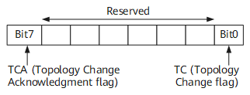
Figure12-7 Flags field format
- TCN BPDU
TCN BPDU content is relatively simple, only the first 3 fields listed in Table12-4: protocol number, version and type. The type field is a fixed value of 0x80, and the length is only 4 bytes.
TCN BPDU refers to sending a topology change notification to the upstream when the downstream topology changes, until the root node. TCN BPDU will be generated in the following two cases:
- The port status changes to Forwarding status.
- The designated port receives the TCN BPDU, copies the TCN BPDU and sends it to the root bridge.

Topology Calculation
After all devices in the network enable the STP protocol, each device considers itself to be the root bridge. At this point, each device only sends and receives configuration BPDUs without forwarding user traffic, and all ports are in the Listening state. After all devices exchange configuration BPDUs, they perform election work to elect the root bridge, root port and designated port.
- BPDU interaction process
As shown in Figure12-8, the quadruple marked with <> represents the root bridge ID (S1_MAC and S2_MAC represent the BIDs of two devices in the figure), the accumulated root path cost, An ordered group consisting of sender BID and sending port PID. The configuration BPDU will be sent at the interval specified by the Hello Timer.
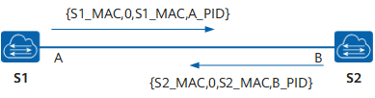
Figure12-8 Initial Information Interaction
Basic process of STP algorithm implementation
- Initial state
Because each bridge thinks it is the root bridge, in the BPDU sent by each port, the root bridge field uses its own BID, and the Root Path Cost field is accumulated to the root bridge. Overhead, the sender BID is its own BID, and the port PID is the port ID of the port that sent the BPDU.
- Select root bridge
When the network is initialized, all STP devices in the network consider themselves to be the 'root bridge', and the root bridge ID is its own device ID. By exchanging configuration messages, devices compare root bridge IDs, and the device with the smallest root bridge ID in the network is selected as the root bridge.
- Select root port and designated port
The selection process of root port and designated port is shown in Table12-5.
Table12-5 Root port and designated port selection process
Step | Process
1 | The non-root bridge device will set the port that receives the optimal configuration message (the selection process of the optimal configuration message is shown in Table12-6) as the root port
2 | The device calculates a designated port configuration message for each port according to the configuration message of the root port and the path cost of the root port:  Replace the root bridge ID with the root bridge ID of the configuration message of the root port;  The root path cost is replaced by the root path cost of the root port configuration message plus the path cost corresponding to the root port;  Replace the sender's BID with the ID of its own device;  Replace the sending port PID with the own port ID.
3 | The device compares the calculated configuration message with the role-pending port's own configuration message:  If the calculated configuration message is better, the port is determined to be the designated port, and its configuration message is also replaced by the calculated configuration message and sent out periodically;  If the port's own configuration message is better, the port's configuration message will not be updated and the port will be blocked. This port will no longer forward data, and will only receive and not send configuration messages.
Table12-6 Optimal configuration message selection process
Step | Process
1 | Each port compares the received configuration message with its own configuration message:  If the received configuration message has a lower priority, it will be discarded directly, and its own configuration message will not be processed;  If the received configuration message has a higher priority, replace the content of the configuration message with the content of the configuration message.
2 | The device compares the configuration messages of all ports and selects the optimal configuration message.
STP algorithm implementation example
Once the root bridge, root port and designated port are elected successfully, the whole tree topology is established. The following describes the specific process of implementing the STP algorithm with an example.
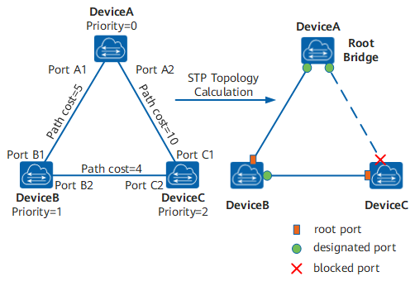
Figure12-9 STP algorithm implementation process networking diagram and calculated topology
As shown in the figure, the priorities of DeviceA, DeviceB, and DeviceC are 0, 1, and 2, respectively. The path cost of the links between DeviceA and DeviceB, between DeviceA and DeviceC, and between DeviceB and DeviceC 5, 10 and 4 respectively.
Initial state of each device
The initial state of each device is shown in the table below.
Table12-7 Initial state of each device
Device | Port Name | Port configuration message  < Root bridge ID, cumulative root path cost, sender BID, sender port PID>
DeviceA | Port A1 | <0,0,0,Port A1>
DeviceA | Port A2 | <0,0,0,Port A2>
DeviceB | Port B1 | <1,0,1,Port B1>
DeviceB | Port B2 | <1,0,1,Port B2>
DeviceC | Port C1 | <2,0,2,Port C1>
DeviceC | Port C2 | <2,0,2,Port C2>
Comparison process and results of each device
The comparison process and results of each device are shown in the table below.
Table12-8 STP topology calculation process and results
Device | Comparison process | Configuration message of port after comparison
DeviceA | Port A1 received the configuration message of Port B1 <1, 0, 1, Port B1>, and found that its configuration message < 0, 0, 0, Port A1> was better, so it throw away.  Port A2 receives the configuration message <2, 0, 2, Port C1> of Port C1, and finds that its configuration message < 0, 0, 0, Port A2> is better, so it throw away.  DeviceA finds that both the root bridge and the designated bridge in the configuration messages of its ports are itself, so it thinks that it is the root bridge, and the configuration messages of each port do not make any changes, and then periodically send out Send configuration message. | Port A1: <0, 0, 0, Port A1>  Port A2: <0, 0, 0, Port A2>
DeviceB | Port B1 receives the configuration message of Port A1 <0,0,0,Port A1>, and finds that it is better than its own configuration message <1,0,1,Port B1>, so Update your own configuration message.  Port B2 receives the configuration message of Port C2 <2, 0, 2, Port C2>, and finds that its configuration message < 1, 0, 1, Port B2> is better, so it throw away. | Port B1: <0, 0, 0, Port A1>  Port B2: <1, 0, 1, Port B2>
DeviceB | DeviceB compares the configuration messages of its own ports and finds that the configuration messages of Port B1 are optimal, so this port is determined as the root port, and its configuration messages remain unchanged.  DeviceB calculates the configuration message <0, 5, 1, Port B2> of the designated port for Port B2 according to the configuration message and path cost of the root port, and then matches the configuration message of Port B2 itself < 1, 0, 1, and Port B2> are compared, and it is found that the calculated configuration message is better, so Port B2 is determined as the designated port, and its configuration message is also replaced with the calculated configuration message and sent out periodically. . | Root port B1: <0, 0, 0, Port A1>  Designated port B2: <0, 5, 1, Port B2>
DeviceC | Port C1 receives the configuration message of Port A2 <0,0,0,Port A2>, and finds that it is better than its own configuration message <2,0,2,Port C1>, so Update your own configuration message.  Port C2 receives the configuration message <1, 0, 1, Port B2> before the update of Port B2, and finds that it is better than its own configuration message < 2, 0, 2, Port C2> , so update your own configuration message. | Port C1 :<0, 0, 0, Port A2>  Port C2: <1, 0, 1, Port B2>
DeviceC | DeviceC compares the configuration messages of its own ports and finds that the configuration messages of Port C1 are optimal, so the port is determined as the root port, and its configuration messages remain unchanged.  DeviceC calculates the configuration message <0, 10, 2, Port C2> of the designated port for Port C2 according to the configuration message and path cost of the root port, and then matches the configuration message of Port C2 itself < 1, 0, 1, Port B2> compare and find that the calculated configuration message is better, so Port C2 is determined as the designated port, and its configuration message is also replaced with the calculated configuration message. | Root port C1: <0, 0, 0, Port A2>  Designated port C2: <0, 10, 2, Port C2>
DeviceC | Port C2 received the updated configuration message <0, 5, 1, Port B2> from Port B2, and found that it is better than its own configuration message <0, 10, 2, Port C2> , so update your own configuration message.  Port C1 receives the configuration message <0, 0, 0, Port A2> periodically sent by Port A2, and finds that it is the same as its own configuration message, so it discards it. | Port C1 :<0, 0, 0, Port A2>  Port C2: <0, 5, 1, Port B2>
DeviceC | DeviceC compares the root path cost 10 of Port C1 (the root path cost 0 in the received configuration message + the path cost 10 of the link where the port is located) and the root path cost 9 of Port C2 (received The root path cost in the configuration message is 5 + the path cost of the link where this port is located 4). It is found that the latter is smaller, so the configuration message of Port C2 is better, so Port C2 is determined as the root port, and its configuration message remains unchanged.  DeviceC calculates the configuration message <0, 9, 2, Port C1> of the designated port for Port C1 according to the configuration message and path cost of the root port, and then matches the configuration message of Port C1 itself < 0, 0, 0, Port A2> compared, and found that its own configuration message is better, so Port C1 is blocked, and its configuration message remains unchanged. From now on, Port C1 will no longer forward data until a new situation that triggers spanning tree calculation occurs, such as the link between DeviceB and DeviceC is down. | Blocking port C1: <0, 0, 0, Port A2>  Root port C2: <0, 5, 1, Port B2>
After the topology is stable, the root bridge still sends configuration BPDUs according to the interval specified by the Hello Timer. Non-root bridge devices receive configuration BPDUs from the root port and forward them through the designated port. If it receives a configuration BPDU with a higher priority than itself, the non-root bridge device will update the configuration BPDU information stored on its corresponding port according to the information carried in the received configuration BPDU.
STP topology change
The STP topology change processing process is shown in the figure below.
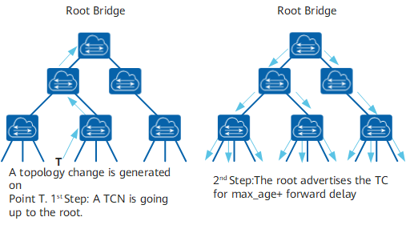
Figure 12-10 TCN sending and TC flooding
After the network topology changes, the downstream device will continuously send TCN BPDUs to the upstream device.
After the upstream device receives the TCN BPDU message from the downstream device, only the designated port processes the TCN BPDU message. Other ports may also receive TCN BPDUs, but will not process them.
The upstream device will set the TCA bit of the Flags in the configuration BPDU message to 1, and then send it to the downstream device to tell the downstream device to stop sending TCN BPDU messages.
The upstream device copies a TCN BPDU and sends it to the root bridge.
Repeat steps 1, 2, 3, and 4 until the root bridge receives a TCN BPDU.
The root bridge sets the TC and TCA bits of the Flags in the configuration BPDU message to 1 and sends it to notify the downstream device to delete the bridge MAC address entry directly.

RSTP

Requirement Background
The 802.1w standard released by the IEEE in 2001 defines the Rapid Spanning Tree Protocol (RSTP), which is based on the STP protocol and makes more detailed modifications and additions to the original STP protocol.
STP deficiencies
Although the STP protocol can solve the loop problem, the slow convergence of the network topology affects the quality of user communication. If the topology in the network changes frequently, the network will also lose connectivity frequently, resulting in frequent interruption of user communication, which is unbearable for users.
The disadvantages of STP are as follows:
STP does not distinguish port status and port role in detail, which is not conducive to beginners' learning and deployment.
The quality of a network protocol often depends on whether the protocol distinguishes each situation carefully.
From the user's point of view, there is no difference between the Listening, Learning and Blocking states, and they also do not forward user traffic.
From the perspective of usage and configuration, the most essential difference between ports is not the state of the port, but the role the port plays.
The root port and the designated port can both be in the Listening state or both in the Forwarding state.
The STP algorithm is a passive algorithm. It relies on the timer to wait to determine the topology change, and the convergence speed is slow.
The STP algorithm requires that in a stable topology, the root bridge actively sends out configuration BPDUs, and other devices process them and spread them throughout the STP network. This is also one of the main reasons for slow topology convergence.
RSTP improves STP
According to the insufficiency of STP, RSTP deletes 3 port states, adds 2 new port roles, and fully decouples port attributes according to state and role; in addition, RSTP also adds some corresponding Enhanced features and protection measures to achieve network stability and rapid convergence, simplifies the understanding and deployment of Spanning Tree Protocol by adding port roles.
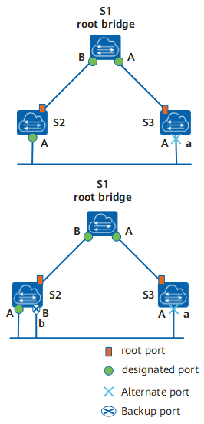
Figure12-11 Port Role Schematic
As shown in the figure above, there are four types of RSTP port roles: root port, designated port, alternate port and backup port.
The functions of the root port and the designated port are the same as those defined in the STP protocol. The description of the alternate port and the backup port is as follows:
From the perspective of configuring BPDU sending:
Alternate port is a port that is blocked due to learning configuration BPDUs sent by other bridges.
The backup port is the port that is blocked due to learning the configuration BPDUs sent by itself.
From a user traffic perspective:
The Alternate port provides an alternate switchable path from the designated bridge to the root, acting as a backup port for the root port.
The Backup port acts as a backup of the designated port, providing another backup path from the root bridge to the corresponding network segment.
The process of assigning roles to all ports in an RSTP network is the process of topology convergence.
Repartition of port state
RSTP state specification reduces the original 5 states to 3. Divided according to whether the port forwards user traffic and learns the MAC address:
If the user traffic is not forwarded and the MAC address is not learned, the port state is Discarding state.
If the user traffic is not forwarded but the MAC address is learned, the port state is the Learning state.
If both user traffic is forwarded and the MAC address is learned, the port state is the Forwarding state.
As shown in Table12-9, the new port state is compared with the port state specified by STP. Port status and port role are not necessarily related. The table shows the port status that various port roles can have.
Table12-9 STP and RSTP Port Status Role Correspondence Table
STP port status | RSTP port status | The role of the port in the topology
Forwarding | Forwarding | Include root port, designated port
Learning | Learning | Include root port, designated port
Listening | Discarding | Include root port, designated port
Blocking | Discarding | Include Alternate port, Backup port
Disabled | Discarding | Include Disable port
The change of the configuration BPDU format makes full use of the Flag field in the STP protocol message and clarifies the port role.
In addition to ensuring that the format of the BPDU is basically the same as the STP format, RSTP has made some minor changes:
Type field, the configuration BPDU type is no longer 0 but 2, so the device running STP will discard the RSTP configuration BPDU when it receives it.
Flags field, using the original reserved middle 6 bits, so the changed configuration BPDU is called RST BPDU, as shown in the following figure.
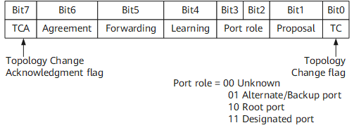
Figure12-12 RSTP Flag field format
- The processing of configuration BPDUs has changed
- Transmission frequency of configuration BPDUs
After the topology is stable, the root bridge sends configuration BPDUs at the interval specified by the Hello Timer. Other non-root bridge devices will trigger configuration BPDUs after receiving the configuration BPDUs sent by the upstream device. This method makes the calculation of the STP protocol complicated and slow. RSTP has been improved, that is, after the topology is stable, no matter whether the non-root bridge device receives the configuration BPDU from the root bridge or not, the non-root bridge device still follows the interval specified by Hello Timer. Sending a configuration BPDU, this behavior is entirely autonomous for each device.
- Shorter BPDU timeout
If a port does not receive a configuration BPDU from an upstream device within 3 consecutive Hello Time, the device considers that the negotiation with this neighbor has failed. Instead of waiting for a Max Age like STP.
- Process inferior BPDUs
When a port receives an RST BPDU from an upstream designated bridge, the port will compare its own stored RST BPDU with the received RST BPDU.
If the priority of the RST BPDU stored by the port is higher than that of the received RST BPDU, the port will directly discard the received RST BPDU and immediately respond to its own stored RST BPDU. When the upstream device receives the RST BPDU responded by the downstream device, the upstream device will immediately update its stored RST BPDU according to the corresponding fields in the received RST BPDU.
Therefore, RSTP processing inferior BPDUs no longer relies on any timer to solve topology convergence through timeout, thus speeding up topology convergence.
- fast convergence
- Proposal/Agreement mechanism
After a port is elected as the designated port, in STP, the port will wait at least one Forward Delay (Learning) time before transitioning to the Forwarding state. In RSTP, this port will first enter the Discarding state, and then quickly enter the Forward state through the Proposal/Agreement mechanism. This mechanism must be used on point-to-point full-duplex links.
Proposal/Agreement mechanism is referred to as P/A mechanism.
- Root port fast switching mechanism
If a root port in the network fails, the optimal alternate port in the network will become the root port and enter the Forwarding state. Because there must be a designated port on the network segment connected through this alternate port that can lead to the root bridge.
Introduction of edge ports
In RSTP, if a designated port is located at the edge of the entire network, that is, it is no longer connected to other switching devices, but directly connected to terminal devices. This port is called an edge port.
The edge port does not receive and process configuration BPDUs, and does not participate in RSTP operations. It can go to the Forwarding state directly from Disable without experiencing delay, just like disabling STP on the port. But once the edge port receives the configuration BPDU, it loses the edge port attributes, becomes a normal STP port, and recalculates the spanning tree, which causes network flapping.
- protection function
The protection functions provided by RSTP are shown in the table below.
Table12-10 Protection function
Protection function | Scene | Principle
BPDU Protection | On switching devices, the ports directly connected to non-switching devices such as user terminals (such as PCs) or file servers are usually configured as edge ports.  Normally, edge ports will not receive RST BPDUs. If someone forges an RST BPDU to maliciously attack a switching device, when an edge port receives an RST BPDU, the switching device will automatically set the edge port as a non-edge port and recalculate the spanning tree, causing network flapping . | After the BPDU protection function is enabled on the switching device, if the edge port receives an RST BPDU, the edge port will be error-down, but the edge port attributes will remain unchanged, and the network management system will be notified at the same time.
Root Protection | Due to the misconfiguration of the maintenance personnel or the malicious attacks in the network, the legitimate root bridges in the network may receive RST BPDUs with higher priority, so that the legitimate root bridges lose their root status, thus causing the network topology Incorrect change of structure. This illegal topology change will cause traffic that should have passed through the high-speed link to be pulled to the low-speed link, causing network congestion. | For the designated port with root protection function enabled, its port role can only remain as designated port. Once a designated port with the root protection function enabled receives a RST BPDU with a higher priority, the port state will enter the Discarding state and will no longer forward packets. After a period of time (usually twice the Forward Delay), if the port has not received RST BPDUs with higher priority, the port will automatically return to the normal Forwarding state.  Description:  Root protection can only be configured on designated ports.

Technical Principles
Proposal/Agreement mechanism
The purpose is to make a designated port enter the Forwarding state as soon as possible. As shown in the figure below, a new link has been added between the root bridge S1 and S2. In the current state, the other ports p2 of S2 are alternate ports, p3 is the designated port and is in the forwarding state, and p4 is the edge port.
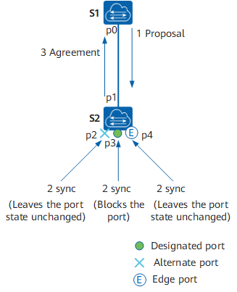
Figure12-13 Proposal/Agreement Process Diagram
After the new link is successfully connected, the P/A mechanism negotiation process is as follows:
- Both ports p0 and p1 will immediately become designated ports and send RST BPDUs.
- The p1 port of S2 received a better RST BPDU, and immediately realized that it would become the root port, not the designated port, and stopped sending RST BPDUs.
- P0 of S1 enters the Discarding state, so the proposal is set to 1 in the sent RST BPDU.
- S2 receives the RST BPDU with proposal sent by the root bridge, and starts to set all its own ports into the sync variable.
- p2 has been blocked and the state remains unchanged; p4 is an edge port and does not participate in the operation; so only the non-edge designated port p3 needs to be blocked.
- After both p2 and p3 enter the Discarding state, the synced variable of the port is set, and the synced of the root port p1 is also set, so the response RST BPDU with the Agreement bit set is returned to S1. This RST BPDU carries the same information as the BPDU sent by the root bridge just now, except that the Agreement bit is set (the Proposal bit is cleared).
- When S1 determines that this is a response to the proposal just sent, port p0 immediately enters the Forwarding state.
The downstream device continues the P/A negotiation process.
In fact, for STP, the selection of the designated port can be completed very quickly. The main speed bottleneck is: in order to avoid loops, it is necessary to wait long enough to make the port status of the entire network all determined, that is Says that all ports must wait for at least one Forward Delay before forwarding. The main purpose of RSTP is to eliminate this bottleneck by blocking its own non-root ports to ensure that there will be no loops. Using the P/A mechanism speeds up the upstream port's transition to the Forwarding state.
RSTP topology change processing
There is only one criterion for detecting topology changes in RSTP: a non-edge port migrates to the Forwarding state.
Once a topology change is detected, the following processing will be performed:
Start a TC While Timer for all non-edge designated ports of this switching device. The timer value is twice the Hello Time.
During this time, clear the MAC addresses learned on all ports.
At the same time, a RST BPDU is sent out from the non-edge port, with TC set. Once the TC While Timer times out, stop sending RST BPDUs.
After receiving the RST BPDU, other switching devices clear all ports to learn the MAC address, except the port that received the RST BPDU. Then also start the TC While Timer for all non-edge designated ports and root ports, and repeat the above process.
In this way, a flood of RST BPDUs will occur in the network.
RSTP and STP interoperability
RSTP can interoperate with STP, but the advantages of RSTP such as fast convergence will be lost at this time.
When a network segment has both STP and RSTP switching devices, the STP switching device will ignore RSTP BPDUs. The switching device running RSTP receives the configuration BPDU sent by the switching device running STP on a port, and after two Hello Time times, it switches its port to STP working mode and sends the configuration BPDU , thus enabling interoperability.

MSTP

Requirement Background
RSTP has been improved on the basis of STP to achieve rapid network topology convergence. But RSTP and STP still have the same defect: because all VLANs in the LAN share a spanning tree, load balancing of data traffic between VLANs cannot be achieved, and the link will not carry any traffic after it is blocked. traffic, resulting in wasted bandwidth, and may also cause some VLAN packets to fail to be forwarded.
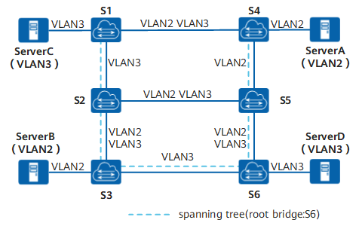
Figure12-14 STP/RSTP defect diagram
In the network shown above, STP or RSTP is applied in the local area network. The spanning tree structure is represented by a dotted line in the figure, and S6 is the root switching device. The links between S2 and S5 and between S1 and S4 are blocked. Except for the links marked 'VLAN2' or 'VLAN3' in the figure, the corresponding VLAN packets are allowed to pass through. The packets of VLAN2 and VLAN3 are not allowed to pass through.
ServerA and ServerB belong to VLAN2, because the link between S2 and S5 is blocked, and the link between S3 and S6 does not allow packets from VLAN2 to pass, so ServerA and ServerB cannot communicate with each other. communicate with each other.
In order to make up for the shortcomings of STP and RSTP, the 802.1S standard released by IEEE in 2002 defines MSTP. MSTP is compatible with STP and RSTP, which can not only converge quickly, but also provide multiple redundant paths for data forwarding to achieve load balancing of VLAN data during data forwarding.
A switching network is divided into multiple regions through MSTP, and multiple spanning trees are formed in each region, and the spanning trees are independent of each other. Each spanning tree is called a Multiple Spanning Tree Instance (MSTI), and each region is called an MST Region (MST Region: Multiple Spanning Tree Region).
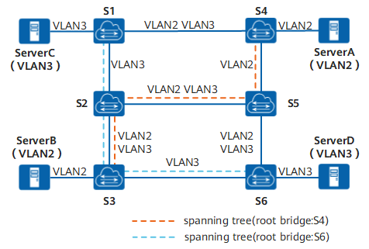
Figure12-15 Multiple spanning trees in the MST region
As shown in the figure above, MSTP connects VLAN and MSTI by setting the VLAN mapping table (that is, the correspondence table between VLAN and MSTI). Each VLAN can only correspond to one MSTI, that is, the data of the same VLAN can only be transmitted in one MSTI, and one MSTI may correspond to multiple VLANs.
After calculation, two spanning trees are finally generated:
MSTI1 uses S4 as the root switching device to forward packets of VLAN2.
MSTI2 uses S6 as the root switching device to forward packets of VLAN3.
In this way, all VLANs can communicate with each other, and packets of different VLANs are forwarded along different paths, realizing load balancing.

Basic Concepts
MSTP Network
As shown in the figure below, the MSTP network contains one or more MST regions (MST Regions), and each MST Region contains one or more MSTIs. MSTI is composed of switching equipment running STP/RSTP/MSTP. MSTI is a tree network formed by all switching equipment running STP/RSTP/MSTP after MSTP protocol calculation.
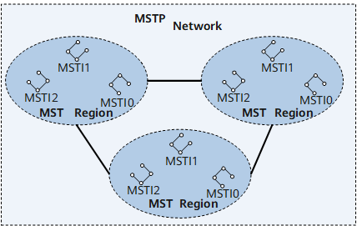
Figure12-16 MSTP Network Diagram
MST Region
The MST region is a Multiple Spanning Tree Region, which consists of multiple switching devices in the switching network and the network segments between them. Devices in the same MST region have the following characteristics:
- MSTP is enabled.
- Has the same region name.
- Has the same VLAN to Spanning Tree instance mapping configuration.
- Has the same MSTP revision level configuration.
A LAN can have multiple MST regions, and the MST regions are physically connected directly or indirectly. Users can divide multiple switching devices into the same MST region through MSTP configuration commands.
As shown in the figure below, MST Region D0 consists of switching devices S1, S2, S3 and S4, and there are 3 MSTIs in the region.
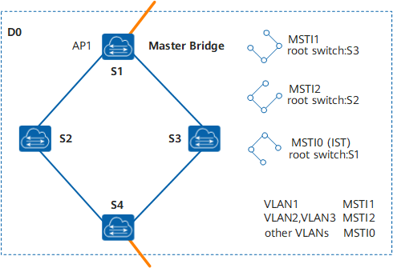
Figure12-17 Basic Concept Diagram of MST Region
VLAN mapping table
VLAN mapping table is an attribute of MST region, which describes the mapping relationship between VLAN and MSTI.
As shown in the figure above, the VLAN mapping table of MST region D0 is:
VLAN1 maps to MSTI1
VLAN2 and VLAN3 are mapped to MSTI2
The rest of the VLANs are mapped to MSTI0
Regional Root
Regional Root is divided into IST (Internal Spanning Tree) regional root and MSTI regional root.
The IST regional root is shown in Figure12-19. In B0, C0 and D0, the switching device closest to the total root (CIST Root) in the IST spanning tree is the IST regional root.
Multiple spanning trees can be generated in one MST region, and each spanning tree is called an MSTI. The MSTI regional root is the root of each multiple spanning tree instance. As shown in Figure12-18, different MSTIs in the region have their own regional root.
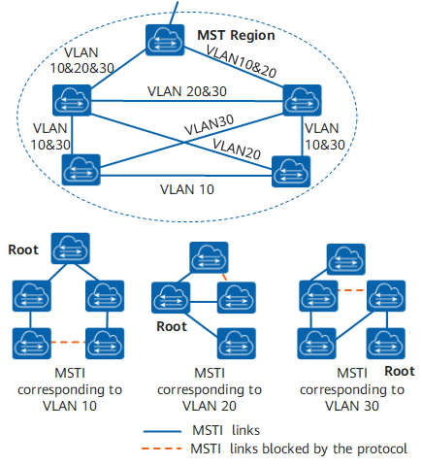
Figure12-18 MSTI basic concept diagram
MSTIs are independent of each other, and MSTIs can correspond to one or more VLANs. But a VLAN can only correspond to one MSTI.
Master Bridge
The Master Bridge, also known as the IST Master, is the switching device closest to the root in the region. S1 as in
Figure12-17.
If the master root is in the MST region, then the master root is the master bridge for this region.
CIST Root
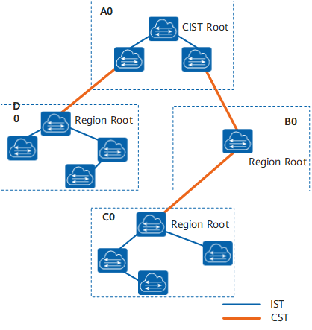
Figure12-19 MSTP network basic concept diagram
As shown above, the total root is the root bridge of CIST (Common and Internal Spanning Tree). The total root is a device in area A0.
CST
Common Spanning Tree (CST) is a spanning tree that connects all MST regions in a switched network.
If each MST region is regarded as a node, the CST is a spanning tree calculated and generated by these nodes through the STP or RSTP protocol.
As shown in Figure12-19, thicker lines connect fields to form CST.
IST
Internal Spanning Tree IST (Internal Spanning Tree) is a spanning tree in each MST region.
IST is a special MSTI, the ID of MSTI is 0, usually called MSTI0.
IST is a fragment of CIST in the MST region.
As shown in Figure12-19, the thinner lines in the region connect all switching devices in the region to form the IST.
CIST
Common and Internal Spanning Tree CIST is calculated and generated by STP or RSTP protocol, connecting all switching devices in a single spanning tree in a switching network.
As shown in Figure12-19, the IST plus CST of all MST regions constitutes a complete spanning tree, namely CIST.
SST
There are two cases of forming a single spanning tree SST (Single Spanning Tree):
A switching device running STP or RSTP can only belong to one spanning tree.
There is only one switching device in the MST region, and this switching device constitutes a single spanning tree.
As shown in Figure12-19, the switching device in B0 is a single spanning tree.
Port role
MSTP adds 2 new ports based on RSTP. MSTP has 7 port roles: root port, designated port, alternate port, backup port, edge port, master port and regional edge port.
The functions of root port, designated port, alternate port, backup port and edge port are the same as those defined in RSTP protocol. All port roles defined in MSTP are shown in the following table.
Table12-11 Port Role
Port Role | Description
Root port | On a non-root bridge, the port closest to the root bridge is the root port of this switch. The root switch device has no root port.  The root port is responsible for forwarding data to the root of the tree.  As shown in Figure12-20, S1 is the root bridge, CP1 is the root port of S3, and BP1 is the root port of S2.
Designated port | For a switching device, its designated port is the port that forwards BPDUs to downstream switching devices.  As shown in Figure12-20, AP2 and AP3 are designated ports of S1, and CP2 is designated port of S3.
Alternate port | From the perspective of sending configuration BPDUs, the alternate port is a port that is blocked by learning configuration BPDUs sent by other bridges.  From a user traffic perspective, the Alternate port provides another switchable path from the designated bridge to the root, acting as a backup port to the root port.  As shown in Figure12-20, BP2 is an alternate port.
Backup port | From the perspective of sending configuration BPDUs, the Backup port is a port that is blocked by learning the configuration BPDUs sent by itself.  From the perspective of user traffic, the Backup port acts as a backup of the designated port, providing another backup path from the root node to the leaf node.  As shown in Figure12-20, CP3 is the backup port.
Master port | The master port is the port on the shortest path among all paths connecting the MST region to the general root. It is the port on the switching device that connects the MST region to the general root.  The master port is the only way for packets in the region to go to the master root.  The master port is a special regional edge port. The role of the master port on the CIST is the root port, and the role of the master port on other instances is the master port.  As shown in Figure12-21, the switching devices S1, S2, S3, S4 and the links between them constitute an MST region, and the port AP1 of the S1 switching device is in all ports in the region to the total root The path cost is the least, so AP1 is the master port.
Regional Edge Port | A regional edge port is a port located at the edge of an MST region and connected to other MST regions or SSTs.  When performing MSTP calculations, the role of the regional edge port on the MSTI is the same as the role of the CIST instance. That is, if the role of the edge port on the CIST instance is the Master port (the port on the shortest path among all paths connecting the region and the general root), then its role on all MSTIs in the region is also the Master port.  As shown in Figure12-21, AP1, DP1 and DP2 in the MST region are directly connected to other regions, and they are all regional edge ports in this MST region.  The role of regional edge ports on spanning tree instances is the same as on CIST. For example, in Figure12-21, AP1 is the regional edge port, and its role in the CIST is the master port, then the role of AP1 in all spanning tree instances in the MST region is the master port.
Edge Port | If the designated port is located at the edge of the entire region and is no longer connected to any switching device, this port is called an edge port.  Edge ports are generally connected directly to user terminal equipment.  After the MSTP function is enabled on a port, the automatic edge port detection function will be enabled by default. When the port does not receive BPDUs within (2 × Hello Timer + 1) seconds, the port will be automatically set to Edge port, otherwise set to non-edge port.
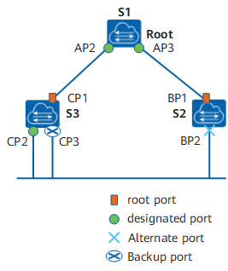
Figure12-20 Root Port, Designated Port, Alternate Port and Backup Port Schematic
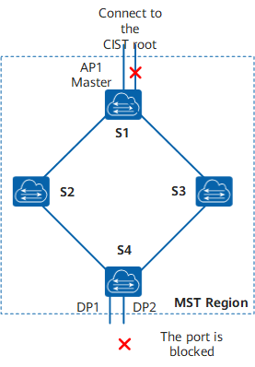
Figure12-21 Master Port and Regional Edge Port Diagram
MSTP port status
The port state defined by MSTP is the same as that defined in the RSTP protocol, as shown in the following table.
Table12-12 Port Status
Port Status | Description
Forwarding | In this state, the port both forwards user traffic and receives/sends BPDUs.
Learning | This is a transitional state. Under Learning, the switching device will build a MAC address table according to the received user traffic, but will not forward the user traffic, so it is called the learning state.  The port in the Learning state receives/sends BPDUs and does not forward user traffic.
Discarding | The port in Discarding state only receives BPDU packets.
Port status and port role are not necessarily related. The following table shows the port status that various port roles can have.
Table12-13 Port Status and Port Role Correspondence Table
Port Status | Root Port/Master Port | Designated port | Regional Edge Port | Alternate port | Backup port
Forwarding | Yes | Yes | Yes | No | No
Learning | Yes | Yes | Yes | No | No
Discarding | Yes | Yes | Yes | Yes | Yes
Yes: indicates the port support status. No: indicates that the port is not supported.

Message Format
MSTP uses Multiple Spanning Tree Bridge Protocol Data Unit (MST BPDU) as the basis for spanning tree calculation. MST BPDUs are used to calculate spanning tree topology, maintain network topology, and communicate topology change records.
The difference between configuration BPDUs defined in STP, RST BPDUs defined in RSTP, MST BPDUs defined in MSTP, and TCN BPDUs is shown in the following table.
Table12-14 Four BPDU Difference Comparison
Version | Type | Name
0 | 0x00 | Configuration BPDU
0 | 0x80 | TCN BPDU
2 | 0x02 | RST BPDU
3 | 0x02 | MST BPDU
MSTP message format
The structure of the MST BPDU is shown in the figure below.
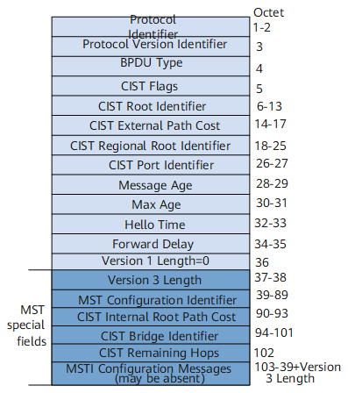
Figure12-22 MST BPDU structure
Whether it is an intra-region MST BPDU or an inter-region MST BPDU, the first 36 bytes are the same as the RST BPDU.
Starting from the 37th byte is an MSTP-specific field. The last MSTI configuration information field consists of several MSTI configuration information groups concatenated.
The main information in the MST BPDU is shown in the table below.
Table12-15 Main information description in MST BPDU
Field Content | bytes | Description
Protocol Identifier | 2 | Protocol identifier.
Protocol Version Identifier | 1 | Protocol version identifier, STP is 0, RSTP is 2, MSTP is 3.
BPDU Type | 1 | BPDU type:  0x00: Configuration BPDU of STP  0x80: STP TCN BPDU (Topology Change Notification BPDU)  0x02: RST BPDU (Rapid Spanning-Tree BPDU) or MST BPDU (Multiple Spanning-Tree BPDU)
CIST Flags | 1 | CIST flag field.
CIST Root Identifier | 8 | CIST 's total root exchange device ID.
CIST External Path Cost | 4 | The CIST external path cost refers to the cumulative path cost from the MST region to which this switching device belongs to the MST region to which the CIST root switching device belongs. CIST external path cost is calculated based on link bandwidth.
CIST Regional Root Identifier | 8 | Indicates the ID of the regional root switching device on the CIST, that is, the IST master ID. If the root is in this region, the CIST Regional Root Identifier is the same as the CIST Root Identifier.
CIST Port Identifier | 2 | The designated port ID of this port in IST.
Message Age | 2 | BPDU lifetime.
Max Age | 2 | The maximum lifetime of a BPDU packet. If the timeout expires, the link to the root switching device is considered to be faulty.
Hello Time | 2 | Hello timer, the default is 2 seconds.
Forward Delay | 2 | Forward Delay timer, the default is 15 seconds.
Version 1 Length | 1 | Version1 BPDU length, the value is fixed to 0.
Version 3 Length | 2 | Version3 length of BPDU.
MST Configuration Identifier | 51 | MST configuration identifier, indicating the label information of the MST region, including 4 fields.
CIST Internal Root Path Cost | 4 | CIST internal path cost refers to the cumulative path cost from this port to the IST Master switching device. CIST internal path cost is calculated based on link bandwidth.
CIST Bridge Identifier | 8 | Indicates the ID of the designated switching device on the CIST.
Indicates the remaining hops of the BPDU in the CIST. | 1 | The remaining hops of the BPDU in the CIST.
MSTI Configuration Messages(may be absent) | 16 | MSTI configuration information. The configuration information of each MSTI occupies 16 bytes. If there are n MSTIs, it occupies n×16 bytes.
The maximum number of BPDUs that the port can send within each Hello Time is configurable
Hello Time is used by the Spanning Tree Protocol to periodically send configuration messages to maintain the stability of the spanning tree. If the switching device does not receive a BPDU within a period of time, it will recalculate the spanning tree due to message timeout.
When a switching device becomes the root switching device, the switching device will send BPDUs at the interval of the set value. The non-root switching device adopts the Hello Time value set by the root switching device.

Topology Calculation
MSTP rationale
MSTP can divide the entire Layer 2 network into multiple MST regions, and CST is generated between each region through calculation. In the region, multiple spanning trees are generated by calculation, and each spanning tree is called a multiple spanning tree instance. where instance 0 is called IST, and the other multiple spanning tree instances are MSTI. MSTP, like STP, uses configuration messages to calculate spanning tree, but the configuration messages carry the configuration information of MSTP on the device.
priority vector
Both MSTI and CIST are calculated from priority vectors, which are included in the MST BPDU. The switching devices exchange MST BPDUs with each other to generate MSTI and CIST.
- Introduction to Priority Vectors
The priority vector participating in the CIST calculation is:
< Root Switch ID, External Path Cost, Regional Root ID, Internal Path Cost, Designated Switch ID, Designated Port ID, Receive Port ID >
The priority vector participating in MSTI calculation is:
< Regional Root ID, internal path cost, designated switching device ID, designated port ID, receiving port ID >
The priority of the vectors in parentheses decreases from left to right.
The following table explains each priority vector.
Table12-16 Vector Description
Vector Name | Description
Root Switch Device ID | The root switch ID is used to select the root switch in CIST. Root Switch ID = Priority(16bits) + MAC(48bits).  Where Priority is the priority of MSTI0.
External Path Cost (ERPC) | Path cost from the regional root of CIST to the total root. The external path cost stored on all switching devices in the MST region is the same. If the CIST root switching device is in the region, the external path cost stored on all switching devices in the region is 0.
Regional Root ID | Regional Root ID is used to select the regional root in MSTI. Regional Root ID = Priority(16bits) + MAC(48bits).  Where Priority is the priority of MSTI0.
Internal Path Cost (IRPC) | The path cost of this bridge to reach the regional root. The internal path cost stored by the regional edge port is greater than the internal path cost stored by the non-regional edge port.
Specify switch device ID | The designated switching device of the CIST or MSTI instance is the nearest upstream bridge from this bridge to the regional root. If this bridge is the general root or regional root, specify the switching device as itself.
Specify port ID | Specify the port on the switching device that is connected to the root port on this device. Port ID = Priority(4 digits) + Port number(12 digits). The port priority must be an integer multiple of 16.
Receive port ID | The port that received the BPDU. Port ID = Priority(4 digits) + Port number(12 digits). The port priority must be an integer multiple of 16.
- Comparison Principle
Comparing the same vector, the vector with the smallest value has the highest priority.
The priority vector comparison principle is as follows.
First, compare the root swap device ID.
If the root switch device ID is the same, then compare the external path cost.
If the external path cost is the same, then compare the regional root ID.
If the regional root ID is still the same, compare the internal path costs.
If the internal path is still the same, then compare the designated switch ID.
If the designated switch device ID is still the same, then compare the designated port ID.
If the designated port ID is still the same, then compare the receiving port ID.
If the configuration message contained in the BPDU received by the port is better than the configuration message saved on the port, the configuration message originally saved on the port is replaced by the newly received configuration message. The port also updates the global configuration message saved by the switching device. On the contrary, the newly received BPDU is discarded.
- Calculation of CIST
After comparing the configuration messages, select a switching device with the highest priority in the entire network as the root of the CIST. MSTP generates IST through calculation in each MST region; at the same time, MSTP treats each MST region as a single switching device, and generates CST between MST regions through calculation. CST and IST constitute the CIST of the entire switching device network.
- Calculation of MSTI
In the MST region, MSTP generates different spanning tree instances for different VLANs according to the mapping relationship between VLANs and spanning tree instances. Each spanning tree is calculated independently, and the calculation process is similar to that of STP.
Characteristics of MSTI:
Each MSTI calculates its own spanning tree independently and does not interfere with each other.
The spanning tree calculation method of each MSTI is basically the same as that of STP.
The spanning tree for each MSTI can have different roots and different topologies.
Each MSTI sends BPDUs within its own spanning tree.
The topology of each MSTI is determined by command configuration.
The spanning tree parameters can be different for each port on different MSTIs.
Each port can have different roles and states on different MSTIs.
In a network running MSTP protocol, a VLAN packet will be forwarded along the following path:
In the MST region, forward along its corresponding MSTI.
Forwarding along CST between MST regions.
- MSTP handling of topology changes
MSTP topology change processing is similar to RSTP topology change processing, please refer to RSTP topology change processing.

Fast Convergence
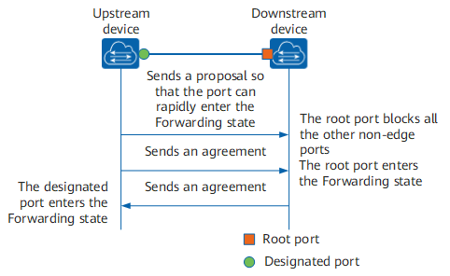
Figure12-23 P/A of MSTP Mechanism
As shown in the figure above, in MSTP, the P/A mechanism works as follows:
The upstream device sends a Proposal message requesting fast migration. After the downstream device receives it, it sets the port connected to the upstream device as the root port, and blocks all non-edge ports.
The upstream device continues to send Agreement packets. After the downstream device receives it, the root port changes to the Forwarding state.
The downstream device responds to the Agreement message. After the upstream device receives it, it sets the port connected to the downstream device as the designated port, and the designated port enters the Forwarding state.

Standard Specification
The protocol specifications related to spanning tree are:
• IEEE 802.1D: Media Access Control (MAC) Bridges
• IEEE 802.1w:Part 3: Media Access Control (MAC) Bridges—Amendment 2: Rapid Reconfiguration
• IEEE 802.1s: Virtual Bridged Local Area Networks—Amendment 3: Multiple Spanning Trees

Configuring

Default Configuration
Parameters | Default
Working mode | RSTP mode
Status | Global disabled, enabled on all ports
Device priority | 32768
Port Priority | 128
Calculation method of path cost | Dot1t, the IEEE 802.1t standard
Forward Delay Time | 1500 centiseconds (15 seconds)
Hello Time | 200 centiseconds (2 seconds)
Max Age Time | 2000 centiseconds (20 seconds)

Configure STP Mode and Status
- Configure STP Mode
Command | SWITCH(config)#spanning-tree mode <stp | rstp | mstp>
Description | stp：Spanning tree protocol(IEEE 802.1d)  rstp：Rapid spanning tree protocol(IEEE 802.1w)  mstp：Multiple spanning tree protocol(IEEE 802.1s)  The default is rstp mode. After the mode is switched, the spanning tree protocol is disabled by default and needs to be re-enabled.  Global configuration mode.
- Enable Spanning Tree Protocol
Command | SWITCH(config)#spanning-tree enable  SWITCH(config)#no spanning-tree enable
Description | Enable/disable STP function; default disabled.  Global configuration mode.

Configure STP Election Parameters
- Configure Device Priority
Command | SWITCH(config)#spanning-tree priority <0-61440>  SWITCH(config)#no spanning-tree priority  SWITCH(config)#spanning-tree instance <1-63> priority <0-61440>  SWITCH(config)#no spanning-tree instance <1-63> priority
Description | Configure/delete STP system priority; default 32768. Optional configuration.  Global configuration mode.
- Configure Port Priority
Command | SWITCH(config-if)#spanning-tree priority <0-240>  SWITCH(config-if)#spanning-tree instance <1-63> priority <0-240>
Description | Configure port STP priority; default 128. Optional configuration.  Interface configuration mode.
- Configure Port Path Cost
Command | SWITCH(config-if)#spanning-tree path-cost <1-200000000>  SWITCH(config-if)#no spanning-tree path-cost
Description | Configure/reset path cost of port; optional configuration.  Interface configuration mode.

Configure Topology Convergence Parameters
- Configure Hello Time
Command | SWITCH(config)#spanning-tree hello-time <1-10>  SWITCH(config)#no spanning-tree hello-time
Description | Configure/reset the BPDU packet period, in seconds; the default is 2s. Optional configuration.  Global configuration mode.
- Configure Forward-Delay Time
Command | SWITCH(config)#spanning-tree forward-time <4-30>  SWITCH(config)#no spanning-tree forward-time
Description | Config/reset STP port forwarding state delay time, in seconds; default is 15s. Optional configuration.  Global configuration mode.
- Configure Max-Age Time
Command | SWITCH(config)#spanning-tree max-age <6-40>  SWITCH(config)#no spanning-tree max-age
Description | Configure/reset the lifetime of BPDU packets, in seconds; the default is 20s. Optional configuration.  Hello Time, Forward-Delay Time, Max-Age Time need to follow the conditions: 2*(Hello Time + 1.0 seconds) <= Max-Age Time <= 2*(Forward-Delay – 1.0 seconds), otherwise it may lead to topology instability.  The longest path of the STP/RSTP network is affected by this parameter. The default longest path is 20 devices. When there are more than 20 devices, the configuration needs to be modified (forward-delay 21s, max-age 40s can be configured) , the maximum support for the longest path is 40.  Global configuration mode.
- Configure Max-Hops
Command | SWITCH(config)#spanning-tree max-hops <1-40>  SWITCH(config)#no spanning-tree max-hops
Description | Configure/reset the maximum hop count for BPDU packets; the default is 20. Optional configuration.  The longest path of the MSTP network is affected by this parameter. When there are more than 20 devices, the configuration needs to be modified, and the maximum is 40.  MSTP is compatible with the max-age function, you need to adjust the max-age parameter at the same time, refer to the corresponding command.  Global configuration mode.

Configure Edge Port
- Configure Edge Port
Command | SWITCH(config-if)#spanning-tree <edgeport | autoedge>  SWITCH(config-if)#no spanning-tree <edgeport | autoedge>
Description | Configure/delete the port Edge Port; if configured as edgeport, it means that the device directly connected to the port is not a bridge device and can be forwarded quickly; if configured as autoedge, it means that the port automatically identifies whether it is an edge port according to BPDU; it is disabled by default; Select configuration.  Interface configuration mode.
- Open Portfast
Command | SWITCH(config-if)#spanning-tree portfast  SWITCH(config-if)#no spanning-tree portfast
Description | Configure/delete port portfast; the port will be forwarded directly after opening portfast. But the Port Fast Operational State will be disabled due to the receipt of BPDUs, so that it can normally participate in the STP algorithm and forwarding; it is disabled by default; optional configuration.  Interface configuration mode.

Configure MST Parameters
- Enter MST Configuration Mode
Command | SWITCH(config)#spanning-tree mst configuration
Description | Enter MST configuration mode.  Global configuration mode.
- Configure MST VLAN Instance
Command | SWITCH(config-mst)# instance <1-63> vlan VLANID  SWITCH(config-mst)# no instance <1-63> vlan VLANID
Description | Configure/delete the association between MST instance and VLAN; optional configuration.  MST configuration mode.
- Configure MST Region Name
Command | SWITCH(config-mst)#region NAME  SWITCH(config-mst)#no region NAME
Description | Configure/delete MST area name; optional configuration.  MST configuration mode.
- Configure MST Version
Command | SWITCH(config-mst)#revision <0-65535>
Description | Configure/delete the MST version number, the default is 0; optional configuration.  MST configuration mode.
- Configure MSTI Port
Command | SWITCH(config-if)# spanning-tree instance <1-63>  SWITCH(config-if)# no spanning-tree instance <1-63>
Description | Configure/delete port-instance association; optional configuration.  By default, when configuring the instance and VLAN relationship, the system will automatically generate port and instance relationship data based on the VLAN and port relationship, and no manual configuration is required.  After the instance configuration is ready, if the relationship between ports and VLANs is manually modified, such as adding/exiting all VLANs of an instance to ports, you need to manually maintain the relationship between ports and instances through this command.  When there are major configuration changes, it is recommended to automatically generate port and instance data by reconfiguring the instance-VLAN relationship or restarting the device.  MST configuration mode.

Configuration Protection Function
- Configure Root Guard
Command | SWITCH(config-if)# spanning-tree guard root  SWITCH(config-if)#no spanning-tree guard root
Description | Configure/delete port root guard; when the root guard function is enabled on an interface, the port role on all instances is forced to be the designated port. Once the port receives configuration information with a higher priority, the root guard The function will put the interface into the blocked state; default closed; optional configuration.  Interface configuration mode.
- Configure BPDU Guard
Command | SWITCH(config)#spanning-tree portfast bpdu-guard  SWITCH(config)#no spanning-tree portfast bpdu-guard  SWITCH(config-if)#spanning-tree portfast  SWITCH(config-if)#no spanning-tree portfast  or:  SWITCH(config-if)#spanning-tree bpdu-guard enable  SWITCH(config-if)#spanning-tree bpdu-guard disable
Description | Configure/delete BPDU Guard; after the port has BPDU Guard enabled, if a BPDU is received on the port, it will enter the Error-disabled (blocked) state; optional configuration.  Interface configuration mode.
- Configure BPDU Filter
Command | SWITCH(config)#spanning-tree portfast bpdu-filter  SWITCH(config)#no spanning-tree portfast bpdu-filter  SWITCH(config-if)#spanning-tree portfast  SWITCH(config-if)#no spanning-tree portfast  or:  SWITCH(config-if)#spanning-tree bpdu-filter enable  SWITCH(config-if)#spanning-tree bpdu-filter disable
Description | Configure/delete BPDU Filter; after the port opens BPDU Filter, it neither sends BPDU nor receives BPDU message; optional configuration.  Interface configuration mode.
- Configure TC Notification
Command | SWITCH(config-if)#spanning-tree restricted-tcn  SWITCH(config-if)#no spanning-tree restricted-tcn  SWITCH(config-if)#spanning-tree instance <1-63> restricted-tcn  SWITCH(config-if)#no spanning-tree instance <1-63> restricted-tcn
Description | Configure/reset the topology change notification limit. After configuration, the port will not forward TC BPDUs, nor refresh the address table; optional configuration.  Interface configuration mode.

- Configure Error Port Recover Time
Command | SWITCH(config)#spanning-tree errdisable-timeout enable  SWITCH(config)#no spanning-tree errdisable-timeout enable  SWITCH(config)#spanning-tree errdisable-timeout interval <10-1000000>  SWITCH(config)#no spanning-tree errdisable-timeout interval
Description | Configure/reset error port timeout feature.  By default, the error port timeout function is not enabled, that is, the error port will never timeout and automatically recover, and must be recovered manually.  The timeout unit is seconds, the default is 300 seconds;  Optional configuration.  Global configuration mode.

Other Optional Configuration
- Configure Transmit-Holdcount
Command | SWITCH(config)#spanning-tree transmit-holdcount <1-10>  SWITCH(config)#no spanning-tree transmit-holdcount
Description | Configure/reset the maximum number of BPDUs sent per second; default is 6. Optional configuration.  Global configuration mode.
- Configure Link-Type
Command | SWITCH(config-if)#spanning-tree link-type <auto | point-to-point | shared>  SWITCH(config-if)#no spanning-tree link-type
Description | Configure/reset link type, default is auto. Optional configuration.  auto: Automatic setting mode based on the duplex capability of link negotiation, full duplex is point-to-point connection.  point-to-point: Enable fast forwarding.  shared: Fast Forwarding is disabled.  Interface configuration mode.
- Configure Protocol Migration Processing
Command | SWITCH#clear spanning-tree detected protocols
Description | Force version checking on all ports.  Execution mode.
- Configure Logging
Command | SWITCH(config)#spanning-tree logging  SWITCH(config)#no spanning-tree logging
Description | Configure logging.  Global configuration mode.

Examples

Example for Configuring RSTP
Simplified topology:
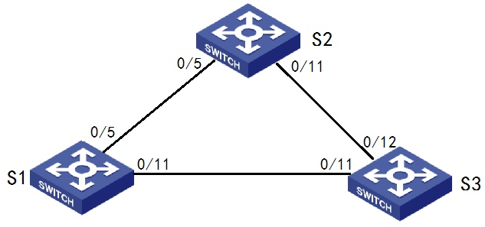
User P1 goes under S1, P2 goes under S2, P3{ 5> followed by S3;

Requirement description:
When the network is not faulty, the communication between users (ping)is ok
When the network has a single chain failure, the communication between users is still ok

Typical configuration:
S1/S2/S3:
- Enter global configuration mode, configure to use rstp mode, enable stp switch:
Use rstp mode
spanning-tree mode rstp
Enable stp switch
spanning-tree enable

Example for Configuring MSTP
Simplified topology:
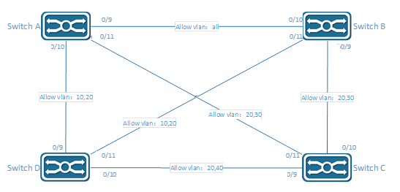
Requirement description:
Users in the same VLAN communicate normally when the network is normal
Improve network reliability through redundant links; for example, for VLAN 10 20, a single link failure between Switch ABDs does not affect the communication of users under it.

Configuration plan:
The devices belong to the same region, the default ‘Default’ region is used here, no additional configuration is required
VLAN 20 is a shared vlan and is directly assigned to CST
Instance | VLAN
0 | 20
1 | 10
3 | 30
4 | 40
Typical configuration:
Switch A :
# Configure VLAN and port
SWITCH(config)#vlan 10,20,30,40
SWITCH(config)#interface gigabitEthernet0/9
SWITCH(config-if)#switchport mode trunk
SWITCH(config)#interface gigabitEthernet0/10
SWITCH(config-if)#switchport mode trunk
SWITCH(config-if)#switchport trunk allowed vlan 10,20
SWITCH(config)#interface gigabitEthernet0/11
SWITCH(config-if)#switchport mode trunk
SWITCH(config-if)#switchport trunk allowed vlan 20,30
# Configure MSTP instance
SWITCH(config)#spanning-tree mode mstp
SWITCH(config)#spanning-tree mst configuration
SWITCH(config-mst)#instance 1 vlan 10
SWITCH(config-mst)#instance 3 vlan 30
SWITCH(config-mst)#instance 4 vlan 40
# Enable MSTP
SWITCH(config)#spanning-tree enable
Switch B:
# Configure VLAN and port
SWITCH(config)#vlan 10,20,30,40
SWITCH(config)#interface gigabitEthernet0/9
SWITCH(config-if)#switchport mode trunk
SWITCH(config-if)#switchport trunk allowed vlan 20,30
SWITCH(config)#interface gigabitEthernet0/10
SWITCH(config-if)#switchport mode trunk
SWITCH(config)#interface gigabitEthernet0/11
SWITCH(config-if)#switchport mode trunk
SWITCH(config-if)#switchport trunk allowed vlan 10,20
# Configure MSTP instance
SWITCH(config)#spanning-tree mode mstp
SWITCH(config)#spanning-tree mst configuration
SWITCH(config-mst)#instance 1 vlan 10
SWITCH(config-mst)#instance 3 vlan 30
SWITCH(config-mst)#instance 4 vlan 40
# Enable MSTP
SWITCH(config)#spanning-tree enable
Switch C:
# Configure VLAN and port
SWITCH(config)#vlan 10,20,30,40
SWITCH(config)#interface gigabitEthernet0/9
SWITCH(config-if)#switchport mode trunk
SWITCH(config-if)#switchport trunk allowed vlan 20,40
SWITCH(config)#interface gigabitEthernet0/10
SWITCH(config-if)#switchport mode trunk
SWITCH(config-if)#switchport trunk allowed vlan 20,30
SWITCH(config)#interface gigabitEthernet0/11
SWITCH(config-if)#switchport mode trunk
SWITCH(config-if)#switchport trunk allowed vlan 20,30
# Configure MSTP instance
SWITCH(config)#spanning-tree mode mstp
SWITCH(config)#spanning-tree mst configuration
SWITCH(config-mst)#instance 1 vlan 10
SWITCH(config-mst)#instance 3 vlan 30
SWITCH(config-mst)#instance 4 vlan 40
# Enable MSTP
SWITCH(config)#spanning-tree enable
Switch D:
# Configure VLAN and port
SWITCH(config)#vlan 10,20,30,40
SWITCH(config)#interface gigabitEthernet0/9
SWITCH(config-if)#switchport mode trunk
SWITCH(config-if)#switchport trunk allowed vlan 10,20
SWITCH(config)#interface gigabitEthernet0/10
SWITCH(config-if)#switchport mode trunk
SWITCH(config-if)#switchport trunk allowed vlan 20,40
SWITCH(config)#interface gigabitEthernet0/11
SWITCH(config-if)#switchport mode trunk
SWITCH(config-if)#switchport trunk allowed vlan 10,20
# Configure MSTP instance
SWITCH(config)#spanning-tree mode mstp
SWITCH(config)#spanning-tree mst configuration
SWITCH(config-mst)#instance 1 vlan 10
SWITCH(config-mst)#instance 3 vlan 30
SWITCH(config-mst)#instance 4 vlan 40
# Enable MSTP
SWITCH(config)#spanning-tree enable

Display Information
- View STP status
SWITCH# show spanning-tree
- View MSTP instance status
SWITCH# show spanning-tree mst instance <1-63>

Configuring MAC Address

Overview of MAC Address
The MAC address table contains address information that the switch uses to forward traffic between ports. The switch sends packets between any combination of ports, based on the destination address of the received packet. Using the MAC address table, the switch forwards the packet only to the port associated with the destination address. If the destination address is on the port that sent the packet, the packet is filtered and not forwarded.
The MAC address table includes these types of addresses:
Dynamic address: a source MAC address that the switch learns and then ages when it is not in use.
Static address: a manually entered unicast address that does not age and that is not lost when the switch resets.
Filter address: Also a static MAC address, but drop the packet with the specified source or destination unicast filter address.
All addresses are associated with a VLAN. An address can exist in more than one VLAN and have different destinations in each. Each VLAN maintains its own logical address table. A known address in one VLAN is unknown in another until it is learned or statically associated with a port in the other VLAN.
Dynamic addresses are source MAC addresses that the switch learns and then ages when they are not in use. You can change the aging time setting for all VLANs or for a specified VLAN. Setting too short an aging time can cause addresses to be prematurely removed from the table. Then when the switch receives a packet for an unknown destination, it floods the packet to all ports in the same VLAN as the receiving port. This unnecessary flooding can impact performance. Setting too long an aging time can cause the address table to be filled with unused addresses, which prevents new addresses from being learned.

Configuring
● Changing MAC Address Aging Time
Command | SWITCH(config)#mac-address-table aging-time <0-600>  SWITCH(config)#no mac-address-table aging-time
Description | Set the length of time that a dynamic entry remains in the MAC address table.  The range is 1 to 600 seconds.  The default is 300 seconds.  You can also enter 0, which disables aging.
● Adding Static MAC Address Entries
Command | SWITCH(config)#mac-address-table static MAC_ADDR vlan VLANID interface IFNAME  SWITCH(config)#no mac-address-table static MAC_ADDR vlan VLANID interface IFNAME
Description | Add a static address to the MAC address table.  MAC_ADDR: specify the destination MAC unicast address to add to the address table. Packets with this destination address received in the specified VLAN are forwarded to the specified interface.  VLANID: specify the VLAN for which the packet with the specified MAC address is received, Valid VLAN IDs are 1 to 4094.  IFNAME: specify the interface to which the received packet is forwarded, Valid interfaces include physical ports or port channels.

● Adding Filter MAC Address Entries
Command | SWITCH(config)#mac-address-table filter MAC_ADDR vlan VLANID  SWITCH(config)#no mac-address-table filter MAC_ADDR vlan VLANID
Description | Add a filter address to the MAC address table.  VLANID: specify the VLAN for which the packet with the specified MAC address is received, Valid VLAN IDs are 1 to 4094.  IFNAME: specify the interface to which the received packet is dropped, Valid interfaces include physical ports or port channels.
● Clearing Dynamic MAC Address Entries
Command | SWITCH#clear mac-address-table dynamic  SWITCH#clear mac-address-table dynamic vlan VLANID  SWITCH#clear mac-address-table dynamic interface IFNAME
Description | Clear Dynamic Mac Address Entries.  Support all, based on vlan or based on interface options.
● Enable/disable Port MAC Address Learning
Mainly used in the following scenarios：
When the network is relatively stable and the MAC addresses of the packets are relatively fixed, the device does not need to continue to learn the MAC addresses of all other packets. At this time, by applying a flow policy, the MAC address learning function is disabled for all traffic classifications under the policy, which can not only save the cost of MAC address entries, but also improve the operation efficiency of the device.
Some illegal users sometimes attack the network by changing the MAC address frequently. At this time, by applying the flow policy, and disabling the MAC address learning function for all traffic classifications under the policy, the device MAC address table caused by such attacks can be avoided. Item overflow problem to protect device performance from being affected.
Command | SWITCH(config-if)#mac-address-table learning disable action (forward | drop)  SWITCH(config-if)#no mac-address-table learning disable
Description | This command supports physical ports and AP ports, but does not support AP member ports.  Disabling the port MAC address learning function.  forward: If there is a matching entry in the MAC address table, the packet is forwarded according to the MAC table; if there is no matching entry, the packet is broadcast.  discard: If there is a matching entry in the MAC address table, the packet is forwarded according to the MAC table; if there is no matching entry, the packet is discarded.  The default port MAC address learning is enabled.
● Port MAC Address Learning Limit
In order to control the number of access users or prevent the MAC address table from being attacked, you can limit the number of MAC addresses that the switch module is allowed to learn, so as to control the number of access users to improve network security.
Command | SWITCH(config-if)#mac-address-table limit maximum MAXINUM action (forward | drop)  SWITCH(config-if)#no mac-address-table limit
Description | This command supports physical ports and AP ports, but does not support AP member ports.  Configuring the function of limiting the number of learned MAC addresses on a port.  MAXINUM: range <1-32767>  forward: After the number of MAC address entries reaches the limit, the packets whose source MAC address is the new MAC address continue to be forwarded, but the MAC address entry is not recorded.  discard: After the number of MAC address entries reaches the limit, the packets whose source MAC address is the new MAC address will be discarded.
● Enable/disable VLAN MAC Address Learning
To improve the security of the device, network administrators can specify certain VLANs to only allow packets from certain MAC addresses to pass through. After the MAC address learning function is disabled, the device will no longer learn a new MAC address from this VLAN, so it will not be able to communicate through this VLAN, which enhances the stability and security of the network.
When the MAC address learning function is enabled, it receives Ethernet frames from peripheral devices, parses out the source MAC address, and adds a new entry to the MAC address entry. Later, when the switching module receives the Ethernet frame destined for the destination MAC address, it can directly query the MAC address entry to obtain the correct sending interface, avoiding broadcast.
Command | SWITCH(config)#mac-address-table learning disable vlan VLAN-LIST action (forward | drop)  SWITCH(config)#no mac-address-table learning disable vlan VLAN-LIST
Description | Disabling the VLAN MAC address learning function.  VLAN-LIST: Support single vlan or range mode, for example: 10 or 10-20.  forward: If there is a matching entry in the MAC address table, the packet is forwarded according to the MAC table; if there is no matching entry, the packet is broadcast.  discard: If there is a matching entry in the MAC address table, the packet is forwarded according to the MAC table; if there is no matching entry, the packet is discarded.  The default port MAC address learning is enabled.
● Limit the Number of Learned Addresses on VLAN
In order to control the number of access users or prevent the MAC address table from being attacked, you can limit the number of MAC addresses that the switch module allows to learn in the VLAN, so as to control the number of access users to improve network security.
Command | SWITCH(config-if)#mac-address-table limit vlan VLAN-LIST maximum MAXINUM action (forward | drop)  SWITCH(config-if)#no mac-address-table limit vlan VLAN-LIST
Description | Configuring the function of limiting the number of learned VLAN MAC addresses.  VLAN-LIST: Support single vlan or range mode, for example: 10 or 10-20.  MAXINUM: range <1-32767>.  forward: After the number of MAC address entries reaches the limit, the packets whose source MAC address is the new MAC address continue to be forwarded, but the MAC address entry is not recorded.  discard: After the number of MAC address entries reaches the limit, the packets whose source MAC address is the new MAC address will be discarded.
● Turn On/off the Flipping Function
MAC address flapping means that the MAC address learned by one interface on the device is also learned on another interface in the same VLAN, and the MAC address entry learned later overwrites the original entry.
MAC address flapping may be caused by the following reasons：
The network cable of the switch module in the network is incorrectly connected or configured incorrectly to form a ring network, resulting in MAC address drift.
Some illegal users in the network conduct MAC address attacks.
Configuring the MAC address flapping detection function can detect whether all the MAC addresses on the device are flapping. If drift occurs, the drift event will be recorded, and maintenance personnel can locate the fault according to the alarm information.
Command | SWITCH(config)#mac-address-table flapping detect  SWITCH(config)#no mac-address-table flapping detect
Description | Configure and enable the MAC address flapping function, which is disabled by default.
● Flapping Detected to Trigger Shutdown
After an interface is configured with a MAC address flapping action, if the system detects that the MAC learned by the interface is flapping, it will shut down the interface.
Whether the port shutdown action is executed depends on whether the Mac-address-table-flapping option of the errdisable module is selected. It is enabled by default.
Command | SWITCH(config)#mac-address-table flapping detect action shutdown  SWITCH(config)#no mac-address-table flapping detect action
Description | Configure and enable the MAC address flapping function, which is disabled by default.
● Configure The Number Of Migrations Triggered By Flipping
MAC address migration may be caused by normal unplugging or plugging, or it may be caused by other abnormal reasons such as loops. If the number of MAC address migration exceeds the configured value, it is considered that a flapping event has occurred.
Command | SWITCH(config)#mac-address-table flapping detect times VALUE  SWITCH(config)#no mac-address-table flapping detect times
Description | Configure the number of migrations triggered by flipping.  VALUE：<1 50>，default value is 5
● Clear the Flapping Record Information
Command | SWITCH#clear mac-address-table flapping
Description | Clear the flapping record information.

Examples
Example 1：This example shows how to change MAC Address aging time to 60 seconds.
Step1: Enter configuration mode：
SWITCH#configure terminal
Enter configuration commands, one per line. End with CNTL/Z.
Step2: Change MAC Address aging time to 60 seconds.
SWITCH(config)#mac-address-table aging-time 60
Example 2: This example shows how to add a static MAC Address entry.
Step1: Enter configuration mode：
SWITCH#configure terminal
Enter configuration commands, one per line. End with CNTL/Z.
Step2: Add a static MAC Address entry.
SWITCH(config)#mac-address-table static 000E.C6C1.C8AB vlan 1 interface gigabitEthernet0/1
Example 3: This example shows how to add a filter MAC Address entry.
Step1: Enter configuration mode：
SWITCH#configure terminal
Enter configuration commands, one per line. End with CNTL/Z.
Step2: Add a filter MAC Address entry
SWITCH(config)#mac-address-table filter 000E.C6C1.C8AB vlan 1
Example 4: This example shows how to clear dynamic MAC Address entries.
Step1: Clear MAC Address entries by interface.
SWITCH#clear mac-address-table dynamic interface gigabitEthernet0/1

Display Information
● Display MAC Address Table Entries
SWITCH#show mac-address-table
VLAN MAC Address Type Ports
-----+----------------+---------+-----------------------+
20 0000.0000.0009 filter drop
20 0000.0000.000a filter drop
● Display MAC Address Table Statistics
SWITCH#show mac-address-table count
Static Address Count: 0
Filter Address Count: 2
Dynamic Address Count: 0
● Display MAC Address Learning Configuration Information
SWITCH#show mac-address-table learning

Interface Status Action
----------------------------------------------------
GiE0/4 Disabled Forward
Vlan 3-6 Disabled Drop
Vlan 9-10 Disabled Drop

● Display MAC Address Limit Configuration Information
SWITCH#show mac-address-table limit

Interface Limit Action
----------------------------------------------------
GiE0/5 1000 Drop
Vlan 20-25 100 forward
● Display MAC Address Flapping Information
SWITCH#show mac-address-table flapping

Mac-address-table Flapping Configurations:
----------------------------------------------------------------
Mac-address-table flapping detect : Disabled
Mac-address-table flapping times : 5
Mac-address-table flapping action : none
----------------------------------------------------------------

Mac-address-table Flapping entries : 0

Configuring LLDP

Overview of LLDP
LLDP (Link Layer Discovery Protocol) provides a standard link layer discovery method, enabling devices of different manufacturers to discover each other in the network and exchange their system and configuration information. LLDP encapsulates the information of the local device (including main capabilities, management address, device identification, interface identification, etc.) in LLDPDU (Link Layer Discovery Protocol Data Unit) It is released to the neighbors directly connected to itself. After receiving the information, the neighbors save it in the form of standard MIB up for the network management system to query and judge the communication status of the link.
LLDPDU
LLDPDU is a data unit encapsulated in the data part of an LLDP message. Before forming an LLDPDU, the device first encapsulates the local information into a TLV format, and then combines several TLVs into one LLDPDU and encapsulates it in the data part of the LLDP packet for transmission.
Figure 1 LLDPDU encapsulation format
As shown in Figure 1, the blue Chassis ID TLV, Port ID TLV, and Time To Live TLV must be carried by each LLDPDU, and the remaining TLVs are optional. Each LLDPDU can carry up to 32 TLVs.
TLV
TLV is the unit that makes up LLDPDU, and each TLV represents a piece of information. The TLVs that LLDP can encapsulate include basic TLVs, 802.1 organization-defined TLVs, 802.3 organization-defined TLVs, and LLDP-MED (Link Layer Discovery Protocol Media Endpoint Discovery, Link Layer Discovery Protocol Media Endpoint Discovery) TLVs.
Basic TLV
Basic TLVs are a set of TLVs that are the basis for network device management. 802.1 organization-defined TLVs, 802.3 organization-defined TLVs, and LLDP-MED TLVs are TLVs defined by standards organizations or other organizations to enhance the management of network devices. Need to choose whether to send in LLDPDU.
Among the basic TLVs, there are several TLVs that are mandatory for implementing the LLDP function, that is, they must be published in the LLDPDU, as shown in Table 1.
Table 1 Basic TLV
TLV name | instruction | Must be published
Chassis ID | Bridge MAC address of the sending device | Yes
Port ID | Identifies the port of the sender of the LLDPDU. If LLDP-MED TLV is carried in LLDPDU, its content is the MAC address of the port; otherwise, its content is the name of the port | Yes
Time To Live | The survival time of this device information on the neighbor device | Yes
End of LLDPDU | The end identifier of the LLDPDU, which is the last TLV of the LLDPDU | no
Port Description | Description of the port | no
System Name | the name of the device | no
System Description | description of the system | no
System Capabilities | The main functions of the system and the function items that have been turned on | no
Management  Address | Management address, as well as the interface number and OID (Object Identifier) corresponding to the address | no
802.1 Organization-Defined TLV
The content of TLV defined by IEEE 802.1 organization is shown in Table2.
Currently, the devices do not support sending Protocol Identity TLV and VID Usage Digest TLV, but can receive these two types of TLVs.
Layer 3 Ethernet interfaces only support Link Aggregation TLVs.
Table2 IEEE 802.1Organization defined TLV
TLV name | instruction
Port VLAN ID (PVID) | Port VLAN ID
Port and protocol VLAN ID (PPVID) | Port Protocol VLAN ID
VLAN Name | The name of the VLAN to which the port belongs
Protocol Identity | The type of protocol supported by the port
DCBX | Data Center Bridging Exchange Protocol
EVB module | (Not currently supported) Edge Virtual Bridging module, including EVB TLV and CDCP (S-Channel Discovery and Configuration Protocol, S-Channel Discovery and Configuration Protocol) TLV. For the detailed introduction of these two TLVs, please refer to "EVB Configuration Guide"
Link Aggregation | Whether the port supports link aggregation and whether link aggregation is enabled
Management VID | management VLAN
VID Usage Digest | Data containing a summary of VLAN ID usage
ETS Configuration | Enhanced Transmission Selection configuration
ETS Recommendations | Enhanced transfer selection recommendation
PFC | Priority-based Flow Control
APP | Application Protocol
QCN | (Not currently supported) Quantized Congestion Notification
802.3 Organization-Defined TLV
The content of TLV defined by Table3.
The Power Stateful Control TLV was defined in the IEEE P802.3at D1.0 version, and later versions no longer support this TLV. The device will only send this type of TLV after receiving the Power Stateful Control TLV.
Table3 IEEE 802.3Organization defined TLV
TLV name | instruction
MAC/PHY Configuration/Status | The rate and duplex status supported by the port, whether it supports port rate auto-negotiation, whether the auto-negotiation function is enabled, and the current rate and duplex status
Link Aggregation | Whether the port supports link aggregation and whether link aggregation is enabled
Power Via MDI | The power supply capability of the port, including the type of PoE (Power over Ethernet) (including PSE (Power Sourcing Equipment) and PD (Powered Device)), the remote power supply mode of the PoE port, Whether PSE power supply is supported, whether PSE power supply is enabled, whether the power supply mode is controllable, power supply type, power source, power priority, PD requested power value, and PSE allocated power value
Maximum Frame Size | Maximum frame length supported by the port
Power Stateful Control | Power status control of ports, including the type of power used by the PSE/PD, the priority of supplying/receiving power, and the power supplied/received
Energy-Efficient Ethernet | Energy Efficient Ethernet
management address
The management address is an address for the network management system to identify and manage network devices. The management address can clearly identify a device, which facilitates the drawing of network topology and facilitates network management. The management address is encapsulated in the Management Address TLV of the LLDP packet and advertised.
LLDP Mode
Under the specified type of LLDP proxy, LLDP has the following four working modes:
- TxRx: Both send and receive LLDP packets.
- Tx: Only sends and does not receive LLDP packets.
- Rx: only receives and does not send LLDP packets.
- Disable: Neither sends nor receives LLDP packets.
When the LLDP working mode of the port changes, the port will initialize the protocol state machine. To prevent the port from continuously performing initialization operations due to frequent changes in the working mode of the port, you can configure the port initialization delay time.
Protocol Specification
The protocol specifications related to LLDP are:
- IEEE 802.1AB-2005: Station and Media Access Control Connectivity Discovery.
- IEEE 802.1AB 2009: Station and Media Access Control Connectivity Discovery.
- ANSI/TIA-1057: Link Layer Discovery Protocol for Media Endpoint Devices.
- IEEE Std 802.1Qaz-2011: Media Access Control (MAC) Bridges and Virtual Bridged Local Area Networks-Amendment 18: Enhanced Transmission Selection for Bandwidth Sharing Between Traffic Classes.

Configuring

Configuring Switch and Operating Mode
- Enabling/disabling the LLDP Function Globally
Command | SWITCH(config)# lldp run  SWITCH(config)# no lldp run
Description | Global configuration mode.  Enable/disable LLDP function.  required.
- Entering LLDP Interface Proxy Configuration Mode
Command | SWITCH(config-if)# lldp -agent  SWITCH(lldp-agent)# exit
Description | Interface configuration mode.  Enter the LLDP interface proxy configuration mode.  Optional.
- Configuring the Working Mode of an LLDP Interface
Command | SWITCH(lldp-agent)# lldp enable { rxonly | txonly | txrx }  SWITCH(lldp-agent)# lldp disable
Description | LLDP interface proxy configuration mode.  Configure the working mode of the LLDP interface.  Optional.

Configuring Optional Basic Parameter
- Configuring System Name
Command | SWITCH(config)# lldp system-name NAME  SWITCH(config)# no lldp system-name
Description | Global configuration mode.  Configure/reset the system name.  Optional.
- Configuring System Descriptor
Command | SWITCH(config)# lldp system-description LINE  SWITCH(config)# no lldp system-description
Description | Global configuration mode.  Configure /reset system descriptors.  Optional.
- Configuring the Device Locally-assigned
Command | SWITCH(config)# lldp chassis locally-assigned NAME  SWITCH(config)# no lldp chassis locally-assigned
Description | Global configuration mode.  Configure/reset the device locally-assigned .  Optional.
- Configuring Interface Locally-assigned
Command | SWITCH(config-if)# lldp locally-assigned NAME  SWITCH(config-if)# no lldp locally-assigned
Description | Interface configuration mode.  Configure/reset the interface locally-assigned .  Optional.
- Configuring Interface Proxy Cable Identification
Command | SWITCH(config-if)# lldp agt-circuit-id VALUE  SWITCH(config-if)# no lldp agt-circuit-id
Description | Interface configuration mode.  Configuration/reset interfaceagt-circuit-id.can be used as a value for port-id-tlv.  Optional.
- Configuring Interface Port Descriptor
Command | SWITCH(config-if)# lldp port-description LINE  SWITCH(config-if)# no lldp port-description
Description | Interface configuration mode.  Configure/reset interface port descriptors.  Optional.
- Configuring the Device ID Type of LLDP Interface
Command | SWITCH(lldp-agent)# lldp chassis-id-tlv { if-alias | if-name | ip-address | locally-assigned | mac-address }  SWITCH(lldp-agent)# no lldp chassis-id-tlv
Description | LLDP interface proxy configuration mode.  Configure the device identification type of the LLDP interface.  Optional.
- Configuring the Management Address Type of LLDP Interface
Command | SWITCH(lldp-agent)# lldp management-address-tlv { ip-address | mac-address }  SWITCH(lldp-agent)# no lldp management-address-tlv
Description | LLDP interface proxy configuration mode.  Configure the management address type of the LLDP interface.  Optional.
- Configuring the Port ID Type of LLDP Interface
Command | SWITCH(lldp-agent)# lldp port-id-tlv { agt-circuit-id | if-alias | if-name | ip-address | locally-assigned | mac-address }  SWITCH(lldp-agent)# no lldp port-id-tlv
Description | LLDP interface proxy configuration mode.  Configure the port ID type of the LLDP interface.  Optional.

Configuring Optional State Machine Parameter
- Configuring the MsgTxHold Parameter of an LLDP Interface
Command | SWITCH(lldp-agent)# lldp msg-tx-hold <1-100>  SWITCH(lldp-agent)# no lldp msg-tx-hold
Description | LLDP interface proxy configuration mode.  This variable is used as a multiplier for msgTxInterval to determine the value of txTTL carried in LLDP frames transmitted by the LLDP proxy.The default msgTxHold is 4. Administrators can change this value to any value in the range 1 to 100.TTL= msgTxInterval * msgTxHold + 1 .  Optional.
- Configuring the TxFastInit Parameter of the LLDP Interface
Command | SWITCH(lldp-agent)# lldp tx-fast-init <1-8>  SWITCH(lldp-agent)# no lldp tx-fast-init
Description | LLDP interface proxy configuration mode.  This variable is used as the initial value of the txFast variable. This value determines the number of LLDPDUs transmitted during the fast transmission period.The default value of txFastInit is 4. Administrators can change this value to any value between 1 and 8.  Optional.
- Configuring the TxCredit Parameter of the LLDP Interface
Command | SWITCH(lldp-agent)# lldp tx-max-credit <1-8>  SWITCH(lldp-agent)# no lldp tx-max-credit
Description | LLDP interface proxy configuration mode.  Configure the maximum value of txCredit.The default value is 5. Administrators can change this value to any value in the range 1 to 10.  Optional.
- Configuring the msgFastTx Parameter of the LLDP Interface
Command | SWITCH(lldp-agent)# lldp timer msg-fast-tx <1-3600>  SWITCH(lldp-agent)# no lldp timer msg-fast-tx
Description | LLDP interface proxy configuration mode.  This variable defines the time interval of the timer interval between two transfers in a fast transfer period (i.e. txFast is not zero). The default value for msgFastTx is 1; administrators can change this value to any value between 1 and 3600.  Optional.
- Configuring the MsgTxInterval Parameter of the LLDP Interface
Command | SWITCH(lldp-agent)# lldp timer msg-tx-interval <5-3600>  SWITCH(lldp-agent)# no lldp timer msg-tx-interval
Description | LLDP interface proxy configuration mode.  This variable defines the timer interval between normal transfers (i.e. txFast is zero). The default value for msgTxInterval is 30 s; admin can change this value to any value between5and 300.  Optional.
- Configuring the ReinitDelay Parameter of an LLDP Interface
Command | SWITCH(lldp-agent)# lldp timer reinit-delay <1-10>  SWITCH(lldp-agent)# no lldp timer reinit-delay
Description | LLDP interface proxy configuration mode.  This parameter represents the amount of delay between when adminStatus becomes "disabled" and when reinitialization is attempted. The default value of reinitDelay is 2 s.  Optional.

Configuring Send Tlv List
- Configuring Tlv Selection for LLDP Interfaces
Command | SWITCH(lldp-agent)# [ no ] lldp tlv-select basic-mgmt { management-address | port-description | system-capabilities | system-description | system-name}  SWITCH(lldp-agent)# [ no ] lldp tlv-select ieee-8021-org-specific { link-agg | mgmt-vid | port-ptcl-vlanid | port-vlanid | ptcl-identity | vid-digest | vlan-name }  SWITCH(lldp-agent)# [ no ] lldp tlv-select ieee-802 3 -org-specific { mac-phy | max-mtu-size }
Description | LLDP interface proxy configuration mode.  tlvs can be selected with multiple commands.  Optional.  Note: When there are many VLAN configurations on the device, the VLAN-related tlv may cause the packet length to exceed the MTU, resulting in packet sending errors. It is necessary to configure not to send this type of tlv.

Examples

LLDP Basic Function Configuration Example
Requirements
NMS (Network Management System, network management system) is connected to Switch A, and Switch A is connected to the Terminal device and Switch B respectively.
By configuring the LLDP function on Switch A and Switch B, the NMS can judge the communication status of the link between Switch A and the terminal device, and between Switch A and Switch B.
Network diagram
Figure2 LLDP basic function configuration network diagram
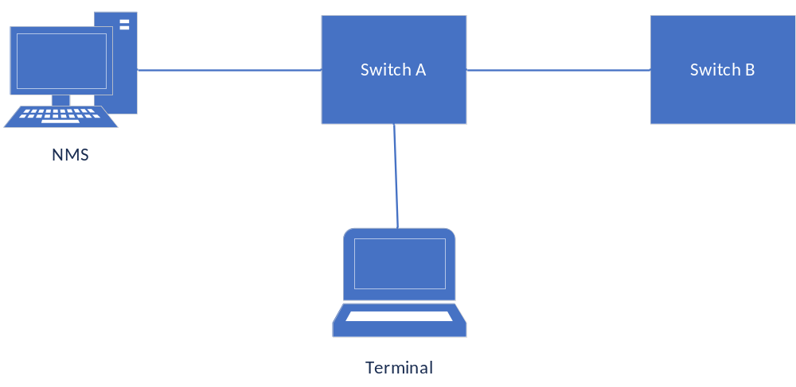
Typical configuration example
Switch A/B:
Lldp run

Display Information
- Display the Status of the LLDP Interface
#show lldp interface gigabitEthernet0/2

Agent Mode : Nearest bridge
Enable (tx/rx): Y/Y
Message fast transmit time:1
Message transmission interval: 30
Reinitialisation delay: 2
MED Enabled:Y
Device Type: NOT_DEFINED
LLDP Agent traffic statistics:
Total frames transmitted: 4608
Total entries aged: 0
Total frames received: 150
Total frames received in error: 0
Total frames discarded: 0
Total discarded TLVs: 0
Total unrecognised TLVs: 0
- Show LLDP Interface Neighbors
#show lldp interface gigabitEthernet0/2 neighbor
Nearest bridge Neighbors
Interface Name : gigabitEthernet0/2
System Name :
System Description :
Port Description :
TTL: 3601
System Capabilities : Routing
Mandatory TLVs :
CHASSIS ID TYPE :
Chassis MAC Address: 000e.c6c1.3841
PORT ID TYPE :
Port MAC Address: 000e.c6c1.3841
8021 ORIGIN SPECIFIC TLV
Port Vlan id :0
PP Vlan id :0
Remote Protocols Advertised :
Remote VID Usage Digest : 0
Remote Management Vlan : 0
Link Aggregation Status : Disabled
Link Aggregation Port ID : 0
8023 ORIGIN SPECIFIC TLV
AutoNego Support : Supported Enabled
AutoNego Capability : 1
Operational MAU Type : 0
Max Frame Size : 0
MED Capabilities : Capabilities
MED Capabilities Dev Type : End Point Class-1
MED Application Type : Reserved
MED Vlan id : 0
MED Tag/Untag: Untagged
MED L2 Priority : 0
MED DSCP Val : 0

Configuring LOOP-DETECT

Overview of LOOP-DETECT
LOOP-DETECT is an Ethernet loop detection protocol, which is used to quickly detect loop faults on downlink interfaces. If a fault is found, LOOP-DETECT will notify the user to manually close or automatically close the relevant port according to the fault handling method configured by the user, so as to avoid affecting the normal data exchange.
Enable control: Enable control is divided into global enable control and port enable control. When the global enable control is enabled and the loop detection is enabled on the port, the port supports the loop detection function.
Loop action: When a loop fault is detected on the port, the user will be notified to manually handle the loop fault by default, and the automatic closing of the port can also be configured. When the port is automatically shut down, the port can recover from the fault by waiting for timeout, shutdown/no shutdown port, recovery command, or restarting the device.
Specify vlan: By default, the port vlan attribute is ignored; if you need to detect whether a loop fault occurs in a specific vlan domain, you can configure the specified vlan on the port, and only detect Whether there is a loop data path in this vlan domain.
The device supports loop fault alarm and loop fault recovery message traps to the snmp server, which is disabled by default.

Configuring

Enable LOOP-DETECT Globally
Command | SWITCH(config)#loop-detect enable  SWITCH(config)#no loop-detect enable
Description | Enable the LOOP-DETECT function globally.  Disabled by default.

Enable LOOP-DETECT On Interface
Command | SWITCH(config-if)#loop-detect enable  SWITCH(config-if)#no loop-detect enable
Description | Enabe the LOOP-DETECT Function Based on Ports.  Disabled by default.  Supports physical ports and AP ports, does not support AP members.
Note：
✦ For a port in the block state, the protocol considers that there is no possibility of a loop. Even if the port is enabled for loop detection, the actual function cannot run normally. In an environment where stp and erps are enabled, a similar situation may exist. It is recommended to make the function mutually exclusive in the configuration.

Configure Port Loop Action
Command | SWITCH(config-if)#loop-detect action (alarm | error-down)  SWITCH(config-if)#no loop-detect action
Description | Configure port loop action.  Alarm: print alarm information.  Error-down: print alarm information and shut down the port at the same time.  The default action is alarm.

Specify Vlan Domain To Detect
Command | SWITCH(config-if)#loop-detect vlan VID  SWITCH(config-if)#no loop-detect vlan VID  SWITCH(config-if)#no loop-detect vlan
Description | Detect whether a data path loop occurs in the specified vlan domain.  VID supports single vlan mode and range mode, such as 10-12, separated by "," in the middle.  A port can specify up to 8 vlans.  By default, if no vlan is specified, the port vlan attribute will be ignored. If the port is in the block state, the data path is considered to be blocked.

Set Packet Sending Interval
Command | SWITCH(config)#loop-detect interval SECONDS  SWITCH(config)#no loop-detect interval
Description | Configure the interval for sending loop detection packets.  SECONDS: range 5-300, default 5, unit second.

Set Error-down Recovery Time
Command | SWITCH(config)#errdisable timeout (interval SECONDS | enable | disable)  SWITCH(config)#no errdisable timeout interval
Description | Configure errdisable recovery time.  SECONDS: range 10-1000000, unit second.  Enable: enable errdisable recovery.  Disable: disable errdisable recovery.  The default time is 300 seconds.  The time is shared by all errdisable applications, configuring this parameter will affect other applications.

Error-down Recovery
Recovery interface from errdisable status. If errdisable timeout is disabled, this command will not work, please use shutdown and no shutdown commands to recovery interface.
Command | SWITCH#errdisable recovery interface IFNAME
Description | Recovery Interface to normal.

Enable Trap
Command | SWITCH(config)#loop-detect trap enable  SWITCH(config)#no loop-detect trap enable
Description | Enable trap loop fault occurrence and loop fault recovery messages to the snmp server.  Disabled by default.
Definition of loop alarm trap node:
Node | Data
Mib files | DK-LDET-MIB.my
oid | 1, 3, 6, 1, 4, 1, 57430, 1, 6, 2,1
Ifindex | port index
Definition of loop alarm recovery trap node:
Node | Data
Mib files | DK-LDET-MIB.my
oid | 1, 3, 6, 1, 4, 1, 57430, 1, 6, 2,2
Ifindex | port index

Examples
Case 1: Configure port gi0/1 to enable the loop detection function, and configure the action to err-down.
SWITCH#configure terminal
Enter configuration commands, one per line. End with CNTL/Z.
SWITCH(config)#loop-detect enable
SWITCH(config)#interface gigabitEthernet 0/1
SWITCH(config-if)# loop-detect enable
SWITCH(config-if)# loop-detect action error-down
When port gi0/1 detects a loop, it prompts the following information and shuts down the port.
LOOPDETECT-4: %Loop error detected on interface GigabitEthernet 0/1.set interface err-down.

Case 2: Configure port gi0/1 to perform loop detection in the vlan10 domain.
SWITCH#configure terminal
Enter configuration commands, one per line. End with CNTL/Z.
SWITCH(config)#vlan 10
SWITCH(config)#loop-detect enable
SWITCH(config)#interface gigabitEthernet 0/1
SWITCH(config-if)#switchport mode trunk
SWITCH(config-if)# loop-detect enable
SWITCH(config-if)# loop-detect vlan 10
The port gi0/1 sends loop detection messages with tag and vid is 10. If a loop is detected in the vlan10 domain, the log information is output. if peer interface not allow vlan10, no loop detected.
LOOPDETECT-4: %Loop error detected on interface GigabitEthernet 0/1.

Case 3: Configure port gi0/1 to enable loop detection, enable trap, and configure the snmp server 192.168.64.1.
SWITCH#configure terminal
Enter configuration commands, one per line. End with CNTL/Z.
SWITCH(config)#snmp-server group public v2c read all write all
SWITCH(config)#snmp-server community public
SWITCH(config)#snmp-server host 192.168.64.1 traps v2c community public
SWITCH(config)#loop-detect enable
SWITCH(config)# loop-detect trap enable
SWITCH(config)#interface gigabitEthernet 0/1
SWITCH(config-if)# loop-detect enable
When port gi0/1 detects a loop, the snmp server receives the loop alarm trap information.

Display Information

Display LOOP-DETECT Information
SWITCH#show loop-detect
Global configuration:
Loop-detect State : Enabled
Loop-detect Interval ：5
Loop-detect trap : Enabled

Interface gigabitEthernet 0/1:
Loop-detect State : Enabled
Loop-detect Action : Alarm
Loop-detect Action Last : Normal
Loop-detect Action Last Time : --
Loop-detect Action Count : 0
Loop-detect Vlans : 10, 20, 30-32
Analysis of the information：
Global Information
Loop-detect State | Global enable status, Enabled or Disabled
Loop-detect Interval | Interval for sending loop detection packets, in seconds
Loop-detect trap | Whether to enable the alarm message trap to the server, Enabled or Disabled
Interface Information
Loop-detect State | Interface enable status, Enabled or Disabled
Loop-detect Action | Action after loop detection, support alarm and error-down
Loop-detect Action Last | The last time a failure occurred:  Normal: normal  Alarm: output alarm  Error-down: The port is down
Loop-detect Action Last Time | Time of last failure:  No failures have occurred:--  Happened, for example: 2022-01-10 22:45:23
Loop-detect Action Count | Count of failures
Loop-detect Vlans | Loop packet specified vlan list

Configuring GVRP

Overview of GVRP

Introduction to GVRP
GVRP (GARP VLAN Registration Protocol) is a protocol for dynamically propagate VLAN attributes, and is an application of GARP (Generic Attribute Registration Protocol). It registers and propagates VLAN attributes through the GARP protocol, and implements dynamic creation and deletion of VLANs on the 802.1Q Trunk port.

Introduction to GARP
GARP provides a mechanism to assist members in the same switching network to distribute, propagate and register information such as VLANs and multicast addresses. The application entities following the GARP protocol are called GARP applications. Currently the main GARP applications are GVRP and GMRP.
GVRP is a GARP application. It can dynamically configure and diffuse VLAN attributes, and realize dynamic automatic registration, log out of VLANs on 802.1Q Trunk ports.
GMRP (GARP Multicast Registration Protocol) is another GARP application. It mainly provides a restricted multicast diffusion function similar to the IGMP detection technology.
The GARP protocol is defined in 802.1D.

Port Registration Mode
There are three port registration modes of GVRP: Normal, Fixed and Forbidden:
Normal mode: Allow the port to dynamically register and log out of VLAN, and propagate dynamic VLAN and static VLAN information.
Fixed mode: Port is prohibited from dynamically registering and deregistering VLANs, and only transmits static VLAN information, not dynamic VLAN information. That is to say, the Trunk port set to Fixed mode, even if all VLANs are allowed to pass, the VLANs actually passed only those manually configured.
Forbidden mode: Port is prohibited from dynamically registering and deregistering VLAN, and does not propagate any VLAN information except VLAN1.

Messages and Timers
GARP message
The information exchange between GARP members is accomplished by means of message transmission. There are three main types of messages that work: Join messages, Leave messages, and LeaveAll messages.
When a GARP application entity wants other devices to register its own attribute information, it will send a Join message to the outside; when it receives a Join message from other entities or the device has statically configured some attributes and needs other GARP application entities to register, The Join message will also be sent out.
When a GARP application entity wants other devices to log out its own attribute information, it will send a Leave message to the outside; when it receives a Leave message from other entities to log off some attributes or statically log off some attributes, it will also send a Leave message to the outside information.
After each GARP application entity is started, it will start the LeaveAll timer at the same time. When the timer expires, the GARP application entity will send a LeaveAll message to the outside. The LeaveAll message is used to cancel all attributes, so that other GARP application entities can re-register with this entity.
The Join message, Leave message and LeaveAll message cooperate to ensure the re-registration or cancellation of information.
Through message exchange, all attribute information to be registered can be propagated to all devices configured with GARP in the same LAN.
GARP Timer
The time interval for sending GARP messages is implemented through timers. GARP defines four timers for controlling the sending period of GARP messages.
Hold timer: When the GARP application entity receives the registration information sent by other devices, it will not immediately send the registration information as a Join message, but start the Hold timer. When the timer expires, the GARP application entity will All registration information received during this period is sent out in the same Join message, thereby saving bandwidth resources.
Join timer: The GARP application entity can send each Join message twice to ensure the reliable transmission of the message. When the Join message sent for the first time is not answered, the GARP application entity will send the Join message for the second time . The time interval between sending two Join messages is controlled by the Join timer.
Leave timer: When a GARP application entity wishes to cancel certain attribute information, it will send a Leave message to the outside world, and the GARP application entity that receives the message starts the Leave timer, and if it does not receive the Join message before the timer expires, it will log out The attribute information.
LeaveAll timer: After each GARP application entity starts, it will start the LeaveAll timer at the same time. When the timer expires, the GARP application entity will send a LeaveAll message to the outside, so that other GARP application entities can re-register all attribute information on this entity . Then start the LeaveAll timer again to start a new cycle.

Packet Format
GVRP protocol packets are encapsulated in Ethernet frames, and the packet format is shown in the figure below.
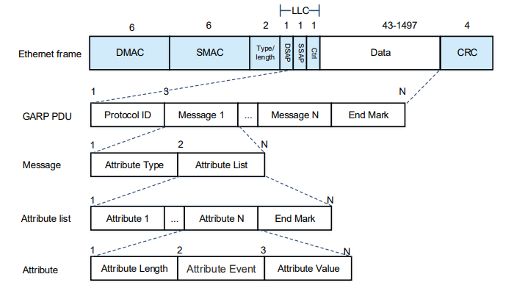
Table GVRP Ethernet packet field meaning:
Packet field | Bytes | Field meaning
Protocol ID | 2 | Protocol ID, Fixed 0x0001
Message | N | Message content, support N messages
Attribute type | 1 | Attribute type, GVRP fixed bit 0x01
Attribute list | N | Attribute list, consisting of multiple attributes and end mask
Attribute | N | attribute content
Attribute length | 1 | attribute content length
Attribute event | 1 | Events：  0x0:LeaveAll Event  0x1:JoinEmpty Event  0x2:JoinIn Event  0x3:LeaveEmpty Event  0x4:LeaveIn Event  0x5:Empty Event
Attribute value | N | Attribute value
End mask | 1 | End mask, fixed 0x00

Configuring

GVRP Enable Control
- Global Enable GVRP
Command | SWITCH(config)#gvrp enable  SWITCH(config)#no gvrp enable
Description | Globally enable the GVRP function  By default, the global GVRP function is disabled
- Port Enable GVRP
Command | SWITCH(config-if)#gvrp enable  SWITCH(config-if)#no gvrp enable
Description | Enable the GVRP function on the interface  By default, GVRP is disabled on an interface  The GVRP function on the interface takes effect only when GVRP is enabled both on the interface and globally.

Set registration Mode
Command | SWITCH(config-if)#gvrp registration (fixed | forbidden | normal)  SWITCH(config-if)#no gvrp registration
Description | Normal mode: Allow the interface to dynamically register and deregister VLANs, and propagate dynamic and static VLAN information.  Fixed mode: This interface is prohibited from dynamically registering and deregistering VLANs, and only propagates static VLAN information, not dynamic VLAN information. That is to say, the Trunk interface set to the fixed mode, even if all VLANs are allowed to pass, the VLANs that actually pass can only be those manually configured.  Forbidden mode: This interface is prohibited from dynamically registering and deregistering VLANs, and does not propagate any VLAN information to the outside world.

Set Timers
Command | SWITCH(config)#gvrp timer (join | leave | leaveall) CENTISEC  SWITCH(config)#no gvrp timer
Description | Set the value of the GARP timer  Join: range <20 32765>, default 20, unit centisecond, required to be less than or equal to 1/3 Leave timer value  Leave: range <20 32765>, default 60, unit centiseconds, required to be greater than or equal to 3 times the value of the join timer, less than the value of the leaveall timer  Leaveall: range <20 32765>, default 1000, unit centisecond, required to be greater than Leave timer value
Note
✦ In the case of multiple devices on the entire network, the value of the LeaveAll timer of each device may be different, but each device will send the LeaveAll message based on the smallest LeaveAll timer on the entire network. Because the LeaveAll message is sent every time the LeaveAll timer expires, other devices will clear the LeaveAll timer after receiving it, so even if there are many different LeaveAll timers on the entire network, only the smallest LeaveAll timer takes effect.

Clear Statistics
Command | SWITCH#clear gvrp statistics (| interface IFNAME)
Description | Clear port event statistics  Without interface parameter, clear all ports  With interface parameter, clear a specific port

Examples

Typical Cases
Case requirements:
SW1, SW2, SW3, and SW4 are connected through trunk ports. There are static VLANs 10-20 on SW1 and SW4, and SW2 and SW3 are required to learn these VLANs automatically without manual configuration. Enable GVRP globally and on the interfaces of each SW to realize dynamic registration and update of VLAN information between devices.
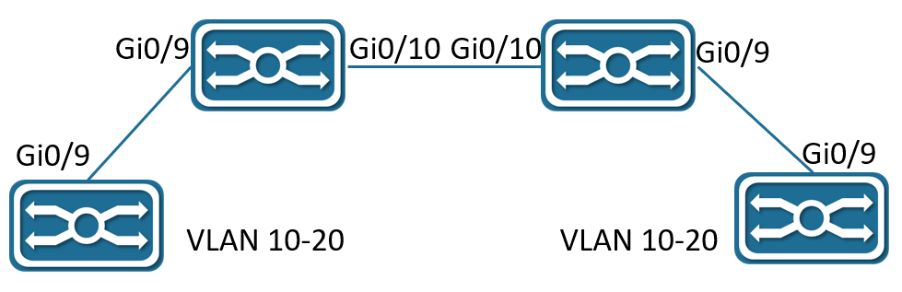
Steps:
SW1 configuration：
SWITCH(config)#Vlan 10-20
SWITCH(config)#gvrp enable
SWITCH(config)#interface gigabitEthernet 0/9
SWITCH(config-if)switchport mode trunk
SWITCH(config-if)gvrp enable
SW2 configuration：
SWITCH(config)#gvrp enable
SWITCH(config)#interface gigabitEthernet 0/9-10
SWITCH(config-if)switchport mode trunk
SWITCH(config-if)gvrp enable
SW3 configuration：
SWITCH(config)#gvrp enable
SWITCH(config)#interface gigabitEthernet 0/9-10
SWITCH(config-if)switchport mode trunk
SWITCH(config-if)gvrp enable
SW4 configuration：
SWITCH(config)#Vlan 10-20
SWITCH(config)#gvrp enable
SWITCH(config)#interface gigabitEthernet 0/9
SWITCH(config-if)switchport mode trunk
SWITCH(config-if)gvrp enable
Verify configuration results:
Execute show gvrp vlan command on SW2 and SW3, and it shows that gi0/9 and gi0/10 have dynamically learned vlan 10-20.
Execute show vlan all conmand on SW2 and SW3, and it shows that gi0/9 and gi0/10 belong to vlan 10-20.

Display Information

Display GVRP Status Information
SWITCH#show gvrp status
GVRP Global Information:
Global State : Enabled
Join Timer : 20 centisec
Leave Timer : 60 centisec
LeaveAll Timer : 1000 centisec

GVRP Port Based Information:
Interface State Registration Mode
-------------------- -------- --------------------
gigabitEthernet0/3 Enabled normal
po1 Enabled normal
Displayed message definition:
GVRP Global Information: | Global Configuration Status Information
Global State | Global state, Enabled or Disabled
Join Timer | Join timer value
Leave Timer | Leave timer value
LeaveAll Timer | Leaveall timer value
GVRP Port Based Information: | Port configuration status information, the default status port is ignored and not displayed
Interface | Interface name
State | Port status, Enabled or Disabled
Registration Mode | Port registration mode, Normal, Fixed, Forbidden

Display GVRP VLAN Information
SWITCH#show gvrp vlan
Interface gigabitEthernet0/3:
Static Vlan List : 1
Dynamic Vlan List : 15-21
Allow Vlan List : all
Interface po1:
Static Vlan List : 1
Dynamic Vlan List : 1000-2000
Allow Vlan List : all
SWITCH#show gvrp vlan interface gigabitEthernet 0/3
Interface gigabitEthernet0/3:
Static Vlan List : 1
Dynamic Vlan List : 15-21
Allow Vlan List : all
Displayed message definition:
Static Vlan List | Static vlan list supported by the port
Dynamic Vlan List | Dynamic vlan list supported by the port
Allow Vlan List | port allow vlan list

Display GVRP Statistics
SWITCH#show gvrp statistics
Interface Received Transmitted Drop
-------------------- ------------ ------------ --------
gigabitEthernet0/3 1462120 7202490 0
po1 7181418 1790511 0
Displayed message definition:
Interface | Interface name
Received | Receive GVRP attribute number
Transmitted | Send GVRP attribute number
Drop | Number of discarded GVRP attributes

SWITCH#show gvrp statistics interface gigabitEthernet 0/3
Interface gigabitEthernet0/3:
Received Valid Attributes : 1017
Transmitted Attributes : 1
Drop Invalid Attributes : 0
Received JoinEmpty Attributes : 14
Received JoinIn Attributes : 2
Received Empty Attributes : 1001
Received LeaveEmpty Attributes : 0
Received LeaveIn Attributes : 0
Received LeaveAll Attributes : 0
Transmitted JoinEmpty Attributes : 1
Transmitted JoinIn Attributes : 0
Transmitted Empty Attributes : 0
Transmitted LeaveEmpty Attributes : 0
Transmitted LeaveIn Attributes : 0
Transmitted LeaveAll Attributes : 0
Displayed message definition:
Received Valid Attributes | The total number of valid Attributes received
Transmitted Attributes | The total number of Attributes transmitted
Drop Invalid Attributes | The total number of Attributes dropped
Received JoinEmpty Attributes | The number of JoinEmpty Attributes received
Received JoinIn Attributes | The number of JoinIn Attributes received
Received Empty Attributes | The number of Empty Attributes received
Received LeaveEmpty Attributes | The number of LeaveEmpty Attributes received
Received LeaveIn Attributes | The number of LeaveIn Attributes received
Received LeaveAll Attributes | The number of LeaveAll Attributes receiveds
Transmitted JoinEmpty Attributes | The number of JoinEmpty Attributes sent
Transmitted JoinIn Attributes | The number of JoinIn Attributes sent
Transmitted Empty Attributes | The number of Empty Attributes sent
Transmitted LeaveEmpty Attributes | The number of LeaveEmpty Attributes sent
Transmitted LeaveIn Attributes | The number of LeaveIn Attributes sent
Transmitted LeaveAll Attributes | The number of LeaveAll Attributes sent

Configuring L3

Overview of L3
L3 functions include: Layer 3 port management, ARP management and Routing management.
- Layer 3 Port Management：
Layer 3 ports are generally divided into routing ports (physical ports switched to Layer 3 ports) or SVI ports (Switch Virtual Interface, corresponding to a VLAN).
The SVI port is a logical interface, which is constructed on top of all the member ports included in the corresponding VLAN, Unlike the routing port, the packets that are forwarded through the SVI at Layer 3 will first pass through Layer 2 (such as VLAN filtering, address learning, etc.) and then go through three layers, and then go through three layers and then two layers when outputting (such as VLAN output rules).
At the network layer, routing devices use IP addresses to complete packet forwarding. (Protocol specification: RFC 1918: Address Allocation for Private Internets, RFC 1166: Internet Numbers).
Layer 3 port management includes IP address maintenance for Layer 3 ports.
An IP address is composed of 32-bit binary. For the convenience of writing and description, it is generally expressed in dotted decimal. When expressed in dotted decimal, it is divided into four groups, each with 8 digits, ranging from 0 to 255. The groups are separated by ".", for example, "192.168.1.1" is the IP address expressed in decimal.
The IP address, as the name suggests, is naturally the interconnection address of the IP layer protocol. A 32-bit IP address consists of two parts:
1) the network address part, which indicates which network it is;
2) the host address part, which indicates which host in the network.
The network address part and the host address part of the IP address are divided by the network mask. The network mask is also a 32-bit value, consisting of several bits "1" in the front and several bits "0" in the back. The IP address is related to the network.
The mask and the obtained is the corresponding part of the network address. Likewise, the netmask can also be directly represented by the mask length.
For example, "192.168.1.1 255.255.255.0" and "192.168.1.1/24" represent the same IP address.
The device supports the configuration of the second IP address, that is, a Layer 3 port can be configured with at most one IP address.
When a Layer 3 port is configured with an IP address, a network segment is determined.
Different Layer 3 ports of the same device must belong to different network segments, and IP addresses configured with different Layer 3 ports must belong to different network segments.
The Layer 3 port represented by the SVI, and the corresponding VLAN is used as the unique identifier of the Layer 3 port.
After the different Layer 3 ports of the device are divided into different network segments, the forwarding between these different network segments (such as VLAN1 and VLAN2) is called "Layer 3 forwarding" (across network segments, or across different VLANs).
- ARP Management：
In a local area network, each IP network device has two addresses:
1) The local address, since it is included in the frame header of the data link layer, should be more precisely the data link layer address, but in fact the local address is processed by the MAC sublayer in the data link layer, Therefore, it is customarily called a MAC address, and a MAC address represents an IP network device on a local area network.
2) The network address represents the IP network device on the Internet, and it also indicates the network to which the device belongs.
To communicate between two IP devices on the LAN, they must know each other's 48-bit MAC address. The process of learning the MAC address from the IP address is called address resolution.
There are two types of address resolution methods:
1) Address Resolution Protocol (ARP).
2) Proxy Address Resolution Protocol (Proxy ARP).
About ARP and Proxy ARP, they are described in RFC 826 and RFC 1027 documents respectively.
ARP (Address Resolution Protocol) is used to bind a MAC address and an IP address. Taking the IP address as an input, ARP can know its associated MAC address. Once the MAC address is known, the IP address to MAC address correspondence is stored in the device's ARP cache. With the MAC address, the IP device can encapsulate the link layer frame, and then send the data frame to the LAN. The encapsulation of IP and ARP on Ethernet is Ethernet II type.
ARP entries are divided into two categories: dynamic entries generated by the ARP protocol and static entries derived from static configuration. Dynamic ARP entries are formed by triggering the opening of IP packets. The opening process is an ARP request/response process. If the ARP entries formed after opening are unreachable, they will automatically age out. Static ARP entries do not need to be opened and will not age out.
- Routing Management：
Routing management is responsible for managing routing tables, integrate routes issued by various routing protocols to select the optimal route.
According to different sources, the routing table is usually divided into the following three categories:
- Directly connected route: The route discovered by the link layer protocol is also called the interface route. A direct route is automatically generated when an IP address is configured on a Layer 3 port, and the route prefix is ​​the network directly connected to the Layer 3 port.
- Static route: manually configured by the network administrator.
- Dynamic routes: routes discovered by dynamic routing protocols (such as RIP, OSPF).
A routing table entry consists of two parts:
- Prefix: It is represented by an IP address and network mask (or mask length), which refers to the destination network or host determined by the routing table entry (when the mask length is 32, it means the host).
- Direct connection or next hop: Direct connection means that the destination network or host belongs to the directly connected network, and the direct connection route belongs to this situation. When configuring a static route, specifying a Layer 3 port instead of an IP address will also generate such a routing table item; the next hop is represented by an IP host address, indicating that to reach the destination network or host, it needs to be forwarded to the IP network device indicated by the IP address.
When forwarding IP packets according to the routing table entry, if the routing table entry specifies the next hop, when the link layer encapsulates the ARP query, the IP of the next hop is used, that is, the destination MAC address of the link layer encapsulation is the next hop. The destination MAC address of the hop. If the routing table entry is directly connected, the destination IP address of the packet is directly used for ARP query, that is, the destination MAC address encapsulated at the link layer is the final destination MAC address of the packet. Either way, if the ARP query fails, the route will be opened (a dynamic ARP entry will be generated). If the connection cannot be made, the IP packet cannot be forwarded and will be discarded.
There may be an inclusion relationship between routing table entries (depending on the length of the mask), so the route lookup process satisfies the LPM (Longest Prefix Match). That is, when IP packets are forwarded for route lookup, if multiple routing entries are hit at the same time, the routing entry with the longest prefix mask length is selected.

Configuring
- Configuring SVI Port IP/IPv6 Address
Command | Configure SVI Port IP：  SWITCH(config)#int vlan10  SWITCH(config-if)#ip address IPADDR/MASKLEN [secondary]  SWITCH(config-if)#ipv6 address IP(X:X::X:X/M)  Or  SWITCH(config-if)#ip address IPADDR MASK [secondary]  Delete SVI Port IP：  SWITCH(config)#int vlan10  SWITCH(config-if)#no ip address IPADDR/MASKLEN [secondary]  SWITCH(config-if)#no ipv6 address IP(X:X::X:X/M)  Or  SWITCH(config-if)#no ip address IPADDR MASK [secondary]  Show the IP/IPv6 address of the Layer 3 port:  SWITCH#show ip interface brief  SWITCH#show ipv6 interface brief
Description | Configure in the interface mode of the SVI.  When a VLAN is created, the SVI is automatically created, and when the VLAN is deleted, the SVI is automatically deleted. int vlanXX is to enter the interface mode of the SVI. Therefore, when the SVI does not exist (the corresponding VLAN does not exist), entering the interface mode of the SVI will fail. At the same time, when the SVI is deleted, the IP address configured on it will be automatically cleared.  Layer 3 ports support IP/IPv6 address configuration update, which has the same effect as deleting and reconfiguring. The IP addresses configured on different Layer 3 ports must belong to different network segments.  SVI supports the configuration of the second ip. When configuring the second ip, you need to configure the primary ip first. When deleting the primary ip, if the second ip already exists, you need to delete all the second ip before deleting the primary ip, otherwise it cannot be deleted.  Note: After this command is configured, the system will clear the management IP configuration (refer to: Configuring Management IP), and use the Layer 3 port IP address as the device management IP instead.
- Configuring Routing Port IP/IPv6 Address
Command | Configure Routing Port IP：  SWITCH(config)#interface gigabitEthernet0/1  SWITCH(config-if)#no switchport  SWITCH(config-if)#ip address IP(A.B.C.D/M) [secondary]  SWITCH(config-if)#ipv6 address IP(X:X::X:X/M)  Or  SWITCH(config-if)#ip address IP(A.B.C.D) MASK(A.B.C.D) [secondary]  Delete Routing Port IP：  SWITCH(config)# interface gigabitEthernet0/1  SWITCH(config-if)#no ip address IP(A.B.C.D/M)  SWITCH(config-if)#no ipv6 address IP(X:X::X:X/M)  Or  SWITCH(config-if)#no ip address IP(A.B.C.D) MASK(A.B.C.D)  SWITCH(config-if)#switchport
Description | Configure in interface mode.  Before configuring the routing port IP, since the default attribute of the interface is the Layer 2 port attribute, you need to use the no switchport command to switch the port from the Layer 2 port attribute to the Layer 3 routing port attribute, and then use the ip address command to configure the routing port attribute. IP configuration, otherwise, switch the routing port to the Layer 2 port attribute, use the switchport command.  Layer 3 ports support IP address configuration update, which has the same effect as deleting and reconfiguring. The IP addresses configured on different Layer 3 ports must belong to different network segments.  The Layer 3 interface supports the configuration of the second ip. When configuring the second ip, you need to configure the primary ip first.  When deleting the primary ip, if the second ip already exists, you need to delete all the second ip before deleting the primary ip, otherwise it cannot be deleted.
- Configuring Static ARP Entries
Command | SWITCH(config)#arp IPADDR MACADD  SWITCH(config)#no arp IPADDR
Description | Configure in global configuration mode.  The IP address configured with static ARP must belong to the directly connected network segment, otherwise the configuration fails.  Static ARP has a higher priority than dynamic ARP. When the two conflict, static ARP takes effect.  When the IP address of the Layer 3 port is deleted or the Layer 3 port is deleted, if the IP address of the static ARP belongs to the directly connected network segment of the Layer 3 port, the static ARP will be invalid (you can see that the entry does not exist through show arp, but show run, you can see that the configuration is still there); Similarly, when a Layer 3 port is configured with an IP address, the ARP entry of the directly connected network segment whose IP address belongs to the Layer 3 port will change from an invalid state to a valid state. (You can see the existence of ARP entries through show arp).
- Clearing ARP Cache
Command | SWITCH#clear arp-cache
Description | Clear the ARP cache in privileged mode.  This Command only clears dynamic ARP entries, and static ARP entries will not be cleared.
- Configuring Static IPv6 Neighbor Entries
Command | SWITCH(config)# ipv6 neighbor IPv6(X:X::X:X) IFNAME MAC(XXXX.XXXX.XXXX)  SWITCH(config)#no ipv6 neighbor IPv6(X:X::X:X) IFNAME
Description | Configure in global configuration mode.  The IPv6 address configured with the static ipv6 neighbor must belong to the directly connected network segment, otherwise the configuration fails.  The static ipv6 neighbor has a higher priority than the dynamic ipv6 neighbor. When the two conflict, the static ipv6 neighbor takes effect.  When the IPv6 address of the Layer 3 port is deleted or the Layer 3 port is deleted, if the IPv6 address of the static ipv6 neighbor belongs to the directly connected network segment of the Layer 3 port, the static ipv6 neighbor will be invalid (you can see that the table does not exist through show ipv6 neighbors Item, but show run can see that the configuration is still there); Similarly, when a Layer 3 port is configured with an IPv6 address, the ipv6 neighbor entry whose IPv6 address belongs to the directly connected network segment of the Layer 3 port will change from an invalid state to valid state. (You can see that the neighbors table entry exists by show ipv6 neighbors).
- Configuring Static Routes
Command | SWITCH(config)#ip route {IPADDR/MASKLEN) | IPADDR MASK} {NH_IPADDR | IFNAME}  SWITCH(config)#no ip route {IPADDR/MASKLEN | IPADDR MASK} {NH_IPADDR | IFNAME}  SWITCH(config)#ipv6 route [IPv6(X:X::X:X/M) [NH_IPv6(X:X::X:X) | IFNAME]  SWITCH(config)#no ip v6 route [IPv6(X:X::X:X/M) [IPv6(X:X::X:X) | IFNAME]
Description | Configure in global configuration mode.  Recursive routing is not supported (the configured next-hop IP must belong to the directly connected network segment);  The route prefix cannot belong to the directly connected network segment (that is, the directly connected route is automatically generated and cannot be statically configured).  When a Layer 3 port is configured with an IP address, if the prefix of a static routing entry belongs to the directly connected network segment of the Layer 3 port, the static route will be automatically deleted and a LOG prompt will be displayed;  When the IP address of a Layer 3 port is deleted or the Layer 3 port is deleted, if the next hop IP of a static routing entry belongs to the directly connected network segment of the Layer 3 port, the static route is automatically deleted and a LOG prompt is displayed.

- Configuring ECMP
If there are redundant links in the network environment, that is, there are multiple next hops for the route to the same destination address. On devices that support ECMP technology, multiple next hops can work at the same time, so that redundant links can be fully utilized, and when a link failure occurs on a redundant link, traffic can be switched to other redundant links. Network reliability and stability.
ECMP (Equal-Cost Multipath Routing), this technology enables the device to use multiple next-hop links of the corresponding route concurrently, and balance the traffic among the multiple next-hop links according to the set balance factor distribution; and supports fast switchover of faulty links.

Examples
Case 1: Weak Layer 3 Gateway
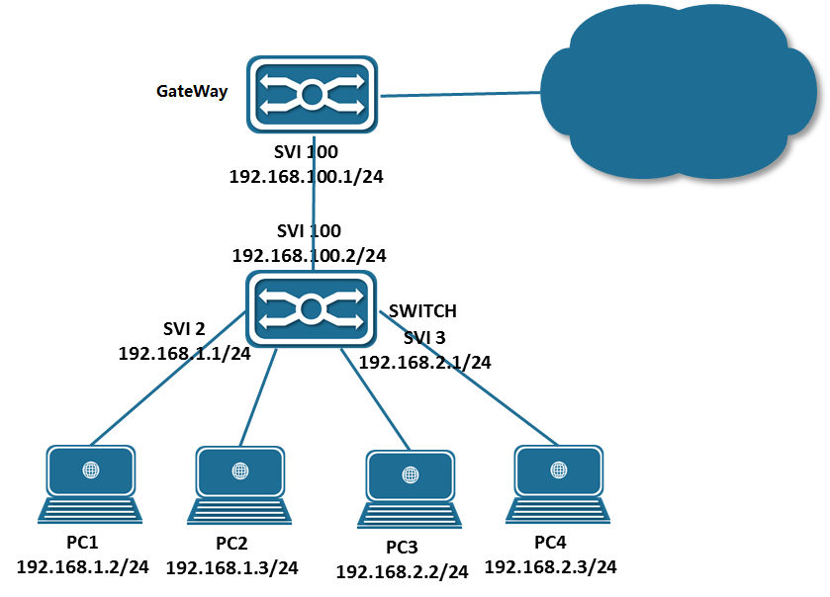
As a weak Layer 3 gateway, the Switch reduces the ARP burden for the real gateway.
- Configure PC：
Configure the IP addresses of PC1, PC2 and PC3 as shown in the figure, and specify the gateway at the same time. For example, the gateway of PC1 and P2 is 192.168.1.1.
- Configure SWITCH：
- Configure the Layer 3 port and IP address: (Assume that the interface connecting PC1-PC4 is gigabitEthernet0/1-4, and the uplink interface is gigabitEthernet0/17)
SWITCH(config)#vlan 2-3,100
SWITCH(config)#interface gigabitEthernet0/1-2
SWITCH(config-if)#switch access vlan 2
SWITCH(config)#interface gigabitEthernet0/3-4
SWITCH(config-if)#switch access vlan 3
SWITCH(config)#interface gigabitEthernet0/17
SWITCH(config-if)#switch access vlan 100
SWITCH(config)#int vlan2
SWITCH(config-if)#ip address 192.168.1.1/24
SWITCH(config)#int vlan3
SWITCH(config-if)#ip address 192.168.2.1/24
SWITCH(config)#int vlan100
SWITCH(config-if)#ip address 192.168.100.2/24

- Configure a static route (default route):
SWITCH(config-if)ip route 0.0.0.0/0 192.168.100.1
Case 2: Intranet Layer 3 Interconnection
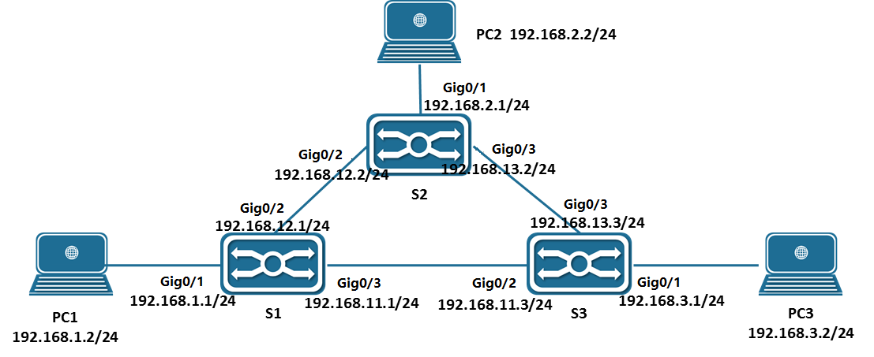
In the network environment shown above, PC1, PC2 and PC3 are interconnected through S1, S2 and S3 respectively.
- Configure PC
Configure the IP addresses of PC1, PC2 and PC3 as shown in the figure, and specify the gateway at the same time. For example, the gateway of PC1 is 192.168.1.1.
- Configure S1
- Configure the Layer 3 port and IP address:
SWITCH(config)#vlan 2-4
SWITCH(config)#interface gigabitEthernet0/1
SWITCH(config-if)#switch access vlan 2
SWITCH(config)#interface gigabitEthernet0/2
SWITCH(config-if)#switch access vlan 3
SWITCH(config)#interface gigabitEthernet0/3
SWITCH(config-if)#switch access vlan 4
SWITCH(config)#int vlan2
SWITCH(config-if)#ip address 192.168.1.1/24
SWITCH(config)#int vlan3
SWITCH(config-if)#ip address 192.168.12.1/24
SWITCH(config)#int vlan4
SWITCH(config-if)#ip address 192.168.13.1/24
- Configure a static route:
SWITCH(config)#ip route 192.168.2.0/24 192.168.12.2
SWITCH(config)#ip route 192.168.3.0/24 192.168.11.3
- S2 and S3 are configured similarly to S1.

Display Information
- Show L3 Interface
SWITCH#show ip interface brief
Interface IP-Address Admin-Status Link-Status
GiE0/3 10.10.20.1 up down
vlan10 192.168.65.166 up up
SWITCH#show ipv6 interface brief
Interface IPv6-Address Admin-Status
vlan10 2001:db8:0:f104::1 [up/up]
vlan1000 unassigned [up/up]
- Show ARP Entries
SWITCH#show arp
Address HWaddress Interface Type
192.168.1.238 00:00:00:00:04:86 vlan2 Static
192.168.2.46 00:00:00:00:05:45 vlan3 Static
192.168.3.110 00:00:00:00:08:59 vlan4 Static
192.168.0.12 00:00:00:00:00:09 vlan1 Static
192.168.0.1 00:0e:c6:d8:c7:f7 vlan1 Dynamic
10.100.2.2 00:01:a0:00:10:11 GiE0/2 Dynamic
- Show Ipv6 Neighbor Entries
SWITCH #show ipv6 neighbors
IPv6 Address MAC Address Interface Type
ff02::16 3333.0000.0016 vlan10 dynamic
ff02::1:ff00:1 3333.ff00.0001 vlan10 dynamic
ff02::1:ff40:251a 3333.ff40.251a vlan10 dynamic
- Show Routing Table Entries
SWITCH#show ip route
Codes: K - kernel, C - connected, S - static, R - RIP, B - BGP
O - OSPF, IA - OSPF inter area
N1 - OSPF NSSA external type 1, N2 - OSPF NSSA external type 2
E1 - OSPF external type 1, E2 - OSPF external type 2
i - IS-IS, L1 - IS-IS level-1, L2 - IS-IS level-2, ia - IS-IS inter area
* - candidate default
IP Route Table for VRF "default"
Gateway of last resort is 192.168.1.3 to network 0.0.0.0
S* 0.0.0.0/0 [1/0] via 192.168.1.3, vlan2
S 192.168.0.0/16 [1/0] via 192.168.0.10, vlan1
C 192.168.0.0/24 is directly connected, vlan1
C 192.168.1.0/24 is directly connected, vlan2
C 192.168.2.0/24 is directly connected, vlan3
C 192.168.3.0/24 is directly connected, vlan4
C 10.100.2.0/30 is directly connected, gigabitEthernet0/2
SWITCH #show ipv6 route
IPv6 Routing Table
Codes: K - kernel route, C - connected, S - static, R - RIP, O - OSPF,
IA - OSPF inter area, E1 - OSPF external type 1,
E2 - OSPF external type 2, N1 - OSPF NSSA external type 1,
N2 - OSPF NSSA external type 2, I - IS-IS, B - BGP
Timers: Uptime

IP Route Table for VRF "default"
C 2001:db8:0:f104::/64 via ::, vlan10, 00:00:56

Configuring ACL

Overview of ACL
The ACL Implement packet filtering by configuring matching rules and processing operations for packets. The ACL can effectively prevent illegal users from accessing the network, and can also control traffic and save network resources.
Packet matching rules defined by ACL can also be referenced by other functions that need to differentiate traffic, such as the definition of traffic classification rules in QoS.
The ACL classifies packets through a series of matching conditions, which can be SMAC, DMAC, SIP, DIP, etc. According to the matching conditions, ACLs can be divided into the following types:
Standard IP-based ACL: Make rules based only on the source IP address of the packet.
Extended IP-based ACL: formulate rules based on the source IP address, destination IP address, ETYPE, and protocol of the data packet.
MAC-based ACL: formulate rules based on the source MAC address and destination MAC address of the data packet.
IPV6-based ACL: develop rules based on the source IPV6 address, destination IPV6 address, protocol, etc. of the data packet.

Configuring

Configure IP Standard ACL
- Configure IP-based Standard ACL Rules
Command | SWITCH(config)# ip-access-list {<1-99> | <1300-1999>} {permit | deny} {host SIPADDR | SIPADDR SIPADDRMASK | any}  SWITCH(config)# no ip-access-list {<1-99> | <1300-1999>}
Description | Create /delete standard IP-based ACL rules
- Create a Standard IP ACL
Command | SWITCH(config)# ip-access-list standard {<1-99> | <1300-1999> | NAME}  SWITCH(config)# no ip-access-list standard {<1-99> | <1300-1999> | NAME}
Description | Create/delete standard IP ACL and switch to IP standard ACL mode
- Configure Standard IP ACL Rules
Command | SWITCH(config-std-acl)# [SN] {permit | deny} {host SIPADDR | SIPADDR SIPADDRMASK | any}  SWITCH( config-std-acl )# no {permit | deny} {host SIPADDR | SIPADDR SIPADDRMASK | any}  SWITCH( config-std-acl )# no SN
Description | Create/delete a standard IP ACL rule  SN: Serial number of each rule (1-2147483647)

Configure IP Extended ACL
- Configure IP-based Extended ACL Rules
Command | SWITCH(config)# ip-access-list {<100-199> | <2000-2699>} {permit | deny} PROTOCOL {host SIPADDR | SIPADDR SIPADDRMASK | any} [eq SPORT] {host | DIPADDR DIPADDRMASK | any} [eq DPORT]  SWITCH(config)# no ip-access-list {<100-199> | <2000-2699>}
Description | Create /delete IP-based extended ACL rules  PROTOCOL list:  <0-255>: Specify the ID of the protocol  any: any protocol message  gre: GRE message  icmp: ICMP message  igmp: IGMP message  ip: IPv4 message (0x4)  ipcomp: IPComp message  ospf: OSPF message  pim: PIM message  rsvp: RSVP message  tcp: TCP message  udp: UDP message  vrrp: VRRP message  The eq option is only available for TCP and UDP protocols.  For the following port number names, you can use the port number name or port number to specify a specific port:  TCP port number list:  <0-65535> Specify port number  bgp (179)  ftp (21)  ftp-data (20)  Login (513)  pop2 (109)  pop3 (110)  smtp (25)  telnet (23)  www (80)  UDP port number list:  <0-65535> Specify port number  bootpc (68)  boots (67)  domain (53)  echo (7)  rip (520)  snmp (161)  syslog (514)  tftp (69)
- Create Extended IP ACL
Command | SWITCH(config)# ip-access-list extended {<100-199> | <2000-2699> | NAME}  SWITCH(config)# no ip-access-list extended {<100-199> | <2000-2699> | NAME}
Description | Create/delete extended IP ACL and switch to IP extended ACL mode
- Configure Extended IP ACL Rules
Command | SWITCH(config-ext-acl)# [SN] {permit | deny} PROTOCOL {host SIPADDR | SIPADDR SIPADDRMASK | any} [eq SPORT] {host DIPADDR | DIPADDR DIPADDRMASK | any} [eq DPORT]  SWITCH( config-ext-acl )# no {permit | deny} PROTOCOL {host SIPADDR | SIPADDR SIPADDRMASK | any} [eq SPORT] {host DIPADDR | DIPADDR DIPADDRMASK | any} [eq DPORT]  SWITCH( config-ext-acl )# no SN
Description | Create/delete an extended IP ACL rule  SN: Serial number of each rule (1-2147483647)  PROTOCOL list:  <0-255>: Specify the ID of the protocol  any: any protocol message  gre: GRE message  icmp: ICMP message  igmp: IGMP message  ip: IPv4 message (0x4)  ipcomp: IPComp message  ospf: OSPF message  pim: PIM message  rsvp: RSVP message  tcp: TCP message  udp: UDP message  vrrp: VRRP message  For the following port number names, you can use the port number name or port number to specify a specific port:  eq (TCP and UDP only)  TCP port number list:  <0-65535> Specify port number  bgp (179)  ftp (21)  ftp-data (20)  Login (513)  pop2(109)  pop3(110)  smtp (25)  telnet (23)  www (80)  UDP port number list:  <0-65535> Specify port number  bootpc (68)  boots (67)  domain (53)  echo (7)  rip (520)  snmp (161)  syslog (514)  tftp (69)

Configure MAC ACL
- Configure MAC-based ACL Rules
Command | SWITCH(config)# mac-access-list <200-699> {permit | deny} {host SMAC | SMAC SMACMASK | any} {host DMAC | DMAC DMACMASK | any} [ethertype ETYPE] [cos VALUE]  SWITCH(config)# no mac-access-list <200-699>
Description | Create/delete MAC-based ACL rules  ethertype: Ethernet protocol type (0x05DD-0xFFFF)  cos: priority value of the message (0-7)
- Create MAC ACL
Command | SWITCH(config)# mac-access-list {<200-699> | NAME}  SWITCH(config)# no mac-access-list {<200-699> | NAME}
Description | Create/delete standard MAC ACL and switch to MAC ACL mode
- Configure MAC ACL Rules
Command | SWITCH(config-mac-acl)# [SN] {permit | deny} {host SMAC | SMAC SMACMASK | any} {host DMAC | DMAC DMACMASK | any} [ethertype ETYPE] [cos VALUE]  SWITCH( config-mac-acl )# no {permit | deny} {host SMAC | SMAC SMACMASK | any} {host DMAC | DMAC DMACMASK | any} [ethertype ETYPE] [cos VALUE]  SWITCH( config-mac-ext-acl )# no SN
Description | Create/delete a MAC ACL rule  SN: Serial number of each rule (1-2147483647)  ethertype: Ethernet protocol type (0x05DD-0xFFFF)  cos: priority value of the message (0-7)

Configure IPv6 ACL
- Create IPv6 ACL
Command | SWITCH(config)# ipv6-access-list {NAME}  SWITCH(config)# no ipv6-access-list {NAME}
Description | Create/delete IPV6 ACL and switch to IPV6 ACL mode
- Configure IPV6 ACL Rules
Command | SWITCH(config-ipv6-acl)# [SN] {permit | deny} [PROTOCOL] {SOURCE-IPV6-PREFIX/PREFIX-LENGTH | any | host SOURCE-IPV6-ADDRESS} [eq SPORT] {DESTINATION- IPV6-PREFIX / PREFIX-LENGTH | any | host DESTINATION-IPV6-ADDRESS} [eq DPORT]  SWITCH(config-ipv6-acl)# no {permit | deny} [PROTOCOL] {SOURCE-IPV6-PREFIX/PREFIX-LENGTH | any | host SOURCE-IPV6-ADDRESS} [eq SPORT] {DESTINATION- IPV6-PREFIX / PREFIX-LENGTH | any| host DESTINATION-IPV6-ADDRESS} [eq DPORT]  SWITCH(config-ipv6-acl)# no SN
Description | Create/delete an IPV6 ACL rule  SN: Serial number of each rule (1-2147483647)  PROTOCOL list:  <0-255>: Specify the ID of the protocol  any: any protocol message  icmp: ICMP message  tcp: TCP message  udp: UDP message  For the following port number names, you can use the port number name or port number to specify a specific port:  eq (TCP and UDP only)  TCP port number list:  <0-65535> Specify port number  bgp (179)  ftp (21)  ftp-data (20)  login (513)  pop2 (109)  pop3 (110)  smtp (25)  telnet (23)  www (80)  UDP port number list:  <0-65535> Specify port number  biff (512)  bootpc (68)  boots (67)  discard (9)  dnsix (195)  domain 53)  echo (7)  Isakmp (500)  ntp (123)  pim-auto-rp (496)  rip (520)  snmp (161)  snmptrap (162)  tftp (69)
Note
✦ Up to 128 rules can be configured under a single ACL-ID;
✦ Mask inversion, if it matches an IP address in the 192.168.1.0/24 range, 192.168.1.0 0.0.0.255 should be configured;
✦ The name of the ACL can be named, and the first character cannot be a number;
✦ MAC ACL does not take effect on IPV6 packets;
✦ The final default configuration of each ACL is deny any item;

Other Configuration Items
- Configure ACL Counters
If the user wants to start the packet matching counting function on the access list, please enable it in the access list.
Command | SWITCH(config-std-acl)# counter enable  SWITCH(config-std-acl)# no counter enable
Description | Enable / disable ACL counter  in all ACL modes
- Clear ACL Counter
Command | SWITCH# clear access-list counter NAME
Description | Clear the ACL count value
- Configure ACL Descriptor
Command | SWITCH(config-std-acl)# description TEXT  SWITCH(config-std-acl)# no description
Description | Configure/delete ACL descriptors  TEXT: descriptor (up to 64 characters)  Configurable in all ACL modes
- Trigger ACL Sequence Number Reordering
SN is the sequence number of the rule entry, and the value range is [1,2147483647]. This sequence number determines the priority of this rule entry in the access list. The smaller the sequence number, the greater the priority. The packet with the higher priority will be matched first. If the sequence number is not specified when configuring the matching rule, the system will automatically Assign a sequence number, the starting value of the sequence number is 10, and the increment value is 10.
Command | SWITCH(config-std-acl)# resequence START STEP  SWITCH(config-std-acl)# no resequence
Description | Reorder serial numbers  START: starting position (default value: 10, range <1-2147483647>)  STEP: step size (default value: 10, range <1-2147483647>)  Configurable in all ACL modes
Note
✦ The serial number is unique;
✦ When configuring an ACL entry, if the sequence number is not specified, it will be specified in steps after the current maximum sequence number (rules cannot be added if it exceeds the set range);
- Applying ACL to an Interface
Command | SWITCH(config-if)# access-group ACLNAME {in | out}  SWITCH(config-if)# no access-group ACLNAME {in | out}
Description | Configure/delete ACL applied to the port
Note
✦ When the ACL has been applied to the port or configured as a QOS flow matching rule, if you need to add or delete a rule, you need to first unapply it from the interface or QOS flow matching rule;
✦ The aggregation port does not support ACL application in the out direction, and the member ports of the aggregation port do not support ACL application;
✦ ACL applications not supported by VLAN ports;

Examples
Case 1: Filter the incoming packets of port gigabitEthernet0/1, release the packets with SIP 192.168.1.0/24, and discard other packets.
- Configure ACL rules:
SWITCH(config)#ip-access-list 1 permit 192.168.1.0 0.0.0.255
or
SWITCH(config)#ip-access-list standard 1
SWITCH(config-std-acl)#permit 192.168.1.0 0.0.0.255
- Apply ACL to port gigabitEthernet0/1
SWITCH(config)#interface gigabitEthernet0/1
SWITCH(config-if)#access-group 1 in
Case 2: Filter the entry packets of port gigabitEthernet0/1 and reject the packets sent by the host IP 192.168.1.2 with the packet type TCP and the source port number 40. Other packets will pass.
- Configure ACL rules:
SWITCH(config)#ip-access-list 100 deny tcp host 192.168.1.2 eq 40 any
SWITCH(config)#ip-access-list 100 permit any any any
or
SWITCH(config)#ip-access-list extended 100
SWITCH(config-ext-acl)#deny tcp host 192.168.1.2 eq 40 any
SWITCH(config-ext-acl)#permit any any any
- Apply ACL to port gigabitEthernet0/1
SWITCH(config)#interface gigabitEthernet0/1
SWITCH(config-if)#access-group 100 in
Case 3: Filter the export packets of port gigabitEthernet0/1 and reject the Ethernet type 0x804 packets sent by the host with MAC 0000.0047.5124. Other packets will pass.
- Configure ACL rules:
SWITCH(config)# mac-access-list 200 deny host 0000.0047.5124 any ethertype 0x804
SWITCH(config)# mac-access-list 200 permit any any
or
SWITCH(config)#mac-access-list 200
SWITCH(config-mac-acl)#deny host 0000.0047.5124 any ethertype 0x804
SWITCH(config-mac-acl)#permit any any
- Apply ACL to port gigabitEthernet0/1
SWITCH(config)#interface gigabitEthernet0/1
SWITCH(config-if)#access-group 200 out
Case 4: Filter the ingress packets of port gigabitEthernet0/1 , release the packets with the IPv6 address of the destination host::D0F8:1900:9F51:0000 , and discard other packets.
- Configure ACL rules:
SWITCH(config)#ipv6-access-list ip6-acl
SWITCH(config-ipv6-acl)#permit any any host ::D0F8:1900:9F51:0000
- Apply ACL to port gigabitEthernet0/1
SWITCH(config)#interface gigabitEthernet0/1
SWITCH(config-if)#access-group ip6-acl in
Case 5: Filter the incoming packets of port gigabitEthernet0/1, release the packets with SIP 192.168. 2. 1, discard other packets , and turn on the counter to view packet statistics .
- Configure ACL rules:
SWITCH(config)#ip-access-list standard 1
SWITCH(config-std-acl)#permit host 192.168.2.1
SWITCH(config-std-acl)#counter enable
- Apply ACL to port gigabitEthernet0/1
SWITCH(config)#interface gigabitEthernet0/1
SWITCH(config-if)#access-group 1 in
- port gigabitEthernet0/1 , send 10 packets with SIP 192.168.2.1 and SIP 192.168.2.2, check the packet statistics
SWITCH#show access-list 1
ip-access-list standard 1
10 permit host 192.168.2.1(10 match)
deng any (10 match)

Display Information
- Display ACL Information
SWITCH#show access-list 1
ip-access-list standard 1
10 permit host 1.1.1.1
deny any

SWITCH#show access-list 200
mac-access-list 200
10 permit host 0001.0002.0003 any
deny any

SWITCH#show access-list ip6-acl
ipv6-access-list ip6-acl
10 permit tcp host a::1 eq bgp any
deny any

Configuring QoS

Overview of QoS
Typically, networks operate on a best-effort delivery basis, which means that all traffic has equal priority and an equal chance of being delivered in a timely manner. When congestion occurs, all traffic has an equal chance of being dropped. When you configure the QoS feature, you can select specific network traffic, prioritize it according to its relative importance, and use congestion-management and congestion-avoidance techniques to provide preferential treatment. Implementing QoS in your network makes network performance more predictable and bandwidth utilization more effective.
The QoS implementation is based on the Differentiated Services (Diff-Serv) architecture, an emerging standard from the Internet Engineering Task Force (IETF). This architecture specifies that each packet is classified upon entry into the network. The following Figure shows the model of the QoS.
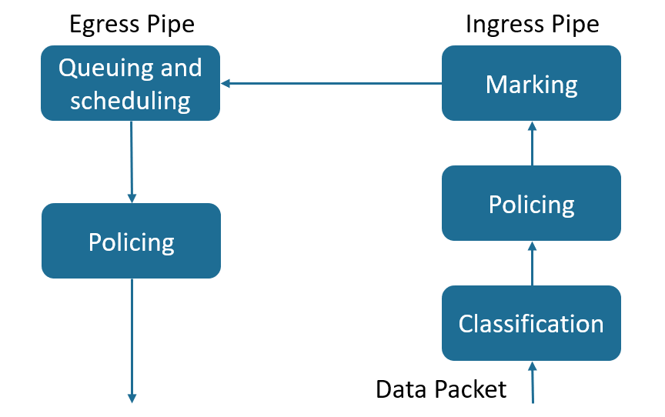
Classification
Classification is the process of distinguishing one kind of traffic from another by examining the fields in the packet. Classification is enabled only if QoS is globally enabled on the switch. By default, QoS is globally disabled, so no classification occurs.
During classification, the switch performs a lookup and assigns a QoS label to the packet. The QoS label identifies all QoS actions to be performed on the packet and from which queue the packet is sent.
The QoS label is based on the DSCP or the CoS value in the packet and decides the queueing and scheduling actions to perform on the packet. The label is mapped according to the trust setting and the packet type.
Trust CoS:
- QoS with CoS label.
- For tagged packets, the CoS uses the CoS information in the tag.
- For packets without tags, the CoS adopts the default CoS value of the port.
Trust DSCP：
- For non-IP packets, the QoS is labeled with CoS; for packets with tags, CoS uses the CoS information in the tag; for packets without tags, the CoS uses the default CoS of the port.
- For IP packets, QoS has a DHCP label; select the DSCP value of the packet.
No trust：
- QoS with CoS label
- CoS adopts the default CoS value of the port.
Policing(Ingress)
The ingress policer meters the given flow and classifies as either in-profile or out-of-profile. Out-of-profile packets may be discarded or have their QOS attributes remarked.
Marking
After a packet is classified and has a DSCP-based or CoS-based QoS label assigned to it, the marking process can begin.
For packets with CoS labels：
- Use the configured CoS-to-DSCP mapping relationship to generate DSCP values ​​for packets.
- Select the egress queue for the packet through the CoS-to-Queue mapping relationship.
For packets with DSCP labels
- Modify the DSCP value of the packet through the DSCP-to-DSCP mapping relationship.
- Generate a new CoS value for the packet through the DSCP-to-CoS mapping relationship.
- Select the egress queue for the packet through the DSCP-to-Queue mapping relationship.
Queuing and scheduling
Generally, there are 8 queues for QoS exit, which map the 0-7 priority relationship of CoS. The packet enters the corresponding egress queue according to the final marked CoS and CoS-to-Queue relationship. For the priority of packet processing in the egress queue, there are the following algorithms:
- WRR：The weight scheduling algorithm processes the packets in each queue in turn. The weight configuration can be used to change the number of queue packets processed in each cycle. The larger the weight, the higher the queue priority.
- SP：Strict scheduling algorithm, traverse queue 7 to queue 0 in each loop, when the initial processing of the packets in the high-priority queue ends, continue to process the low-priority queue.
- SP+WRR：The combination of WRR and SP, the global WRR mode, supports a specific queue configured as SP mode, and the queue configured as SP mode is a high-priority queue, which is processed first.
Policing(Egress)
The egress policer meters the given flow and classifies as either in-profile or out-of-profile. Out-of-profile packets may be discarded.

Configuring
- Enabling QoS Globally
Command | SWITCH(config)#mls qos enable  SWITCH(config)#no mls qos
Description | Enabling QoS Globally.  Default is disabled.
- Configuring Scheduling algorithm
Command | SWITCH(config)#mls qos algorithm {sp | wrr}
Description | Configuring the queue scheduling algorithm, support two modes: wrr and sp.
- Configuring Queue Wrr-weight
Command | SWITCH(config)#mls qos weight <0-7> <0-32>
Description | Configure the queue weight. The queue weight is only valid for wrr mode.  The default weight of all queues is 1.  When in wrr mode, configure the queue weight to 0, the queue will schedule in sp mode.
- Configuring Trust Mode on the Interface
Command | SWITCH(config-if)#mls qos trust {cos | dscp}  SWITCH(config-if)#no mls qos trust
Description | Configure the port trust mode, the default is not trust mode.  When in no trust mode, the CoS field and DHCP field of the packet will be modified according to the default CoS of the port.  When in trust cos mode, the same as the no trust mode for untagged packets, and for tagged packets, use the own CoS of the packet.  When configuring trust dscp mode, for ip packets, select the packet with DSCP, and for non-ip packets, the same as trust cos mode.
- Configuring Default CoS on the interface
Command | SWITCH(config-if)#mls qos cos <0-7>  SWITCH(config-if)#no mls qos cos
Description | Configure the default CoS of the port. The default CoS takes effect for the ingress packets without tags.  The default port cos is 0.
- Configuring CoS-to-DSCP Mapping
Command | SWITCH(config)#mls qos cos-dscp <0-63> <0-63> <0-63> <0-63> <0-63> <0-63> <0-63> <0-63>  SWITCH(config)#no mls qos cos-dscp
Description | Configure CoS-to-DSCP mapping.  Default CoS-to-DSCP mapping: 0-0, 1-8, 2-16, 3-24, 4-32, 5-40, 6-48, 7-56.
- Configuring CoS-to-Queue Mapping
Command | SWITCH(config)#mls qos cos-queue <0-7> <0-7>  SWITCH(config)#no mls qos cos-queue <0-7>
Description | Configure CoS-to-Queue mapping.  Default CoS-to-Queue mapping: 0-0, 1-1, 2-2, 3-3, 4-4, 5-5, 6-6, 7-7.
Note
When the configured port is no trust, trust cos or trust dscp and the port is not ip: the cos-dscp configuration takes effect, modify the packet dscp according to the mapping relationship, and the cos-queue configuration takes effect, modify the packet export queue according to the mapping relationship.
- Configuring DSCP-to-CoS Mapping
Command | SWITCH(config)#mls qos dscp-cos <0-63> to <0-7>  SWITCH(config)#no mls qos dscp-cos
Description | Configure DSCP-to-CoS mapping.  Default DSCP-to-CoS mapping: <0-7>-0, <8-15>-1, <16-23>-2, <24-31>-3, <32-39>-4, <40-47>- 5, <48-55>-6, <56-63>-7.
- Configuring DSCP-to-DSCP Mapping
Command | SWITCH(config)#mls qos dscp-mutation <0-63> to <0-63>  SWITCH(config)#no mls qos dscp-mutation
Description | Configure DSCP-to-DSCP mapping.
- Configuring DSCP-to-Queue Mapping
Command | SWITCH(config)#mls qos dscp-queue <0-63> <0-7>  SWITCH(config)#no mls qos dscp-queue <0-63>
Description | Configure DSCP-to-Queue mapping.  Default DSCP-to-Queue mapping: <0-7>-0, <8-15>-1, <16-23>-2, <24-31>-3, <32-39>-4, <40-47>- 5, <48-55>-6, <56-63>-7.
Note
When configuring the port as trust dscp and ip packets: the dscp-cos configuration takes effect, modify the packet dscp according to the mapping relationship, and the dscp-queue configuration takes effect, and modify the packet egress queue according to the mapping relationship. When a colleague configures dscp-dscp at the same time, first perform dscp-dscp conversion, and then perform dscp-cos mapping as a result.
- Creating Class-map
Command | SWITCH(config)#class-map CNAME  SWITCH(config-cmap)#  SWITCH(config)#no class-map CNAME
Description | Create class-map.  After creating a class-map, automatically enter the class-map mode.
- Configuring Class-map Maching Rule
Command | SWITCH(config-cmap)# match access-group ACLNAME  SWITCH(config-cmap)#no match access-group ACLNAME
Description | Configure to match ACL entries for class-map.

Command | SWITCH(config-cmap)#match ip-dscp <0-63>  SWITCH(config-cmap)#no match ip-dscp
Description | Configure to match the DHCP field in the IP packet, up to 64 different DHCP values ​​can be configured.

Command | SWITCH(config-cmap)#match cos <0-7>  SWITCH(config-cmap)#no match cos
Description | Configure to match the CoS field in the packet, up to 8 different CoS values ​​can be configured.

Command | SWITCH(config-cmap)#match ethertype ETYPE  SWITCH(config-cmap)#no match ethertype
Description | Configure to match the ethernet protocol type field of the packets.

Command | SWITCH(config-cmap)#match {vlan <1-4094> | vlan-range <1-4094> to <1-4094>}  SWITCH(config-cmap)#no match {vlan | vlan-range}
Description | Configure to match vlan field in the packet, support range configuration.

Command | SWITCH(config-cmap)#match layer4 {tcp | udp} {source-port | destination-port} VALUE  SWITCH(config-cmap)#no match layer4 {tcp | udp} {source-port | destination-port} VALUE
Description | Configure to match Layer 4 port fields of TCP and UDP packets.

Command | SWITCH(config-cmap)#match vlan-range <1-4094> to <1-4094> ethertype ETYPE  SWITCH(config-cmap)#no match vlan-range
Description | Configure to match vlan and etype fields in the packets.
- Creating Policy-map
Command | SWITCH(config)#policy-map PNAME  SWITCH(config-pmap)#  SWITCH(config)#no policy-map PNAME
Description | Configure policy-map
- Attaching Policy-map to Class-map
Command | SWITCH(config-pmap)# class CNAME  SWITCH(config-pmap-c)#  SWITCH(config-pmap)#no class CNAME
Description | Attach class-map to policy-map.  A policy-map can attach up to 8 class-maps.
- Configuring Action
Command | SWITCH(config-pmap-c)#set cos <0-7>  SWITCH(config-pmap-c)#no set cos
Description | Configure policy action: modify the cos field of packets.

Command | SWITCH(config-pmap-c)#set ip-dscp <0-63>  SWITCH(config-pmap-c)#no set ip-dscp
Description | Configure policy action: modify the ip-dscp field of packets.

Command | SWITCH(config-pmap-c)#set vlan <1-4094>  SWITCH(config-pmap-c)#no set vlan
Description | Configure policy action: modify packet vlan.

Command | SWITCH(config-pmap-c)#nest vlan <1-4094>  SWITCH(config-pmap-c)#no nest vlan
Description | Configure policy action: add external tags to matching packets.

Command | SWITCH(config-pmap-c)#police cir <32-1000000> cbs <4-31250> exceed-action drop  SWITCH(config-pmap-c)#no police
Description | Configure policy action: rate-limit.  Cir is the speed limit water line, in kbps.  Cbs is burst capacity, unit Kbyte.
Note
The value of cir is determinable. For example, if the speed limit is 1M, then the value of cir is 1024, but the value of cbs is taken from the empirical value. When the cbs value is set large, the flow peak is higher, and the speed limit is stable, but the average speed may be higher than the speed limit value; when the cbs value is set small, the flow peak is lower, the speed limit fluctuates greatly, and the average speed may be lower than the speed limit value. It is recommended that the cbs configuration take 4 times the value of cir.
- Applying Policy-map on the Interface
Command | SWITCH(config-if)#service-policy input PNAME  SWITCH(config-if)#no service-policy input PNAME
Description | Apply the policy-map on the interface.  Only one policy-map can be applied to an interface.
- Configuring Ingress Rate-limit on the interface
Command | SWITCH(config-if)#rate-limit input <64-1000000> <32-16384>  SWITCH(config-if)#no rate-limit input
Description | Configure port ingress rate limit.  The first parameter is limit level, in kbps.  The second parameter is burst level, in Kbyte.
- Configuring Egress Rate-limit on the interface
Command | SWITCH(config-if)#rate-limit output <64-1000000> <32-16384>  SWITCH(config-if)#no rate-limit output
Description | Configure port egress rate limit.  The first parameter is limit value, in kbps.  The second parameter is burst value, in Kbyte.
Note
The limit value is determinable. For example, if the speed limit is 1M, then the limit value is 1024, but the burst value is taken from the experience value. When the burst value is large, the flow peak is higher, and the speed limit is stable, but the average rate may be higher than the speed limit value; when the burst value is small, the flow peak is lower, the speed limit fluctuates greatly, and the average rate may be lower than the speed limit value. . It is recommended that the burst configuration be 4 times the limit value.

Examples
Example 1: This example shows how to Configure ingress and egress rate-limit on the interface.
Step 1: Configuring Ingress rate-limit on interface gigabitEthernet0/1.
SWITCH(config-if)#rate-limit input 1024 4096
Step 2: Configuring Egress rate-limit on interface gigabitEthernet0/1.
SWITCH(config-if)#rate-limit output 1024 4096
Example 2: This example shows how to configure flow-based rate-limit.
Step 1: Enable QoS globally.
SWITCH(config)#mls qos enable
Step 2：Create ACL rule.
SWITCH(config)#ip-access-list 1 permit 192.168.64.1
Step 3：Create class-map, policy-map, attach ACL to the class-map, attach class-map to the policy-map, and configure the policy-map action.
SWITCH(config)#class-map c1
SWITCH(config-cmap)#match access-group 1
SWITCH(config-cmap)#exit
SWITCH(config)#policy-map p1
SWITCH(config-pmap)#class c1
SWITCH(config-pmap-c)#police cir 1024 cbs 4096 exceed-action drop
Step 4: Apply policy-map to the interface.
SWITCH(config)#interface gigabitEthernet0/1
SWITCH(config-if)#service-policy input p1
Example 3: This example shows how to configure port-based QoS service, to Implement preferential forwarding of specific port packets.
Step 1: Enable QoS globally.
SWITCH(config)#mls qos enable
Step 2: Configure interface gigabitEthernet0/1 and gigabitEthernet0/2 trust cos. Set gigabitEthernet0/1 default CoS to 0. Set gigabitEthernet0/2 default CoS to 2.
SWITCH(config)#interface gigabitEthernet0/1
SWITCH(config-if)#mls qos trust cos
SWITCH(config-if)#mls qos cos 0
SWITCH(config-if)#exit
SWITCH(config)#interface gigabitEthernet0/2
SWITCH(config-if)#mls qos trust cos
SWITCH(config-if)#mls qos cos 2
Step 3: Configure CoS-to-Queue mapping.
SWITCH(config)#mls qos cos-queue 0 0
SWITCH(config)#mls qos cos-queue 2 2
Step 4: Configure scheduling algorithm wrr.
SWITCH(config)#mls qos algorithm wrr
Step 5: Configuring queue 2 weight 0.
SWITCH(config)#mls qos weight 2 0

Display Information
- Display Scheduling Algorithm and Weight Information
SWITCH#show mls qos algorithm
Mls qos algorithm is WRR.
Queue-id 0 1 2 3 4 5 6 7
Weight 1 1 1 1 1 1 1 1
- Display CoS-to-DSCP and CoS-to-Queue Mapping Information
SWITCH#show mls qos cos-maps
----------------------------
Cos Dscp Queue
----------------------------
0 0 0
1 8 1
2 16 2
3 24 3
4 32 4
5 40 5
6 48 6
7 56 7
- Display DSCP-to-CoS, DSCP-to-DSCP and DSCP-to-Queue Mapping Information
SWITCH#show mls qos dscp-maps
------------------------------------------
Dscp Cos Mutation Queue
------------------------------------------
0 0 0 0
1 0 1 0
2 0 2 0
3 0 3 0
4 0 4 0
5 0 5 0
6 0 6 0
7 0 7 0
8 1 8 1
9 1 9 1
10 1 10 1
11 1 11 1
12 1 12 1
13 1 13 1
14 1 14 1
15 1 15 1
- Display QoS Configuration on the Interfaces
SWITCH#show mls qos interfaces
-------------------------------
Interface Trust mode Cos
-------------------------------
GiE0/1 Not 0
GiE0/2 Not 0
GiE0/3 Not 0
GiE0/4 Not 0
GiE0/5 Not 0
GiE0/6 Not 0
GiE0/7 Not 0
GiE0/8 Not 0
- Display Class-map Configuration
SWITCH#show class-map

CLASS-MAP-NAME: c1
Match Cos: 3
- Display Policy-map Configuration
SWITCH#show policy-map

POLICY-MAP-NAME: p1
State: detached

CLASS-MAP-NAME: c1
Match Cos: 3
Police: Mode: SrTCM
cir (1024 Kbps)
cbs (4096 KBytes)
exceed-action (drop)
- Display Rate-limit Configuration on the Interfaces
SWITCH#show rate-limit
-------------------------------------------------------
Interface In limit In burst Out limit Out burst
-------------------------------------------------------
GiE0/1 -- -- -- --
GiE0/2 -- -- -- --
GiE0/3 1024 4096 -- --
GiE0/4 -- -- -- --
GiE0/5 -- -- -- --
GiE0/6 -- -- -- --
GiE0/7 -- -- -- --
GiE0/8 -- -- -- --
GiE0/9 -- -- -- --
GiE0/10 -- - 1024 4096

Configuring DHCP Snooping

Overview of DHCP Snooping
DHCP snooping (Dynamic Host Configuration Protocol) is a security feature that acts like a firewall between untrusted hosts and trusted DHCP servers. When DHCP snooping is enabled on a VLAN, the system examines DHCP messages sent from untrusted hosts associated with the VLAN and extracts their IP addresses and lease information. This information is used to build and maintain the DHCP snooping database.
DHCP snooping is enabled on a per-VLAN basis. By default, the feature is inactive on all VLANs. You can enable the feature on a single VLAN or a range of VLANs.
Trusted Sources
The DHCP snooping feature determines whether traffic sources are trusted or untrusted. DHCP snooping acts as a guardian of network security by keeping track of valid IP addresses assigned to downstream network devices by a trusted DHCP server. The default trust state of all interfaces is untrusted.
DHCP Snooping Limit Rate
Configure the number of DHCP packets per second that an interface can receive, to reduce or eliminate the impact of DHCP packet attack from this interface.
MAC Address Verification
With DHCP snooping MAC address verification enabled, DHCP snooping verifies that the source MAC address and the client hardware address match in DHCP packets that are received on untrusted ports. The source MAC address is a Layer 2 field associated with the packet, and the client hardware address is a Layer 3 field in the DHCP packet.
Option-82 Insertion
DHCP Option82 option is also called DHCP relay agent information option, one of many dhcp options. The Option82 option is a DHCP option proposed to enhance the security of the DHCP server and improve the IP address allocation strategy. The addition and stripping of options are implemented by the relay component.
DHCP Database
The DHCP snooping feature dynamically builds and maintains the database using information extracted from intercepted DHCP messages. The database contains an entry for each untrusted host with a leased IP address if the host is associated with a VLAN that has DHCP snooping enabled. The database does not contain entries for hosts connected through trusted interfaces. When the ip verify source function is enabled on the interface, database entrys act as valid users on the interface.

Configuring
- Enable DHCP Snooping Globally
Command | SWITCH(config)#ip dhcp snooping  SWITCH(config)#no ip dhcp snooping
Description | Enables DHCP snooping globally.
- Enable DHCP Snooping on Vlans
Command | SWITCH(config)#ip dhcp snooping vlan VID  SWITCH(config)#no ip dhcp snooping vlan VIID
Description | Enables DHCP snooping on a VLAN or VLAN range, For example:  Ip dhcp snooping vlan 3-10.  By default, DHCP Snooping is enabled on all VLANs.

- Configuring Trust Resources
Command | SWITCH (config-if)#ip dhcp snooping trust  SWITCH (config-if)#no ip dhcp snooping trust
Description | Configures the interface as trusted.  By default, All interfaces are untrusted.
- Enabling Mac Address Verification
Command | SWITCH (config)#ip dhcp snooping verify mac-address  SWITCH (config)#no ip dhcp snooping verify mac-address
Description | Enables DHCP snooping MAC address verification.  By default is disabled.
- Configuring Rate Limit on Interface
Command | SWITCH (config-if)#ip dhcp snooping rate-limit PPS  SWITCH (config-if)#no ip dhcp snooping rate-limit
Description | Configures DHCP packet rate limiting.  PPS range from 0 to 128.  If PPS is set to 0, this interface will drop all Incoming DHCP packets.
Note
✦ Due to hardware limitations, for DHCP rate limit, when the limit value is not 0, the software rate limit is used, and when the limit value is 0, the hardware rate limit is used. Software rate limit will consume CPU resources.
- Enabling Option-82 Data Insertion
Command | SWITCH (config)#ip dhcp snooping information option-82  SWITCH (config)#no ip dhcp snooping information option-82
Description | Enables DHCP option-82 data insertion.
- Configuring Option-82 Circuit-id
Command | SWITCH (config-if)#ip dhcp snooping information option-82 circuit-id WORD  SWITCH (config-if)#no ip dhcp snooping information option-82 circuit-id
Description | Configure circuit-id customization content.  Default vlan+port information.  WORD: String information, valid length 3-63 characters.
- Configuring Option-82 Remote-id
Command | SWITCH (config-if)#ip dhcp snooping information option-82 remote-id WORD  SWITCH (config-if)#no ip dhcp snooping information option-82 remote-id
Description | Configure remote-id custom content.  Default device MAC address information.  WORD: String information, valid length 1-63 characters.

- Configuring DHCP Snooping Database Write-delay Time
Command | SWITCH (config)#ip dhcp snooping database write-delay SECONDS  SWITCH (config-if)#no ip dhcp snooping database write-delay
Description | Configuring DHCP Snooping data to be written to flash at regular intervals  SECONDS range from 600 to 86400 by unit second.
- Trigger DHCP Snooping Database Write-flash
Command | SWITCH (config)#ip dhcp snooping database write-flash
Description | Trigger DHCP Snooping database write-flash.
- Trigger DHCP Snooping Database renew from flash
Command | SWITCH(config)#ip dhcp snooping database renew
Description | Trigger DHCP Snooping database renew from flash.
- Clear DHCP Snooping Database
Command | SWITCH#clear ip dhcp snooping database (vlan VLANID | interface IFNAME | mac-address XXXX.XXXX.XXXX | ip-address A.B.C.D | flash)
Description | Clear DHCP Snooping database based on port, vlan, MAC address, or IP address.  Support to clear database in flash.

Examples
Example 1：This is an example of DHCP Snooping typical application. The interface of gigabitEthernet0/8 is connected to DHCP server; USER-A obtains IP address by dynamic; There are other DHCP servers in the LAN, which will affect the IP address assignment of USER-A. Diagram as show in the Figure 1-1 below.
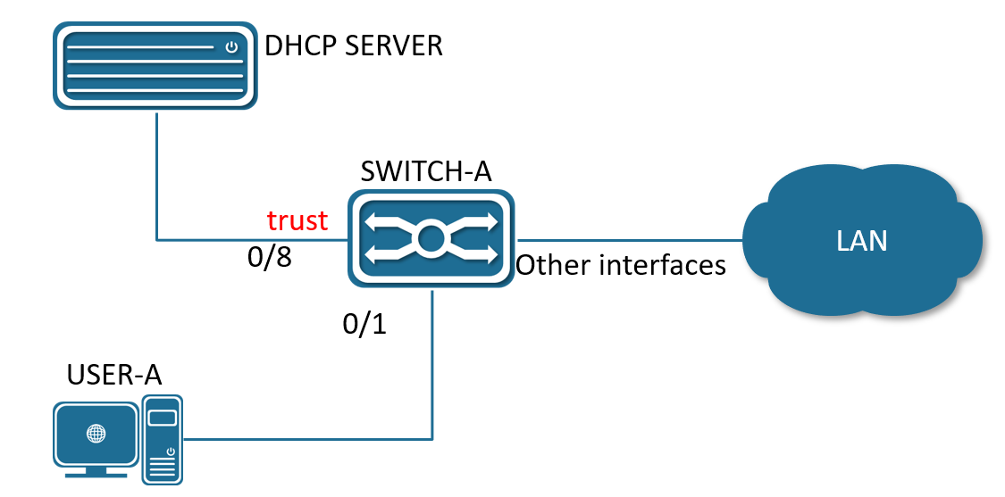
Figure 1-1 Typical application of DHCP Snooping Diagram
- Enable DHCP Snooping Globally.
SWITCH#configure terminal
SWITCH(config)#ip dhcp snooping
- Configuring gigabitEthernet0/8 as Trusted Resource.
SWITCH(config)#interface gigabitEthernet0/8
SWITCH(config-if)#ip dhcp snooping trust

Display Information
- Display DHCP Snooping Information
SWITCH#show ip dhcp snooping
Ip dhcp snooping : Enabled
No ip dhcp snooping vlan : 2-5
Verify mac-address : Disabled
Information option-82 : No
database write-delay : 0 seconds

Interface Trusted Rate limit (pps)
----------------------------------------------------------
gigabitEthernet0/16 yes unlimited

Configuring 802.1X Authentication

Overview of 802.1X Authentication
The IEEE802 LAN/WAN committee proposed the 802.1X protocol to solve the problem of wireless LAN network security. Later, the 802.1X protocol was widely used in Ethernet as a common access control mechanism for LAN ports, mainly to solve the problems of authentication and security in Ethernet.
The 802.1X protocol is a port based network access control protocol. "Port-based network access control" means that, at the port level of the LAN access device, the access to the network resources is controlled through authentication for the connected user equipment.

802.1X Architecture
The 802.1X system is a typical Client/Server structure, as shown in Figure 3, including three entities: Client, Device and Authentication server.
Figure 3 802.1X Authentication System Architecture
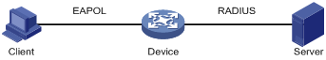
- A client is an entity on a local area network that is authenticated by the device on the other end of the link. The client is generally a user terminal device, and the user can initiate 802.1X authentication by starting the client software. The client must support EAPOL (Extensible Authentication Protocol over LAN).
- The device side is another entity on the local area network that authenticates connected clients. The device side is usually a network device that supports the 802.1X protocol. It provides the client with a port to access the LAN. The port can be a physical port or a logical port.
- The authentication server is an entity that provides authentication services for the device. The authentication server is used for user authentication, authorization and accounting, usually a RADIUS (Remote Authentication Dial-In User Service) server.

802.1X Authentication Method
The 802.1X authentication system uses EAP (Extensible Authentication Protocol) to realize the exchange of authentication information between the client, the device and the authentication server.
- Between the client and the device, the EAP protocol packets use the EAPOL encapsulation format and are directly carried in the LAN environment.
- There are two ways to exchange information between the device and the RADIUS server. One is that the EAP protocol packet is relayed by the device, and is carried in the RADIUS protocol using the EAPOR (EAP over RADIUS) encapsulation format; the other is that the EAP protocol packet is terminated by the device. Packets with the PAP (Password Authentication Protocol) or CHAP (Challenge Handshake Authentication Protocol) attribute interact with the RADIUS server for authentication.

802.1X Basic Concepts

Controlled/Uncontrolled Port
The device side provides a port for the client to access the LAN. This port is divided into two logical ports: a controlled port and an uncontrolled port. Any frame arriving at this port is visible on both controlled and uncontrolled ports.
- The uncontrolled port is always in a two-way connection state and is mainly used to transmit EAPOL protocol frames to ensure that the client can always send or receive authentication packets.
- The controlled port is in a bidirectional connection state in the authorized state and is used to transmit service packets; in the unauthorized state, it is forbidden to receive any packets from the client.

Authorized/Unauthorized Status
The device uses the authentication server to authenticate the client that needs to access the LAN, and controls the authorization/unauthorized status of the controlled port according to the authentication result (Accept or Reject).
Figure 4 Shows the effect of different authorization states on the controlled port on packets passing through this port. The figure compares the port status of two 802.1X authentication systems. The controlled port of system 1 is in an unauthorized state (equivalent to opening the port switch), and the controlled port of system 2 is in an authorized state (equivalent to closing the port switch).
Figure 4 Effects of Authorization Status on Controlled Ports
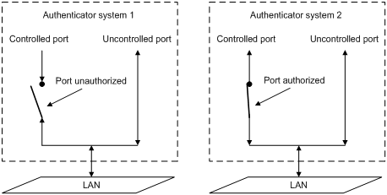
The user can control the authorization status of the port through the access control mode configured under the port. The port supports the following three access control modes:
- Forced authorization mode (authorized-force): indicates that the port is always in an authorized state, allowing users to access network resources without authorization.
- Force unauthorized mode unauthorized-force): Indicates that the port is always in an unauthorized state and does not allow users to authenticate. The device does not provide authentication services for clients accessing through this port.
- Auto-identification mode (auto): indicates that the initial state of the port is an unauthorized state, only EAPOL packets are allowed to send and receive, and users are not allowed to access network resources; If the authentication is passed, the port switches to the authorized state, allowing the user to access network resources. This is also the most common case.

Controlled Direction
In the unauthorized state, the controlled port can be set as one-way controlled and two-way controlled.
- When two-way control is implemented, the transmission and reception of frames are prohibited;
- When unidirectional control is implemented, receiving frames from the client is prohibited, but sending frames to the client is allowed.

Authentication process for 802.1X
The 802.1X system supports EAP relay mode and EAP termination mode to interact with the remote RADIUS server to complete authentication. The following descriptions of the two authentication methods take the client's initiative to initiate authentication as an example.

EAP Relay Mode
This method is specified by the IEEE 802.1X standard, and EAP (Extensible Authentication Protocol) is carried in other high-level protocols, such as EAP over RADIUS, so that the extensible authentication protocol packets can reach the authentication server through complex networks. Generally speaking, the EAP relay mode requires the RADIUS server to support EAP attributes: EAP-Message and Message-Authenticator, which are used to encapsulate EAP packets and protect RADIUS packets carrying EAP-Message respectively.
The following takes EAP-MD5 as an example to introduce the basic business process, as shown in Figure5
Figure5 IEEE 802.1X EAP relay business process of authentication system
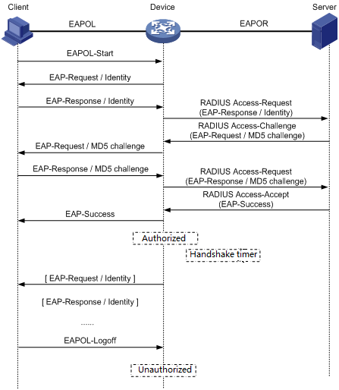
The authentication process is as follows:
- When the user needs to access the network, open the 802.1X client program, enter the username and password that have been applied and registered, and initiate a connection request (EAPOL-Start message).At this point, the client program will send a message requesting authentication to the device to start an authentication process.
- After receiving the data frame requesting authentication, the device will send a request frame (EAP-Request/Identity message) to request the user's client program to send the entered username.
- The client program responds to the request from the device and sends the username information to the device through a data frame (EAP-Response/Identity message). The device sends the data frame sent by the client through packet processing (RADIUS Access-Request message) to the authentication server for processing.
- After receiving the username information forwarded by the device, the RADIUS server compares the information with the username table in the database, finds the password information corresponding to the username, and encrypts it with a randomly generated encrypted word, and also send this encrypted word to the device through the RADIUS Access-Challenge message, and the device forwards it to the client program.
- After receiving the encrypted word (EAP-Request/MD5 Challenge message) from the device, the client program uses the encrypted word to encrypt the password part (this encryption algorithm is usually irreversible), generate an EAP-Response/MD5 Challenge packet, and send it to the authentication server through the device.
- The RADIUS server compares the received encrypted password information (RADIUS Access-Request message) with the local encrypted password information. If they are the same, the user is considered to be a legitimate user, and the authentication is passed. messages (RADIUS Access-Accept packets and EAP-Success packets).
- After receiving the authentication message, the device changes the port to the authorized state, allowing users to access the network through the port. During this period, the device will monitor the user's online status by periodically sending handshake messages to the client. By default, if the two handshake request packets are not answered by the client, the device will log the user offline, preventing the user from going offline due to abnormal reasons and the device cannot sense it.
- The client can also send an EAPOL-Logoff message to the device to actively request to log off. The device changes the port status from authorized to unauthorized, and sends an EAP-Failure packet to the client.

Configuring
- Enabling/disabling 802.1X Authentication Globally
Command | SWITCH(config)# dot1x enable  SWITCH(config)#no dot1x enable
Description | Enable and disable the 802.1X function globally.
- Enabling/disabling 802.1X authentication on the Interface
Command | SWITCH(config-if)# dot1x port-control auto  SWITCH(config-if)#no dot1x port-control auto
Description | The port enables or disables the 802.1X function.
- Configuring RADIUS Server
Command | SWITCH(config)# radius-server host A.B.C.D auth-port <0-65535> acct-port <0-65535> key WORD  SWITCH(config)#no radius-server host A.B.C.D
Description | Configure authentication server information.  The default authentication port is 1812 and the accounting port is 1813.  Please ensure that the RADIUS server and the device management address communicate with each other.
- Configuring EAPOL Protocol Version Number
Command | SWITCH(config-if)# dot1x protocol-version <1-2>  SWITCH(config-if)#no dot1x protocol-version
Description | Configure the version number of the EAPOL protocol on the specified port.  Optional configuration, default is 2.
- Configuring Authentication Silent Time
Command | SWITCH(config-if)# dot1x quiet-period <1-65535>  SWITCH(config-if)#no dot1x quiet-period
Description | Configure the hold time of the HELD state.  Optional configuration, the unit is seconds, the default is 60.
- Configuring the Re-authentication Function
Command | SWITCH(config-if)# dot1x reauthentication  SWITCH(config-if)#no dot1x reauthentication
Description | The re-authentication function is enabled on the configuration port.  Optional configuration, disabled by default.
- Configuring the Maximum Number of Re-authentications
Command | SWITCH(config-if)# dot1x reauthMax <1-10>  SWITCH(config-if)#no dot1x reauthMax
Description | Configure the maximum number of times for port re-authentication. If the number of re-authentication requests exceeds the limit and there is no response, the port becomes unauthorized.  Optional configuration, default 2 times.
- Configuring to Enable key Transfer Capability
Command | SWITCH(config-if)# dot1x keytxenabled { disable | enable}
Description | Configure the port key transfer function.  Optional, disabled by default.
- Configuring Timer Timeout
Command | SWITCH(config-if)# dot1x timeout {re-authperiod <1-4294967295> | server-timeout <1-65535> | supp-timeout <1-65535> | tx-period <1-65535>}  SWITCH(config-if)#no dot1x timeout {re-authperiod | server-timeout | supp-timeout | tx-period}
Description | Configure the port timer time.  Optional configuration, the default re-authentication period is 3600 seconds, the server timeout is 30 seconds, the client authentication timeout is 30 seconds, and the client request timeout is 30 seconds.
- Enabling/disabling MAC Authentication Globally
Command | SWITCH(config)# mac-auth enable  SWITCH(config)#no mac-auth enable
Description | Enable or disable the MAC authentication function globally.
- Enabling/disabling MAC Authentication on the Interface
Command | SWITCH(config-if)# mac-auth {enable | disable}
Description | The port enables or disables the MAC authentication function.
- Enabling/disabling MAC Authentication Dynamic VLAN Delivery on the Interface
Command | SWITCH(config-if)# mac-auth dynamic-vlan-creation {enable | disable}
Description | The port enables or disables dynamic VLAN delivery of MAC authentication.  The current version is not supported.
- Configuring MAC Authentication Failure Handling
Command | SWITCH(config-if)# mac-auth auth-fail-action {drop-traffic | restrict-vlan <2-4094>}
Description | Configure the behavior of MAC authentication failure.  Optional configuration, default is drop-traffic: drop traffic.  The current version is not supported.
- Configuring RADIUS Server Death Time
Command | SWITCH(config)# radius-server deadtime <0-1440>  SWITCH(config)# no radius-server deadtime
Description | Configure the RADIUS server death time.During the authentication process, the dead server will be automatically skipped, and the non-dead server will be selected for authentication.  Optional configuration, the default is 0 minutes.
- Configuring RADIUS Server Default Key
Command | SWITCH(config)# radius-server key STRING  SWITCH(config)# no radius-server key
Description | Configure the RADIUS server default key.  Optional configuration.
- Configuring RADIUS Server Retransmission Times
Command | SWITCH(config)# radius-server retransmit <1-100>  SWITCH(config)# no radius-server retransmit
Description | Configure the RADIUS server retransmission times.  Optional configuration, the default is 3 times.
- Configuring RADIUS Server Timeout
Command | SWITCH(config)# radius-server timeout <1- 60>  SWITCH(config)# no radius-server timeout
Description | Configure the RADIUS server timeout period.  Optional configuration, the default is 5 seconds.

Examples

802.1X Port Authentication Scenario
- Requirement
- Requires authentication of access users on port GigabitEthernet0/3 to control their access to the Internet.
- RADIUS server group IP address 1.1.1.2.
- Set the shared key to be used when the system exchanges packets with the RADIUS server as name.
- Network Diagram
Figure 6 802.1X Typical network diagram for 802.1x authentication
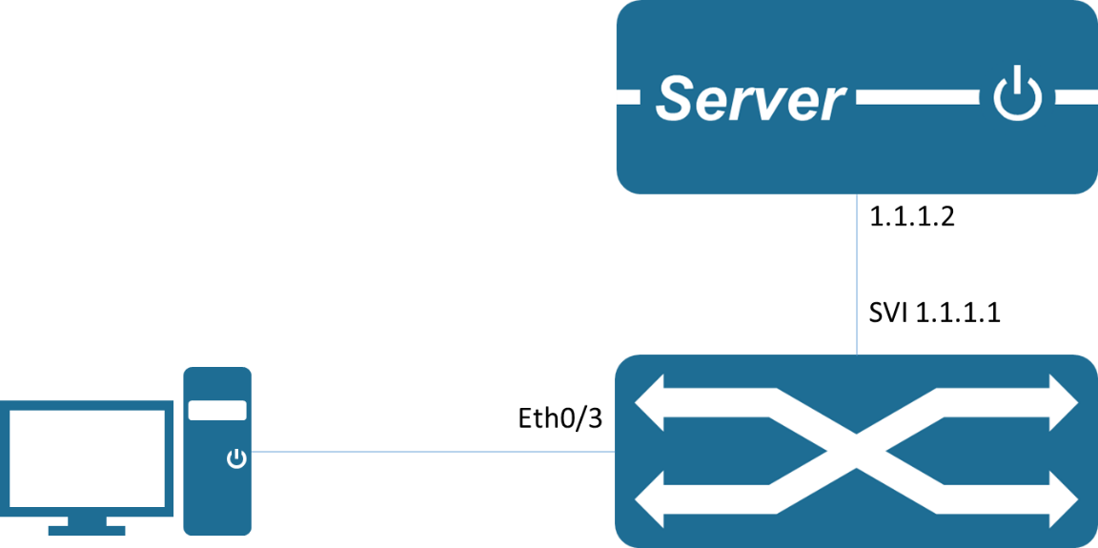
- Typical configuration example
Device side:
SWITCH(config)#dot1x enable
SWITCH(config)#interface gigabitEthernet0/3
SWITCH(config-if)#dot1x port-control auto
SWITCH(config-if)#exit
SWITCH(config)#radius-server host 1.1.1.2 key name
Server:
Configure NAS authentication device 1.1.1.1 and communication key name.
Add user account test password test.
The corresponding authentication method needs to be supported, such as EAP-MSCHAPv2
Client:
Enable 802.1X authentication client and log in with account test.
The corresponding authentication method needs to be supported, such as the EAP-MSCHAPv2 method.

MAC Authentication Scenario
- Requirement
- Requires authentication of access users on port GigabitEthernet0/3 to control their access to the Internet.
- RADIUS server group IP address 1.1.1.2.
- Set the shared key when the system and the RADIUS server exchange messages as name.
- Network Diagram
Figure 7 Typical network diagram for MAC authentication
- Typical configuration example
Device side:
SWITCH(config)# mac-auth enable
SWITCH(config)#interface gigabitEthernet0/3
SWITCH(config-if)#mac-auth enable
SWITCH(config-if)#exit
SWITCH(config)#radius-server host 1.1.1.2 key name
Server:
Configure NAS authentication device 1.1.1.1 and communication key name.
Add the client MAC address as the user account and password to the user database.
Client:
Enable the 802.1X authentication client and log in with any account.

Display Information
- Show 802.1X Port Authentication Information
SWITCH#show dot1x all
802.1X Port-Based Authentication Enabled
RADIUS server address: 1.1.1.2:1812
Next radius message id: 0
RADIUS client address: not configured

802.1X info for interface gigabitEthernet0/6
portEnabled: true - portControl: Auto
portStatus: Unauthorized - currentId: 1
protocol version: 2
reAuthenticate: disabled
reAuthPeriod: 3600
abort:F fail:F start:F timeout:F success:F
PAE: state: Connecting - portMode: Auto
PAE: reAuthCount: 1 - rxRespId: 0
PAE: quietPeriod: 60 - reauthMax: 2 - txPeriod: 30
BE: state: Idle - reqCount: 0 - idFromServer: 0
BE: suppTimeout: 30 - serverTimeout: 30
CD: adminControlledDirections: in - operControlledDirections: in
CD: bridgeDetected: false
KR: rxKey: false
KT: keyAvailable: false - keyTxEnabled: false
- Display MAC Authentication Information
SWITCH#show bridge
Bridge CVLAN SVLAN BVLAN Port MAC Address FWD Time-out
---------+------+------+------+-----------+-- ---------------+-----+---------+

Configuring Port Security

Overview of Port Security
You can use port security to block input to a Fast Ethernet, or Gigabit Ethernet port when the MAC address of the station attempting to access the port is different from any of the MAC addresses that are specified for that port. Alternatively, you can use port security to filter traffic that is destined to or received from a specific host that is based on the host MAC address.
The maximum number of MAC addresses that you can allocate for each port depends on your network configuration. After you allocate the maximum number of MAC addresses on a port, you can either specify the secure MAC address for the port manually or have the port dynamically configure the MAC address of the connected devices.
When a secure port receives a packet, the source MAC address of the packet is compared to the list of secure source addresses that were manually configured or autoconfigured (learned) on the port. If a MAC address of a device that is attached to the port differs from the list of secure addresses, A violation occurs. Users can set a port to the following two modes to handle a security violation:
Restrict: Drops all packets from insecure hosts, but remains enabled, until the MAC of the host aged out dynamic. You can manually shutdown and no-shutdown the interface to recover from violation.
Shutdown: The shutdown mode option allows you to specify whether the port is to be permanently disabled or disabled for only a specified time. The default is for the port to shut down permanently. You can manually shutdown and no-shutdown the interface to recover from violation.
If you want to convert dynamic security users to static security users, you can enable the sticky function on the port. If the sticky function is enabled, the dynamic users learned on the port will exist as static users. If the configuration is saved, it will still exist after the device restarts.
Note
- Only support L2 port for port security, such as physical port and L2 AP port.
- Only supports configuring port security function in access mode.
- Do not support AP member port configuration port security function.
- The destination port of the SPAN does not support the port security function.
- Does not support the port security function on ports that have been configured with static MAC addresses.

Configuring
- Enable Port Security
Command | SWITCH(config-if)#switchport port-security  SWITCH(config-if)#no switchport port-security
Description | Enable Port Security on the interface.
- Setting the Max Number of Security Mac-address
Command | SWITCH(config-if)#switchport port-security maximum VALUE  SWITCH(config-if)#no switchport port-security maximum
Description | The default maximum number of secure addresses is 1  VALUE range from 1 to 1024.
- Entering a Security Mac-address
Command | SWITCH(config-if)#switchport port-security mac-address MAC_ADDR  SWITCH(config-if)#no switchport port-security mac-address MAC_ADDR
Description | Enters a secure MAC address for the interface.  If you configure fewer secure MAC addresses than the maximum, the remaining MAC addresses will be dynamically learned.
- Enable sticky
Command | SWITCH(config-if)# switchport port-security mac-address sticky  SWITCH(config-if)#no switchport port-security mac-address sticky
Description | Enable sticky learning on the interface.
- Configuring Port Security Aging
Command | SWITCH(config-if)#switchport port-security aging time MINUTES  SWITCH(config-if)#no switchport port-security aging time
Description | Sets the aging time for the secure port.  Valid range for aging_time is from 0 to 1440 minutes. If the time is equal to 0, aging is disabled for this port.
- Enable Port Security Aging Static Mac-address
Command | SWITCH(config-if)# switchport port-security aging static  SWITCH(config-if)#no switchport port-security aging static
Description | enables aging for statically configured secure addresses on this port.
- Setting the Violation Mode
Command | SWITCH(config-if)# switchport port-security violation { strict | shutdown }  SWITCH(config-if)#no switchport port-security violation
Description | Sets the violation mode, the action to be taken when a security violation is detected, as one of these:  Restrict: A port security violation restricts data and causes the SecurityViolation counter to increment and send an SNMP trap notification.  Shutdown: The interface is error-disabled when a security violation occurs.  You can manually reenable the by entering the shutdown and no shut down commands.  When a secure port is in the error-disabled state, it will recover after errdisable recovery time.

Examples
Example 1：This is an example of Port Security typical application. Port Security is enabled on the interface gigabitEthernet0/1, the MAX secure Mac-address of the interface gigabitEthernet0/1 is 3, and we enter 3 secure Mac-address on the interface.
When the interface gigabitEthernet0/1 receives a packet, If the SRC MAC-address of the packet differs from the list of secure Mac-addresses, the packet will be dropped.
SWITCH(config-if)#switchport port-security
SWITCH(config-if)#switchport port-security maximum 3
SWITCH(config-if)#switchport port-security mac-address 0001.0001.0001
SWITCH(config-if)#switchport port-security mac-address 0001.0001.0002
SWITCH(config-if)#switchport port-security mac-address 0001.0001.0003

Display Information
- Display Interfaces Port Security Brief
SWITCH#show port-security brief
interface mac-address mac-address violation violation
maxinum count count action
-------------------------------------------------------------------------------------------------
GiE0/1 10 3 0 shutdown
GiE0/2 1 0 0 restrict
GiE0/3 1 0 0 restrict
GiE0/4 1 0 0 restrict
GiE0/5 1 0 0 restrict
GiE0/6 1 0 0 restrict
GiE0/7 1 0 0 restrict
GiE0/8 1 0 0 restrict
- Display an Interface Port Security Information
SWITCH#show port-security interface gigabitEthernet0/1
Port Security : Enabled
Maimum MAC Addresses : 10
Violation Mode : Shutdown
Aging Time(mins) : 10
Aging static : Enabled
Total MAC Addresses : 3
Configured MAC Addresses : 2
Security Violation Count : 0
Last Violate Address : --
- Display Secure Mac-address
SWITCH#show port-security Mac-address
interface vlan mac-address type left-time(min)
------------------------------------------------------------------------------------
GiE0/1 1 0001.0002.0004 static 10
GiE0/1 1 0001.0002.0003 static 10
GiE0/1 1 000e.c6c1.3a03 dynamic 10
- Display an Interface Secure Mac-address
SWITCH#show port-security mac-address interface gigabitEthernet0/1
interface vlan mac-address type left-time(min)
------------------------------------------------------------------------------------
GiE0/1 1 0001.0002.0004 static 10
GiE0/1 1 0001.0002.0003 static 10
GiE0/1 1 000e.c6c1.3a03 dynamic 10

Configuring Ip Source Guard

Overview of Ip Source Guard
IP Source Guard is a per-interface traffic filter that permits IP traffic only when the IP address and MAC address of each packet matches one of two sources of IP and MAC address bindings: Entries in the Dynamic Host Configuration Protocol (DHCP) snooping binding table; Static IP source entries that you configure.
Filtering on trusted IP and MAC address bindings helps prevent spoofing attacks, in which an attacker uses the IP address of a valid host to gain unauthorized network access.
Note
- Only support L2 port for port security, such as physical port and L2 AP port.
- Do not support AP member port configuration port security function.

Configuring
- Enabling Ip Source Guard
Command | SWITCH(config-if)#ip verify source  SWITCH(config-if)#no ip verify source
Description | Enables IP Source Guard on the interface.
- Configuring Static Ip Source Binding Entry
Command | SWITCH(config)# ip source binding XXXX.XXXX.XXXX vlan VALUE A.B.C.D interface IFNAME  SWITCH(config)#no ip source binding XXXX.XXXX.XXXX vlan VALUE A.B.C.D interface IFNAME
Description | Creates a static IP source binding entry for the current interface.  Example:  SWITCH(config)# ip source binding 0001.0001.0001 vlan 1 1.1.1.10 interface gigabitEthernet0/1  A single port can be configured with a maximum of 128 entries.

Examples
Example 1：This is an example of Ip Source Guard typical application. Ip Source Guard is enabled on the interface gigabitEthernet0/1, and we enter 3 static binding entrys on the interface.
When the interface gigabitEthernet0/1 receives a packet, If the IP address and the MAC address of the packet differs from the list of static entrys, the packet will be dropped.
SWITCH(config)#interface gigabitEthernet0/1
SWITCH(config-if)#ip verify source
SWITCH(config)#ip source binding 0001.0001.0001 vlan 1 1.1.1.10 interface gigabitEthernet0/1
SWITCH(config)#ip source binding 0001.0001.0002 vlan 1 1.1.1.11 interface gigabitEthernet0/1
SWITCH(config)#ip source binding 0001.0001.0003 vlan 1 1.1.1.12 interface gigabitEthernet0/1

Display Information
- Display Ip Verify Source Binding Rules
SWITCH#show ip verify source
interface Filter-type Filter IP-address Mac-address vlan
---------------------------------------------------------------------
GiE0/1 Ip Permit 1.1.1.1 0001.0001.0001 1
GiE0/1 Ip Deny All All All
GiE0/2 Ip Deny All All All
- Display Ip Verify Source Binding Entrys on the Interface
SWITCH#show ip verify source interface gigabitEthernet0/1
interface Filter-type Filter IP-address Mac-address vlan
-----------------------------------------------------------------------------------------------
GiE0/1 Ip Permit 1.1.1.1 0001.0001.0001 1
GiE0/1 Ip Deny All All All
- Display Ip Source Binding Entrys
SWITCH#show ip source binding
interface vlan IP-address Mac-address Lease Type
-----------------------------------------------------------------------------------------------
GiE0/1 1 1.1.1.1 0001.0001.0001 infinite static
GiE0/2 1 1.1.2.1 0001.0002.0001 infinite static
- Display Ip Source Binding Entrys on the Interface
SWITCH#show ip source binding interface gigabitEthernet0/1
interface vlan IP-address Mac-address Lease Type
-----------------------------------------------------------------------------------------------
GiE0/1 1 1.1.1.1 0001.0001.0001 infinite static

Configuring Arp-check

Overview of Arp-check
Arp-check is a per-interface traffic filter that permits ARP traffic only when the IP address and MAC address of each packet matches one of two sources of IP and MAC address bindings: Entries in the Dynamic Host Configuration Protocol (DHCP) snooping binding table; Static IP source entries that you configure.
Filtering on trusted IP and MAC address bindings helps prevent spoofing attacks, in which an attacker uses the IP address of a valid host to gain unauthorized network access.
Note
- Only support L2 port for port security, such as physical port and L2 AP port.
- Do not support AP member port configuration port security function.

Configuring
- Enabling Arp-check on the Interface
Command | SWITCH(config-if)#arp-check  SWITCH(config-if)#no arp-check
Description | Enables Arp-check on the interface.

Examples
Example 1：This is an example of Arp-check typical application. Arp-check is enabled on the interface gigabitEthernet0/1, and we enter 3 static binding entrys on the interface.
When the interface gigabitEthernet0/1 receives a ARP packet, If the IP address and the MAC address of the packet differs from the list of static entrys, the packet will be dropped.
SWITCH(config)#interface gigabitEthernet0/1
SWITCH(config-if)#ip verify source
SWITCH(config-if)#arp-check
SWITCH(config)#ip source binding 0001.0001.0001 vlan 1 1.1.1.10 interface gigabitEthernet0/1
SWITCH(config)#ip source binding 0001.0001.0002 vlan 1 1.1.1.11 interface gigabitEthernet0/1
SWITCH(config)#ip source binding 0001.0001.0003 vlan 1 1.1.1.12 interface gigabitEthernet0/1

Configuring SNMP Network Management

Overview of SNMP Network Management
SNMP is the abbreviation of Simple Network Management Protocol, which became a network management standard RFC1157 in August 1988.Up to now, due to the support of this protocol by many manufacturers, SNMP has become the de facto network management standard and is suitable for use in the interconnected environment of multi-manufacturer systems.
Using the SNMP protocol, network administrators can perform information query, network configuration, fault location, and capacity planning for nodes on the network. Network monitoring and management are the basic functions of SNMP.
Currently the following versions of SNMP exist:
SNMPv1: The first official version of the Simple Network Management Protocol, defined in RFC1157.
SNMPv2C: Community-Based SNMPv2 Management Architecture, defined in RFC1901.
SNMPv3: By authenticating and encrypting data, it provides the following security features:
- Make sure that data is not tampered with during transmission.
- Make sure the data is sent from a legitimate data source.
- Encrypt messages to ensure data confidentiality.

Configuring
- Configuring Communication Community Words
Command | SWITCH( config)# snmp-server community COMMUNITY { ro | }  SWITCH( config)# no snmp -server community COMMUNITY
Description | Configure/delete SNMP communication community word.  ro : read-only identifier, configure the community word as a community word with only read permission; the default configuration is a community word with both read and write permissions.  Supports configuring multiple community characters at the same time.
- Configuring SNMPv3 Views
Command | SWITCH( config)# snmp -server view NAME {include | exclude} OID  SWITCH( config)# no snmp -server view name
Description | Configure/delete SNMPv3 views;  Supports configuring multiple views at the same time, and supports configuring multiple rules for a single view;  The system has all and none views by default and cannot be modified
- Configuring SNMP Groups
Command | SWITCH( config)# snmp -server group NAME {v3 | } { noAuthNoPriv | authNoPriv | authPriv } read RVIEW write WVIEW  SWITCH( config)# snmp -server group NAME {v1 | v2c} read RVIEW write WVIEW  SWITCH( config)# no snmp -server group name
Description | configure/delete SNMP groups;  Support to configure multiple groups at the same time;  create group information in order to be compatible with the old configuration when configuring the community , usually without additional attention

- Configuring SNMPv3 Users
Command | SWITCH( config)# snmp -server user NAME group GROUPNAME auth {md5 | sha} {AUTHPASS} priv { aes | des} PRIVPASS  SWITCH( config)# no snmp -server user name
Description | configure/delete SNMP users;  Support to configure multiple users at the same time;
- Configuring SNMP Host Notification Server
Command | SWITCH( config)# snmp -server host IPADDR {informs | traps} {v3 |} { noAuthNoPriv | authNoPriv | authPriv } user NAME  SWITCH( config)# snmp -server host IPADDR {informs | traps} {v1 | v2c} community NAME  SWITCH( config)# no snmp -server hostname _
Description | configure/delete SNMP server;  Support to configure multiple servers at the same time;

Examples
Requirements: The IP address of the SNMP network management server is 2.2.2.2, and the read-write communication group word is unified as public.
- Enter the global configuration mode configuration:
SWITCH#
SWITCH#configure terminal
Enter configuration commands, one per line. End with CNTL/Z.
SWITCH( config)#snmp-server community public
SWITCH( config)#snmp-server 2.2.2.2 community public
SWITCH( config)#
Case requirements: The IP address of the SNMP network management server is 2.2.2.2, SNMPv3 is used, the user test password is 12345678, the encryption key is 87654321; the authentication algorithm MD5, the encryption algorithm DES
SWITCH#
SWITCH#configure terminal
Enter configuration commands, one per line. End with CNTL/Z.
SWITCH( config)# snmp -server group test v3 authPriv read all write all
SWITCH( config)# snmp -server user test group test auth MD5 12345678 priv DES 87654321
SWITCH( config)# snmp -server host 2.2.2.2 informs v3 authPriv user test

Configuring RMON

Overview of RMON
SNMP is the most widely used network management protocol in the Internet. The collection and statistics of network communication information are realized through the agent software embedded in the device. The management software obtains the information by sending query signals to the MIB of the agent through polling, and realizes the management of the network through the obtained information. The management software sends queries to the proxy MIB by means of a query to obtain this information and manages the network through the information obtained. Although the MIB counter records the sum of the statistics, it does not allow historical analysis of the day-to-day communication situation. In order to provide a comprehensive view of the flow and traffic changes over the day, web hosting software requires continuous poll to analyze the status of the network through the information available.
Polling with SNMP has two distinct disadvantages:
- Occupies a lot of network resources. In a large-scale network, a large number of network communication packets will be generated by polling, which will cause network congestion and even cause network congestion. Therefore, SNMP is not suitable for managing large-scale networks. , not suitable for recycling large amounts of data, such as routing table information.
- The task of collecting data in SNMP polling is done by the network administrator through the network management software. If the network administrator monitors more than 3 network segments, it may occur that the network is overloaded due to the heavy burden. A situation in which a manager is unable to complete a task.
In order to improve the availability of management information, reduce the burden of management stations, and meet the needs of network administrators to monitor the performance of multiple network segments, IETF developed RMON to solve the limitations of SNMP in the expanding distributed interconnection. The monitoring function of the data traffic of the network segment and even the entire network. The following are the features of RMON:
- SNMP is the basis for the realization of RMON, and RMON is the enhancement of SNMP functions.
RMON is implemented based on the SNMP architecture and is compatible with the existing SNMP framework. It is still composed of the network management workstation NMS and the agent running on each network device. Since RMON does not use another set of mechanisms, which are shared between NMS and SNMP, network managers do not need additional learning and are therefore simpler to achieve.
- RMON enables SNMP to monitor remote network devices more effectively and proactively, and provides an efficient means for monitoring the operation of the network.
The RMON protocol stipulates that the managed device can automatically send Trap information when the alarm threshold is reached, so the management device does not need to obtain the value of the MIB variable through polling multiple times for comparison. The purpose of efficiently managing large interconnected networks.
RMON allows multiple monitors, and monitors can collect data in the following two ways:
- Through a dedicated RMON Probe (detector), the NMS directly obtains management information from the RMON Probe and controls network resources. In this way, all the information of the RMON MIB can be obtained.
- Embed RMON Agent directly into network devices, making them network devices with RMON Probe function. The NMS uses SNMP to exchange data information with it and collect network management information. This method is limited by device resources and generally cannot obtain all the data of the RMON MIB. Basically, only four groups (alarms, events, history, and statistics) are collected.
Our equipment adopts the second method and implements the RMON Agent function on the equipment. Through this function, the management device can obtain information such as overall traffic, error statistics, and performance statistics on the network segment connected to the managed network device interface, thereby realizing network monitoring.

Rationale
Before configuring RMON, you need to understand the basic concepts of the four groups of statistics, history, alarms, and events defined by the RMON specification.
RMON features
RMON mainly implements statistics and alarm functions, and is used for remote monitoring and management of managed devices by management devices in the network.
The RMON statistics function can be implemented through the RMON statistics group or the RMON history group, which are divided into Ethernet statistics functions and historical statistics functions.
- Historical statistics function (corresponding to the historical group in the RMON MIB): The system periodically samples and collects network status statistics and stores them for subsequent processing. The system will periodically collect statistics on various traffic information, including bandwidth utilization, number of error packets and total number of packets.
- Ethernet statistics function (corresponding to the statistics group in the RMON MIB): The system collects basic statistics about each network being monitored. The system will continuously count the traffic of a certain network segment and the distribution of various types of packets, or the number of error frames of various types, the number of collisions, etc. The system will keep track of all traffic information on a regular basis, including bandwidth utilization, erroneous packages and total packages.
The RMON alarm function includes the event definition function and the alarm threshold setting function. The RMON alarm function is realized by the combination of these two sub-functions.
- Event definition function (corresponding to the event group in the RMON MIB): The event group controls the events and prompts from the device, and provides all events generated by the RMON Agent. When an event occurs, it can record logs or send Trap to the network management station.
- Set the alarm threshold function (corresponding to the alarm group in the RMON MIB): The system monitors the specified alarm variable (the OID corresponding to any alarm object). After the user pre-defines a set of thresholds and sampling time for the specified alarm, the system will obtain the value of the specified alarm variable according to the defined time period. When the value of the alarm variable is greater than or equal to the upper threshold, an upper alarm event will be triggered; When the value of the variable is less than or equal to the lower limit threshold, a lower limit alarm event is triggered. RMON Agent will record the above monitored status as a log or send Trap to the network management station.
Multiple RMON groups are defined in the RMON specification (RFC2819), and the device implements four groups of statistics, history, alarm, and events supported in the public MIB. These groups are introduced separately below.
- Statistics group
The statistics group specifies that the system will continuously collect statistics on various traffic information of the Ethernet interface, and store the statistical results in the Ethernet statistics table (etherStatsTable) for the management device to view at any time. Statistics include the number of network collisions, the number of CRC check error packets, the number of data packets that are too small (or too large), the number of broadcast and multicast packets, the number of bytes received, and the number of received packets.
After the statistics entry is successfully created on the specified interface, the statistics group collects statistics on the number of packets on the current interface, and the statistics result is a continuous accumulated value.
- History group
The history group periodically collects network status statistics and stores them for subsequent processing.
The history group contains two tables:
- historyControlTable: It is mainly used to set control information such as sampling interval time.
- etherHistoryTable: It is mainly used to store the historical data collected by the historical group on a regular basis for network status statistics, and to provide network administrators with historical data on network segment traffic, error packets, broadcast packets, utilization, and collision times and other statistical information.
- Event group
The event defined by the event group is used in the alarm group configuration item and the extended alarm group configuration item. When the monitoring object reaches the alarm condition, the event will be triggered. RMON event management is to add events to the specified row of the event table and define how the events are handled:
- log: only send logs
- trap: only send trap messages to NMS
- log-trap: send both logs and trap messages to NMS
- none: do nothing
- Alarm group
Alarm groups allow monitoring of a predefined set of thresholds for alarm variables (which can be arbitrary objects in the local MIB). After the user defines the alarm table item (alarmTable), the system will obtain the value of the monitored alarm variable according to the defined time period. When the value of the alarm variable is greater than or equal to the upper limit threshold, an upper limit alarm event will be triggered; If the value is less than or equal to the lower limit threshold, a lower limit alarm event is triggered, and the alarm management will perform corresponding processing according to the definition of the event.

Configuring
- Configuring Statistics Group
Command | SWITCH(config)# rmon statistics <1-65535> interface IFNAME {owner OWNERNAME |}  SWITCH(config-if)# no rmon statistics <1-65535>
Description | configure/delete statistics group.  <1-65535>: Group index.  IFNAME : interface name.  OWNERNAME : owner information.
- Configuring History Group
Command | SWITCH(config)# rmon history <1-65535> interface IFNAME buckets <1-65535> interval <1-3600> {owner OWNERNAME |}  SWITCH(config-if)# no rmon history <1-65535>
Description | configure/delete history group.  <1-65535>: Group index.  IFNAME : interface name.  <1-65535>: History bucket size.  <1-3600>: Recording period; the unit is seconds.  OWNERNAME : owner information.
- Configuring Event Groups
Command | SWITCH(config)# rmon event <1-65535> {description DESCRIPTION |} {log | trap COMMUNITY | log-trap COMMUNITY | none} {owner OWNERNAME |}  SWITCH(config-if)# no rmon event <1-65535>
Description | configure/delete event groups.  <1-65535>: Group index.  DESCRIPTION: Event description.  COMMUNITY: Trap communication group word.  OWNERNAME: owner information.
- Configuring an Alarm Group
Command | SWITCH(config)# rmon alarm <1-65535> object STRING <1-65535> {absolute | delta} rising-threshold <1-2147483645> <1-65535> falling-threshold <1-2147483645> <1-65535> {owner OWNERNAME |}  SWITCH(config-if)# no rmon alarm <1-65535>
Description | Configure/delete alarm groups.  <1-65535>: Group index.  STRING: OID of alarm monitoring; for example, 1.3.6.1.2.1.2.2.1.10.1 indicates the number of bytes received by monitoring interface 1.  <1-65535>: Monitoring period; the unit is seconds.  <1-2147483645>: Rising Threshold.  <1-65535>: Rising event index; corresponds to the index in the event group.  <1-2147483645>: Falling Threshold.  <1-65535>: Fall event index; corresponds to the index in the event group.  OWNERNAME: owner information.
- Configuring the Upper Limit of Log Entries
Command | SWITCH(config)# rmon max-log <1-65535>  SWITCH(config-if)# no rmon max-log
Description | Configure/reset the upper limit of log entries.  <1-65535>: Number of entries.  The log here refers to the log generated by the event group, not the system log.  The default upper limit is 100; when the number of logs generated exceeds the limit of entries, the old logs will be deleted according to the generation time to maintain the upper limit.

Examples
Requirements
The IP address of the SNMP network management server is 2.2.2.2, and the community word for read and write communication is public.
The network management server needs to query the traffic of port 1 of the device through rmon
The network management server needs to monitor the input traffic of port 1 of the device through rmon. The cycle is 10 seconds. Once the number of input bytes changes by more than 1MB (1000000B), an alarm is triggered and a log is recorded.
Configuration steps
Initialize the network management configuration
SWITCH#
SWITCH#configure terminal
Enter configuration commands, one per line. End with CNTL/Z.
SWITCH(config)#snmp-server community public
SWITCH(config)#snmp-server 2.2.2.2 community public
SWITCH(config)#
Configure the rmon statistics group (the following rmon configurations can be configured on the NMS through the MIB)
SWITCH(config)# rmon statistics 1 interface gigabitEthernet0/1 owner abc
Configure rmon events and alarm groups (the following rmon configurations can be configured on the NMS through MIB)
SWITCH(config)# rmon event 1 log-trap public owner abc
SWITCH(config)# rmon alarm 1 object 1.3.6.1.2.1.2.2.1.10.1 10 delta rising-threshold 1000000 1 falling-threshold 1000000 1

Display Information
- Show Event Group LSog
SWITCH#show rmon log
event 1 log 226 time 2304 desc
event 1 log 227 time 2314 desc
event 1 log 228 time 2324 desc
event 1 log 229 time 2334 desc
event 1 log 230 time 2344 desc
event 1 log 231 time 2354 desc
event 1 log 232 time 2364 desc
event 1 log 233 time 2374 desc
……

Configure sFlow

Overview
sFlow is a network monitoring technology jointly developed by InMon , HP and Foundry Networks in 2001. It has been standardized and can provide complete second to fourth layer information and can adapt to traffic analysis in extremely large network traffic environments. Allows users to analyze the performance , trends and existing problems of network transmission streams in detail and in real time.
sFlow has the following advantages:
- Enables precise monitoring of network traffic on gigabit or higher-speed networks.
- sFlow Collector can monitor thousands or hundreds of sFlow Agents, has good scalability.
- sFlow agent is embedded in the network device and the cost is low.

Principle

sFlow system composition
As shown in the figure, the sFlow system includes an sFlow Agent embedded in the device and a remote sFlow Collector. Among them, sFlow Agent obtains interface statistics and data information through sFlow sampling, and encapsulates the information into sFlow messages. When the sFlow message buffer is full or the sFlow message cache time times out (the cache time is 1 second), sFlow Agent The sFlow message will be sent to the specified sFlow Collector. sFlow Collector analyzes sFlow messages and displays the analysis results.
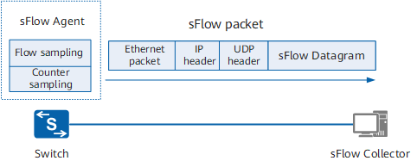

sFlow sampling
sFlow Agent provides two sampling methods for users to analyze network traffic conditions from different perspectives, namely Flow sampling and Counter sampling.
Flow sampling
Flow sampling means that the sFlow Agent device performs sampling and analysis on packets on a specified interface according to a specific sampling direction and sampling comparison to obtain information related to the packet data content. This sampling method mainly focuses on the details of traffic, so that the traffic behavior on the network can be monitored and analyzed.
Field | Description
Raw packet | Intercept all or part of the header of the original message (the specific length of the interception is determined by the configuration), encapsulate this part of the original message into an sFlow message and send it to the Collector.
Ethernet Frame Data | For Ethernet messages, parse the Ethernet header information of the message, encapsulate the parsed data into sFlow messages and send them to the Collector.
Extended Switch Data | For forwarded Ethernet packets, record the VLAN conversion and VLAN priority conversion of the packets, encapsulate the forwarding information into sFlow packets and send them to the Collector. When the VLAN ID is 0, it indicates an invalid VLAN.
Counter sampling
Counter sampling allows the sFlow Agent device to periodically obtain traffic statistics information on the interface. Counter sampling supports the acquisition of sampling information as shown in the following table. Compared with Flow sampling, Counter sampling only focuses on the quantity of traffic on the interface, but not on the detailed information of the traffic.
Field | Description
Generic Interface Counters | General interface statistics, including basic interface information and general interface traffic statistics.
Ethernet Interface Counters | For the Ethernet interface, it is used to collect Ethernet-related traffic statistics.
Processor Information | Used to count device CPU usage and memory usage.

sFlow message
sFlow messages are encapsulated by UDP, and the default destination port number is the well-known port 6343. There are four header formats for sFlow messages, namely Flow sample, Expanded Flow sample, Counter sample, and Expanded Counter sample. The Expanded Flow sample and Expanded Counter sample are new additions to sFlow version 5 and are extensions of the Flow sample and Counter sample, but are not forward compatible. All Extended sampling content must be encapsulated using the Expanded sampling packet header.

Configuration commands
- Configure agent address
Order | SWITCH( config )# sflow agent { ip IPV4ADDR | ipv6 IPV6ADDR }  SWITCH( config )# no sflow agent { ip | ipv6}
describe | Configure/delete a gent address;  IPV4ADDR: agent/ device IPv4 address  IPV6ADDR: a gent/device IPv6 address  Supports configuring ipv 4 and ipv 6 addresses at the same time, for collectors of ipv 4 and ipv 6 respectively  There is no configuration by default. If not configured, the protocol may not send packets.
- Configure collector
Order | SWITCH(config )# sflow collector <1-2> { ip IPV4ADDR | ipv6 IPV6ADDR } [datagram-size <200-9000> | port <1024-65535> | description STRING ]  SWITCH(config )# no sflow collector <1-2>
describe | Configure/delete collector;  <1-2>: collector index  IPV4ADDR: collector/ server IPv4 address  IPV6ADDR: collector/ server IPv6 address  <200-9000>: Maximum length of data packet, optional, default 1 400  <1024-65535>: Server port number, optional, default 6 343  STRING: c collector description information, optional, default is none
- Configure interface flow sampling
Order | SWITCH(config -if) #sflow flow -sampling collector <1-2>  SWITCH(config -if)# no flow-sampling collector
describe | Configure/delete interface flow sampling;  <1-2>: c collector index ss
- Configure interface counter sampling
Order | SWITCH(config -if)# sflow counter-sampling collector <1-2>  SWITCH(config -if)# no counter-sampling collector
describe | Configure/delete interface counter sampling;  <1-2>: collector index ss
- Configure interface flow sampling parameters
Order | SWITCH( config-if)# sflow flow-sampling direction { inbound | outbound }  SWITCH( config-if)# sflow flow-sampling rate <1024-65536>  SWITCH( config-if)# sflow flow-sampling max-header <18-256>  SWITCH( config-if)# no flow-sampling direction  SWITCH(config -if)# no flow-sampling rate  SWITCH(config -if)# no flow-sampling max-header
describe | Configure/ reset interface flow sampling parameters;  { inbound | outbound } : flow sampling direction, optional, the default is to sample inbound + outbound at the same time  <1024-65536>: flow sampling rate, optional, default is 2 048, one sample for every 2 048 flows  <18-256> : Flow sampling message length, unit byte, optional, default 6 4
- Configure interface counter sampling parameters
Order | SWITCH(config -if)# sflow counter-sampling interval <3-65535>  SWITCH(config -if)# no sflow counter-sampling interval
describe | Configure/reset interface counter sampling parameters;  <3-65535>: counter sampling period, unit seconds, optional, default 1 0

Examples
Requirements
sFlow network management server is 2.2.2.2 and the device IP address is 2.2.2.95.
The network management server needs to monitor the status of device port 3 through sFlow . It is required to perform flow sampling and counter sampling at the same time. The parameters can be defaulted.
Configurations
Initialize network management configuration
SWITCH#
SWITCH#configure terminal
Enter configuration commands, one per line. End with CNTL/Z.
SWITCH(config )# sflow -agent- ip 2.2.2.95
SWITCH(config )# sflow collector 1 ip 2.2.2.2
SWITCH(config )#
Configure sampling for port 3
SWITCH( config)#int gi 0/3
SWITCH( config-if)#sflow flow-sampling collector 1
SWITCH( config-if)#sflow counter-sampling collector 1

Display Information
- Show sFlow
SWITCH#show sflow
Collector 1:
Address: 2.2.2.2 Agent: 2.2.2.95
Port: 6343 Datagram-Size: 1400 Description:
Fd : 11 Seq: 45 Tx Timer: (nil)
Buf : 0xab0d8 Alloc : 1400 Used: 0
-------------------------------------------------- ----------------------------------
| Flow | Counter |
Interface | ID Rate Direction Max-header Sequence | ID Interval Sequence |
-------------------------------------------------- ----------------------------------
GiE0/3 1 2048 both 64 2 1 10 7462
SWITCH#

Configuring DHCP Server

Overview of DHCP Server
DHCP (Dynamic Host Configuration Protocol) is a local area network network protocol that works using the UDP protocol and is widely used to dynamically allocate reusable network resources such as IP addresses.
DHCP is based on the Client/Server working mode. The DHCP client obtains the IP address from the DHCP server by sending a request message, and other configuration information. When the DHCP client and server are not on the same subnet, there must be a DHCP relay agent (DHCP Relay) to forward DHCP request and reply messages.
Protocol Standard:
RFC2132 DHCP Options and BOOTP Vendor Extensions. S. Alexander, R. Droms. March 1997. (Format: TXT, HTML) (Obsoletes RFC1533) (Updated by RFC3442, RFC3942, RFC4361, RFC4833, RFC5494) (Status: DRAFT STANDARD) (DOI: 10.17487/RFC2132)

Configuring

Global Configuration Commands
- Enabling/disabling DHCP Server Globally
Command | SWITCH(config)# ip dhcp-server enable  SWITCH(config)#no ip dhcp-server enable
Description | Enable and disable the DHCP server globally.
- Configuring Global Parameters
Command | SWITCH(config)# ip dhcp-server parameter NAME VALUE  SWITCH(config)# ip dhcp-server parameter (authoritative (on|off) | server-name NAME | server-identifier IDENTIFY | default-lease-time <1-2147483648> | max-lease-time <1-2147483648> | ping-timeout-ms <1-65535> | ping-timeout <1-65535>)  SWITCH(config)# no ip dhcp-server parameter NAME  SWITCH(config)# no ip dhcp-server parameter (authoritative | server-name | server-identifier | default-lease-time | max-lease-time | ping-timeout-ms | ping-timeout)
Description | Global parameter configuration. When parameter values conflict, global parameters take precedence over parameters for subnets and address pools with more precise ranges.  Default lease time: 43200s/12h.  Optional.
- Configuring Global Options
Command | SWITCH(config)# ip dhcp-server option NAME VALUE  SWITCH(config)# ip dhcp-server option (routers A.B.C.D | domain-name NAME | domain-name-servers A.B.C.D | capwap-ac-v4 A.B.C.D)  SWITCH(config)# no ip dhcp-server option NAME  SWITCH(config)# no ip dhcp-server option (routers | domain-name | domain-name-servers | capwap-ac-v4)
Description | Global option configuration. When option values conflict, global options take precedence over options for subnets and address pools with more precise ranges.  Optional.
- Configuring Custom Domain Fields
Command | SWITCH(config)# ip dhcp-server custom-space NAME [code width <1-4>] [length width <1-4>] [hash size <1-65535>]  SWITCH(config)#no ip dhcp-server custom-space NAME
Description | Configure custom domain information fields.  Optional.
- Configuring Custom Options
Command | SWITCH(config)# ip dhcp-server custom-option NAME code <1-255> (boolean|integer|ip-address|text|string|encapsulate)  SWITCH(config)#no ip dhcp-server custom-option NAME
Description | Configure custom options fields. The configured custom option code value cannot conflict with the configured common options.  Optional.
- Configuring Force Send Options
Command | SWITCH(config)# ip dhcp-server force-option <1-255>  SWITCH(config)#no ip dhcp-server force-option <1-255>
Description | Configure mandatory options fields.  Optional.
- Configuring Static Address
Command | SWITCH(config)# ip dhcp-server static-lease NAME XX:XX:XX:XX:XX:XX A.B.C.D  SWITCH(config)#no ip dhcp-server static-lease NAME
Description | Configure static address binding.  Optional.
- Configuring Whitelist
Command | SWITCH(config)# ip dhcp-server whitelist NAME XX:XX:XX:XX:XX:XX  SWITCH(config)#no ip dhcp-server whitelist NAME
Description | Configure the whitelist.  Optional.
- Configuring Blacklist
Command | SWITCH(config)# ip dhcp-server blacklist NAME XX:XX:XX:XX:XX:XX  SWITCH(config)#no ip dhcp-server blacklist NAME
Description | Configure the blacklist.  Optional.
- Configuring Custom Classification
Command | SWITCH(config)# ip dhcp-server class NAME match EXP  SWITCH(config)#no ip dhcp-server class NAME
Description | Configure custom classification. For professional usage, please configure it under the guidance of technicians.  Example: ip dhcp-server class win_pc match " substring (option vendor-class-identifier,0,4)=MSFT "  Optional.

Subnet Configuration Command
- Configuring Subnet Information
Command | SWITCH(config)# ip dhcp-server subnet A.B.C.D/M  SWITCH(config)#no ip dhcp-server subnet A.B.C.D/M
Description | Configure subnet information and enter subnet configuration mode.  At least one correct subnet configuration is required for the server to start normally.
- Configuring Subnet Address Range
Command | SWITCH(config-dhcp-subnet)# range A.B.C.D A.B.C.D  SWITCH(config-dhcp-subnet)#no range A.B.C.D
Description | Configure the address range of the subnet.  The server needs at least one assignable address range to start normally, which can be configured in the address pool below.  Can be configured multiple times, with different ranges.
- Configuring Subnet Parameters
Command | SWITCH(config-dhcp-subnet)# parameter NAME VALUE  SWITCH(config-dhcp-subnet)# parameter (authoritative (on|off) | server-name NAME | server-identifier IDENTIFY | default-lease-time <1-2147483648> | max-lease-time <1-2147483648> | ping-timeout-ms <1-65535> | ping-timeout <1-65535>)  SWITCH(config-dhcp-subnet)#no parameter NAME  SWITCH(config-dhcp-subnet)#no parameter (authoritative | server-name | server-identifier | default-lease-time | max-lease-time | ping-timeout-ms | ping-timeout)
Description | Configuration parameter information.  Optional.
- Configuring Subnet Options
Command | SWITCH(config-dhcp-subnet)# option NAME VALUE  SWITCH(config-dhcp-subnet)# option (routers A.B.C.D | domain-name NAME | domain-name-servers A.B.C.D | capwap-ac-v4 A.B.C.D)  SWITCH(config-dhcp-subnet)#no option NAME  SWITCH(config-dhcp-subnet)#no option (routers | domain-name | domain-name-servers | capwap-ac-v4)
Description | Configuration option information. It is usually necessary to configure the gateway routing address and DNS server address of the subnet.  Optional.

Address Pool Configuration Command
- Configuring Address Pool Information
Command | SWITCH(config-dhcp-subnet)# pool NAME  SWITCH(config-dhcp-subnet)#no pool NAME
Description | Configure the address pool in subnet mode. Subnets can be further divided through the address pool and used on demand.  Optional.
- Configuring the Address Range of the Address Pool
Command | SWITCH(config-dhcp-pool)# range A.B.C.D A.B.C.D  SWITCH(config-dhcp-pool)#no range A.B.C.D
Description | Configure the address range of the address pool.  The server needs at least one assignable address range to start normally, which can be configured in the above subnet.  Can be configured multiple times, with different ranges.
- Configuring Address Pool Parameters
Command | SWITCH(config-dhcp-pool)# parameter NAME VALUE  SWITCH(config-dhcp-pool)# parameter (authoritative (on|off) | server-name NAME | server-identifier IDENTIFY | default-lease-time <1-2147483648> | max-lease-time <1-2147483648> | ping-timeout-ms <1-65535> | ping-timeout <1-65535>)  SWITCH(config-dhcp-pool)#no parameter NAME  SWITCH(config-dhcp-pool)#no parameter (authoritative | server-name | server-identifier | default-lease-time | max-lease-time | ping-timeout-ms | ping-timeout)
Description | Configuration parameter information.  Optional.
- Configure Address Pool Options
Command | SWITCH(config-dhcp-pool)# option NAME VALUE  SWITCH(config-dhcp-pool)# option (routers A.B.C.D | domain-name NAME | domain-name-servers A.B.C.D | capwap-ac-v4 A.B.C.D)  SWITCH(config-dhcp-pool)#no option NAME  SWITCH(config-dhcp-pool)#no option (routers | domain-name | domain-name-servers | capwap-ac-v4)
Description | Configuration option information. It is usually necessary to configure the gateway routing address and DNS server address of the address pool.  Optional.
- Configuring Condition Filter Command
Command | SWITCH(config-dhcp-pool)# (allow|deny|ignore) CLASSNAME  SWITCH(config-dhcp-pool)# (allow|deny|ignore) (known-clients|unknown-clients|bootp|duplicates|declines)  SWITCH(config-dhcp-pool)# no (allow|deny|ignore) (CLASSNAME|known-clients|unknown-clients|bootp|duplicates|declines)
Description | Configure the address pool filter conditions. Custom CLASSNAME refer to the Configuring Custom Classifications section in the global configuration.  Optional.

Examples

General DHCP Server Address Assignment Scenario
- Requirement
See the description of the network diagram.
- Network Diagram
Figure28-1 DHCP server typical network diagram
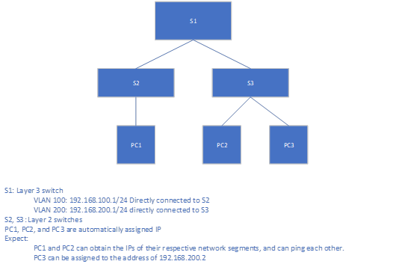
Description: The MAC address of PC3 during the test is 00:0E:C6:C1:38:41
- Typical Configuration Example
S1:
SWITCH(config)# ip dhcp-server subnet 192.168.100.0/24
SWITCH(config-dhcp-subnet)#range 192.168.100.2 192.168.100.254
SWITCH(config-dhcp-subnet)#option routers 192.168.100.1
SWITCH(config-dhcp-subnet)#exit
SWITCH(config)# ip dhcp-server subnet 192.168.200.0/24
SWITCH(config-dhcp-subnet)#range 192.168.200.2 192.168.200.254
SWITCH(config-dhcp-subnet)#option routers 192.168.200.1
SWITCH(config-dhcp-subnet)#exit
SWITCH(config)# ip dhcp-server static-lease pc3 00:0E:C6:C1:38:41 192.168.200.2
SWITCH(config)#ip dhcp-server option domain-name-servers 114.114.114.114
SWITCH(config)#ip dhcp-server enable
S2/S3: Empty configuration transparent transmission.

Supports DHCP Server Address Allocation Scenarios Delivered by Private Attributes
- Requirement
See the description of the network diagram.
- Network Diagram
Figure 28-2 DHCP server typical network diagram
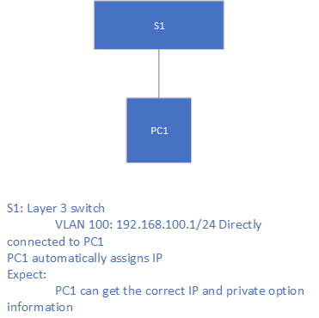
- Typical Configuration Example
S1:
SWITCH(config)# ip dhcp-server custom-space dkwl code width 1 length width 1
SWITCH(config)# ip dhcp-server custom-option dkwl.name code 1 string
SWITCH(config)# ip dhcp-server custom-option dkwl.ip code 2 ip-address
SWITCH(config)# ip dhcp-server custom-option vendor_dkwl code 43 encapsulate dkwl
SWITCH(config)# ip dhcp-server option dkwl.ip 1.1.1.1
SWITCH(config)# ip dhcp-server option dkwl.name "dockeer"
SWITCH(config)# ip dhcp-server subnet 192.168.100.0/24
SWITCH(config-dhcp-subnet)#range 192.168.100.2 192.168.100.254
SWITCH(config-dhcp-subnet)#option routers 192.168.100.1
SWITCH(config-dhcp-subnet)#exit
SWITCH(config)#ip dhcp-server option domain-name-servers 114.114.114.114
SWITCH(config)#ip dhcp-server enable

A DHCP Server Address Assignment Scenario that Supports Guest Separation
- Requirement
- See the description of the network diagram.
- Normal user allocation addresses 192.168.100.2-192.168.100.100 and 192.168.200.2-192.168.200.100.
- Guest assigned address 192.168.100.200-192.168.100.254.
- Network Diagram
Figure 28-3 DHCP server typical network diagram
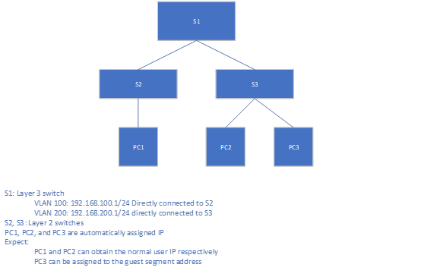
- Typical Configuration Example
S1:
SWITCH(config)# ip dhcp-server subnet 192.168.100.0/24
SWITCH(config-dhcp-subnet)#range 192.168.100.2 192.168.100.100
SWITCH(config-dhcp-subnet)#option routers 192.168.100.1
SWITCH(config-dhcp-subnet)#exit
SWITCH(config)# ip dhcp-server subnet 192.168.200.0/24
SWITCH(config-dhcp-subnet)#pool employee
SWITCH(config-dhcp-pool)#range 192.168.200.2 192.168.200.100
SWITCH(config-dhcp-pool)#deny unknown-clients
SWITCH(config-dhcp-pool)#pool guest
SWITCH(config-dhcp-pool)#range 192.168.200.200 192.168.200.254
SWITCH(config-dhcp-pool)#allow unknown-clients
SWITCH(config-dhcp-pool)#exit
SWITCH(config-dhcp-subnet)#option routers 192.168.200.1
SWITCH(config-dhcp-subnet)#exit
SWITCH(config)#ip dhcp-server option domain-name-servers 114.114.114.114
SWITCH(config)#ip dhcp-server enable
S2/S3: Empty configuration transparent transmission.

Display Information
- Display DHCP Server Status Information
SWITCH#show ip dhcp-server status
DHCP Server: Enable (conf.Enable)
- Display Address Assignment Information
SWITCH#show ip dhcp-server leases
Name MAC IP Begin End Manufacturer
-------------------- -------------------- --- ----------------- -------------------- ------------- ------- --------------------
liulang-work 00:0e:c6:c1:38:4a 3.3.3.254 1970-01-01 00:00:36 1970-01-01 00:10:36 ASIX ELECTRONICS CORP.

Configuring AAA

Overview of AAA
AAA is the abbreviation of Authentication Authorization and Accounting, which provides for authentication, authorization and accounting function into the configuration of the consistency framework.
AAA provides the following services in a modular fashion:
- Authentication: Verify whether the user can obtain access rights. Optionally use RADIUS protocol, TACACS+ protocol or Local (local) and so on. Identity authentication is a method of identifying a user's identity before allowing access to the network and network services.
- Authorization: Which services are available to authorized users. AAA authorization is achieved by defining a series of attribute pairs, these attribute pairs describe the operations that the user is authorized to perform. These attribute pairs can be stored on a network device or remotely on a secure server.
- Accounting: record the user's use of network resources. When AAA accounting is enabled, the network device starts to send user usage of network resources. Each accounting record is composed of attribute pairs and stored on a secure server. These records can be read and analyzed by special software, so as to realize accounting, statistics and tracking of users' use of network resources.
Using AAA has the following advantages:
- Flexibility and controllability.
- Scalability.
- Standardized Certification.
- Multiple backup systems.
AAA has the following relevant standards:
RFC2865 Remote Authentication Dial In User Service (RADIUS). C. Rigney, S. Willens, A. Rubens, W. Simpson. June 2000. (Format: TXT, HTML).
RFC2866 RADIUS Accounting. C. Rigney. June 2000. (Format: TXT, HTML).
RFC8907 The Terminal Access Controller Access-Control System Plus (TACACS+) Protocol. T. Dahm, A. Ota, DC Medway Gash, D. Carrel, L. Grant. September 2020.

Configuring
- Enabling/disabling AAA Function Globally
Command | SWITCH( config)# aaa new-model  SWITCH( config)# no aaa new-model
Description | Globally enable or disable the AAA function.
- Configuring AAA Server Group
Command | SWITCH( config)# aaa group server (radius) ( default| NAME )  SWITCH( config ) # aaa group server ( tacacs + ) ( default| NAME )  SWITCH( config)# no aaa group server ( radius|tacacs +) ( default| NAME )
Description | Server group configuration.  Optional.  By default there is no server group configuration and no server method is used.
- Configuring AAA Server
Command | SWITCH(config-gs-rad )# server A.B.C.D (auth-port <1-65535> |) (acct-port <1-65535> |) (key STRING )  SWITCH(config-gs-tac)# server A.B.C.D (port <1-65535> |) (key STRING )  SWITCH(config-gs-rad)# no server A.B.C.D  SWITCH(config-gs-tac)# no server A.B.C.D
Description | server group mode .  Configure RADIUS, TACACS + server information, including basic IP address, port information, shared key  Optional.  Note: Due to implementation restrictions, the current radius accounting port number is always the authentication port number + 1, and the configuration is invalid.
- Configuring Server Group Timeout
Command | SWITCH(config-gs-rad)# timeout <1-120>  SWITCH(config-gs-tac)# timeout <1-120>  SWITCH(config-gs-rad)# no timeout  SWITCH(config-gs-tac)# no timeout
Description | server group mode .  Configure the timeout period for servers in the group.  Optional.
- Configuring Group Service Information Fields
Command | SWITCH(config-gs-tac)# service NAME  SWITCH(config-gs-tac)# no service
Description | TACACS+ server group mode .  Configure the service information in the group.  Optional.
- Configuring AAA Method Information
Command | SWITCH(config)# aaa (authentication|authorization|accounting) (login|ssh|web|dot1x|command) default {group (radius|tacacs+|NAME)|local|none}  SWITCH(config)#no aaa (authentication|authorization|accounting) (login|ssh|web|dot1x|command) default
Description | Global configuration mode.  Configure AAA method information.  Optional.Local authentication is used by default.  Note1: The username (such as admin) that exists on the machine also needs to be provided during the none authentication, otherwise an error may occur.  Note2: Web do not support accounting/authorization now.

Examples

SSH Login Authentication Using Tacacs+ Method
- Requirements
- See the description of the network diagram
- Network diagram
Figure 8 Typical networking diagram for SSH through tacacs+ server authentication and accounting
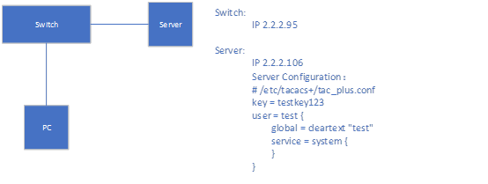
Description: none
- Typical configuration example
Switch：
SWITCH(config)# aaa new-model
SWITCH(config)# aaa group server tacacs+ default
SWITCH(config-gs-tac) # server 2.2.2.106 key testkey123
SWITCH(config-gs-tac)# exit
SWITCH(config)# aaa authentication ssh default group tacacs+
SWITCH(config)# aaa accounting ssh default group tacacs+
SWITCH(config)# username test remote

Device IP configuration and ssh configuration refer to the corresponding chapters in the configuration documentation, which are omitted here.

Use the None Method to Perform Serial Port Login
- Requirements
- See the description of the network diagram
- Network diagram
Figure9 Typical network diagram of serial port using none authentication and accounting
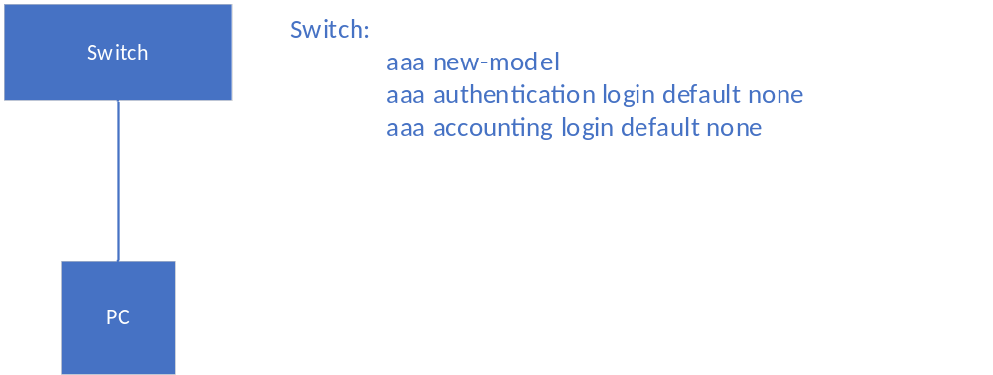
- Typical configuration example
Refer to the network diagram

Display Information
- None

Fault Diagnosis

Ping/tracerout
- ping
Command | SWITCH#ping {ip IPADDR | ipv6 IPV6ADDR}
Description | Ping a remote host through IP.
- traceroute
Command | SWITCH# traceroute {ip IPADDR | ipv6 IPV6ADDR }
Description | Trace the path that packets take through the network.

Port Optical Module

Configuring Port Optical Module
- Configuring Optical-transceiver Monitor Enable
Command | SWITCH(config-if)# optical-transceiver monitor enable  SWITCH(config-if)# no optical-transceiver monitor enable
Description | Enable monitor the specified interface, detect the status of optical module periodically.  Default is disabled.
- Configuring Optical-transceiver Monitor Interval
Command | SWITCH(config)# optical-transceiver monitor interval MINUTES  SWITCH(config-if)# no optical-transceiver monitor interval
Description | Set the interval of the transceiver monitor.  Default is 15 minutes.  Range from 1 to 1440 minutes.
- Configuring Optical-transceiver Temperature Threshold
Command | SWITCH(config-if)# optical-transceiver threshold temperature HALARM HWARN LWARN LALARM  SWITCH(config-if)# no optical-transceiver threshold temperature
Description | By default, the optical module has own temperature threshold setting, so it is not recommended to configure the temperature threshold.  HALARM: high-alarm threshold value, range from -255 to 255 C  HWARN: high-warning threshold value, range from -255 to 255 C  LWARN: low-warning threshold value, range from -255 to 255 C  LALARM: low-alarm threshold value, range from -255 to 255 C  The HALARM value should not smaller than HWARN value.  The LWARN value should not smaller than LALARM value.
- Configuring Optical-transceiver Voltage Threshold
Command | SWITCH(config-if)# optical-transceiver threshold voltage HALARM HWARN LWARN LALARM  SWITCH(config-if)# no optical-transceiver threshold voltage
Description | By default, the optical module has own voltage threshold setting, so it is not recommended to configure the voltage threshold.  HALARM: high-alarm threshold value, range from 0.00 to 5.00 V  HWARN: high-warning threshold value, range from 0.00 to 5.00 V  LWARN: low-warning threshold value, range from 0.00 to 5.00 V  LALARM: low-alarm threshold value, range from 0.00 to 5.00 V  The HALARM value should not smaller than HWARN value.  The LWARN value should not smaller than LALARM value.
- Configuring Optical-transceiver Bias Threshold
Command | SWITCH(config-if)# optical-transceiver threshold bias HALARM HWARN LWARN LALARM  SWITCH(config-if)# no optical-transceiver threshold bias
Description | By default, the optical module has own bias threshold setting, so it is not recommended to configure the bias threshold.  HALARM: high-alarm threshold value, range from 0.00 to 500.00 mA  HWARN: high-warning threshold value, range from 0.00 to 500.00 mA  LWARN: low-warning threshold value, range from 0.00 to 500.00 mA  LALARM: low-alarm threshold value, range from 0.00 to 500.00 mA  The HALARM value should not smaller than HWARN value.  The LWARN value should not smaller than LALARM value.
- Configuring Optical-transceiver Rx-power Threshold
Command | SWITCH(config-if)# optical-transceiver threshold rx-power HALARM HWARN LWARN LALARM  SWITCH(config-if)# no optical-transceiver threshold rx-power
Description | By default, the optical module has own rx-power threshold setting, so it is not recommended to configure the rx-power threshold.  HALARM: high-alarm threshold value, range from -40.00 to 10.00 dBm  HWARN: high-warning threshold value, range from -40.00 to 10.00 dBm  LWARN: low-warning threshold value, range from -40.00 to 10.00 dBm  LALARM: low-alarm threshold value, range from -40.00 to 10.00 dBm  The HALARM value should not smaller than HWARN value.  The LWARN value should not smaller than LALARM value.
- Configuring Optical-transceiver Tx-power Threshold
Command | SWITCH(config-if)# optical-transceiver threshold tx-power HALARM HWARN LWARN LALARM  SWITCH(config-if)# no optical-transceiver threshold tx-power
Description | By default, the optical module has own tx-power threshold setting, so it is not recommended to configure the tx-power threshold.  HALARM: high-alarm threshold value, range from -40.00 to 10.00 dBm  HWARN: high-warning threshold value, range from -40.00 to 10.00 dBm  LWARN: low-warning threshold value, range from -40.00 to 10.00 dBm  LALARM: low-alarm threshold value, range from -40.00 to 10.00 dBm  The HALARM value should not smaller than HWARN value.  The LWARN value should not smaller than LALARM value.

Alarm/Warning Trap
In addition to the alarm or warning message, the optical module monitor will also send a trap message to the smmp server.
Node | data
Mib files | TNPL_private_2.1.89(interface_ddm).mib
Alarm oid | 1, 3, 6, 1, 4, 1, 37831, 101, 110, 1
Warning oid | 1, 3, 6, 1, 4, 1, 37831, 101, 110, 2
Ifindex oid | 1, 3, 6, 1, 4, 1, 37831, 100, 30, 2, 1, 1
Information oid | 1, 3, 6, 1, 4, 1, 37831, 100, 30, 2, 1, 2

Display Port Optical Module DDM Information
- Show interface optical-transceiver information
Display the information of the optical/copper module inserted in the optical port.
Command | SWITCH#show interface {IFNAME |} optical-transceiver {info |}
Description | If no interface-id is specified, the module information of all ports will be displayed.  If info is not specified, the DDM information of the port module will be displayed, and if specified, the complete module information (basic information, alarm information, manufacturer information) will be displayed.
DDM information display elements are as follows:
Key Word | Description
Temp | The temperature of the module, in °C, accurate to 1°C.
Voltage | The voltage of the module, the unit is V, accurate to 0.01V.
Bias | The current of the module, in mA, accurate to 0.01mA.
RX power | The received optical power of the module, in dBm, accurate to 0.01dBM.
TX power | The transmit optical power of the module, in dBm, accurate to 0.01dBM.
OK | normal, no intervention required.
WARN | Alarm, indicating that the allowable range of the device is exceeded, and attention should be paid to.
ALARM | Abnormal, indicating that the device's allowable state is seriously exceeded and immediate intervention is required.
ABSENT | Absent.
NA | Port not supported/module not supported.
TIMEOUT | Time out.
ERR | Mistake.
Display all port module DDM information
SWITCH#show interface optical-transceiver
Port Temp Voltage Bias RX power TX power
[C] [V] [mA] [dBm] [dBm]
------- ---------- ------------- ------------- ------------- -------------
GiE0/9 42(OK) 3.20(OK) 32.34(OK) -3.98(OK) 1.64(OK)
GiE0/10 ABSENT ABSENT ABSENT ABSENT ABSENT
GiE0/11 ABSENT ABSENT ABSENT ABSENT ABSENT
GiE0/12 ABSENT ABSENT ABSENT ABSENT ABSENT
- Display the overall information of the port optical module/copper module
Error message:
Key Word | Description
Transceiver absent! | Failed to get information, maybe the module is not in place.
Get transceiver info timeout! | Timeout to get information, need to get it again.
Port doesn't support get module info! | The port does not support getting module information.
Basic Information
Key Word | Description
Transceiver Type | module type.
Connector Type | Interface Type.
Wavelength(nm) | Wavelength.
Link Length | Supported link lengths.
Digital Diagnostic Monitoring | Whether to support DDM function.
Vendor Serial Number | Module serial number.
Warning Information
Key Word | Description
RX Channel loss of signal | Received signal loss.
RX Channel power high | High received optical power alarm.
RX Channel power low | Low received optical power alarm.
TX Channel fault | Send Error.
TX Channel bias high | Bias current high alarm.
TX Channel bias low | Bias current low alarm.
TX Channel power high | Sending high optical power alarm.
TX Channel power low | Sending low optical power alarm.
Temperature high | High temperature alarm.
Temperature low | Low temperature alarm.
Voltage high | High voltage alarm.
Voltage low | Low voltage alarm.
None | no alarm.
This module doesn't support getting alarm! | The module does not support getting alarm information.
Manufacturer information
Key Word | Description
Vendor Name | Manufacturer Names.
Vendor OUI | Manufacturer OUI.
Vendor Part Number | Manufacturer part number.
Vendor Revision | Manufacturer version number.
Manufacturing Date | Production Date.
Encoding | encoding type.
Displays overall information about a single port module
SWITCH#show interface gigabitEthernet0/9 optical-transceiver info
###################################################
gigabitEthernet0/9
+-------------------------------------------------+
|Transceiver base information: |
+-------------------------------------------------+
|Transceiver Type : 1000BASE-ZX-SFP |
|Connector Type : LC |
|Wavelength(nm) : 1550 |
|Link Length : |
| SMF fiber |
| -- 80km |
|Digital Diagnostic Monitoring : YES |
|Vendor Serial Number : WT1703230031 |
+-------------------------------------------------+
|Transceiver current alarm information: |
+-------------------------------------------------+
|None |
+-------------------------------------------------+
|Transceiver vendor information: |
+-------------------------------------------------+
|Vendor Name : OEM |
|Vendor OUI : 000000 |
|Vendor Part Number : SFP-GE-ZX-SM1550 |
|Vendor Revision : V2 |
|Manufacturing Date : 2017-03-25 |
|Encoding : 8B10B |
+-------------------------------------------------+
SWITCH#
Displays overall information for all port blocks
SWITCH#show interface optical-transceiver info
###################################################
gigabitEthernet0/9
+-------------------------------------------------+
|Transceiver base information: |
+-------------------------------------------------+
|Transceiver Type : 1000BASE-ZX-SFP |
|Connector Type : LC |
|Wavelength(nm) : 1550 |
|Link Length : |
| SMF fiber |
| -- 80km |
|Digital Diagnostic Monitoring : YES |
|Vendor Serial Number : WT1703230031 |
+-------------------------------------------------+
|Transceiver current alarm information: |
+-------------------------------------------------+
|None |
+-------------------------------------------------+
|Transceiver vendor information: |
+-------------------------------------------------+
|Vendor Name : OEM |
|Vendor OUI : 000000 |
|Vendor Part Number : SFP-GE-ZX-SM1550 |
|Vendor Revision : V2 |
|Manufacturing Date : 2017-03-25 |
|Encoding : 8B10B |
+-------------------------------------------------+
###################################################
gigabitEthernet0/10
+-------------------------------------------------+
|Transceiver base information: |
+-------------------------------------------------+
|Transceiver Type : 1000BASE-GT-SFP |
|Connector Type : Unknown or unspecified |
|Wavelength(nm) : 16652 |
|Link Length : |
| Cable Assembly copper |
| -- 100m |
|Digital Diagnostic Monitoring : NO |
|Vendor Serial Number : MTC100046 |
+-------------------------------------------------+
|Transceiver current alarm information: |
+-------------------------------------------------+
This module doesn't support getting alarm!
|This module doesn't support getting alarm! |
+-------------------------------------------------+
|Transceiver vendor information: |
+-------------------------------------------------+
|Vendor Name : OEM |
|Vendor OUI : 000000 |
|Vendor Part Number : SFP-T-CBTX |
|Vendor Revision : F |
|Manufacturing Date : 2014-10-01 |
|Encoding : 8B10B |
+-------------------------------------------------+
###################################################
gigabitEthernet0/11
Get result error(Maybe Transceiver absent)!
###################################################
gigabitEthernet0/12
Get result error(Maybe Transceiver absent)!
SWITCH#
- Show interface opticatl-transceiver threshold information
Display the information of the optical/copper module inserted in the optical port.
Command | SWITCH#show interface {IFNAME |} optical-transceiver threshold
Description | If no IFNAME is specified, the module information of all ports will be displayed.  If the threshold is not configured, the own threshold information of the module will be displayed.

SWITCH#show interface optical-transceiver threshold

Interface tengigabitEthernet0/25:
Item High-alarm High-warn Low-warn Low-alarm
Temp(Celsius) 100 90 -40 -50
Voltage(V) 3.50 3.47 3.15 3.04
Bias(mA) 15.00 12.00 4.00 5.58
RX power(dBm) 10.25 5.30 -10.22 -12.40
TX power(dBm) 2.100 1.100 -9.100 -11.00

Dying Gasp
Dying Gasp is referenced in section 7.1.2.5.3 of ITU-T Recommendation G.991.2 (12/2003) as the Power Status bit.
The networking devices rely on a temporary back-up power supply on a capacitor, that allows for a graceful shutdown and the generation of the dying-gasp message. This temporary power supply is designed to last from 10 to 20 milliseconds to perform these tasks.
In addition to the dying-gasp message, the power-down device will also send a trap message to the smmp server.
Node | data
Mib files | DOT3-OAM-MIB.mib
oid | 1, 3, 6, 1, 2, 1, 158, 1, 6, 1, 4
value | dyingGaspEvent(257)
- Enable dying-gasp
Command | SWITCH(config)#dying-gasp enable  SWITCH(config)#no dying-gasp
Description | Enable dying gasp function
LOG messages
For example：”Device 00:d0:f8:c8:23:12 power down.”

Cable Detect
A cable fault may cause the interface to be in the Down state or the interface rate to be abnormal even though the interface is in the Up state. Users can execute this command to detect whether the cable is faulty and locate the fault point to help solve the cable fault. Please pay attention to the following points when using the cable detection function:
- Only copper interfaces support this command.
- When this command is executed, the normal service of the interface may be affected in a short period of time.
- When the line length is less than 6 meters, there will be a deviation between the test results and the actual value. The shorter the line, the greater the deviation.
- Port Performs Cable Detection Function
Command | SWITCH(config-if)#cable-detect
Description | Perform a cable detection on the port. After 2 seconds, use the show command to view the detection results.
Perform a cable test on port g i0 /1:
SWITCH# configure terminal
SWITCH(config)#interface gigabitEthernet 0/1
SWITCH(config-if)#cable-detect
%Please wait for about 2 seconds and execute the show cable-detect command to view the execution results.
View cable test results:
SWITCH#show cable-detect interface gigabitEthernet 0/1
Pair A length(meters): 0
Pair B length(meters): 0
Pair C length(meters): 0
Pair D length(meters): 0
Pair A state: OK
Pair B state: OK
Pair C state: OK
Pair D state: OK

Field | Explain
Pair X length(meters) | Cable length.  When there is a fault, it represents the length from the interface to the fault.  Unit：meter
Pair X state | Network cable status:  OK: Indicates that the line pair is terminated normally.  Open: Indicates that the line pair is open.  Short: Indicates a short circuit on the pair.  Unknown: Other unknown causes of failure.

